Luis David B. Espino, Abdullah Ibn Mujahid J. Egil, Joshua M. Libag, and John Paul S. Penola
College of Computer Studies, Technological Institute of the Philippines – Quezon City
IT 304 - Capstone Project 1
Mr. Juvert De Los Reyes
June 2026

TABLE OF CONTENTS
Content | Page
Title Page | i
Table of Contents | ii
List of Tables | iii
List of Figures | iv

CHAPTER 1 | 11
THE PROBLEM AND ITS BACKGROUND | 11
Background of the Study | 11
Project Objectives | 16
Significance of the Study | 18
Scope and Delimitations | 21
CHAPTER 2 | 28
THEORETICAL AND CONCEPTUAL FRAMEWORK | 28
Theoretical Framework | 28
Review of Related Literature and Studies | 34
AI-Assisted 3D Venue Layout Planning and Spatial Arrangement | 34
Drag-and-Drop Interfaces and User-Guided Layout Design | 36
Collision Detection in 3D Layout Validation | 37
A* Pathfinding and Walkway Validation in Grid-Based Venues | 37
AI Layout Recommendation and Better Visualization | 38
Catering Event Management and Digital Reservation Platforms | 39
Comparative Analysis of Existing Venue Layout Platforms | 40
Food Waste and Perishable Inventory in Catering and Food Service | 42
Digital Inventory Management and Expiry-Aware Stock Logic | 42
SARIMA Demand Forecasting for Procurement Planning | 43
Collaborative Filtering and Food Recommendation Systems | 44
AI-Powered Conversational Assistants in Food Service Applications | 45
Offline-First and Cross-Platform Mobile Application Design | 45
Conceptual Framework | 46
System Architecture | 51
Definition of Terms | 55
CHAPTER 3 | 62
RESEARCH METHODOLOGY AND OPERATIONAL FRAMEWORK | 62
Project Design | 62
Mathematical Models | 63
Spatial Validation Models: AABB Collision Detection and A* Pathfinding | 63
Batch-Level Expiry Tracking and FEFO Integration | 64
Data Architecture for Expiry Tracking | 65
Expiry Capture at Delivery Inspection | 65
State-Check Monitoring and FEFO Integration | 66
Collaborative Filtering and Expiry-Aware Recommendation Integration | 67
Implicit Preference Scoring | 67
User Similarity Computation | 68
Expiry-Aware Integration and Dynamic Weighting | 68
Time-Series Demand Forecasting Using the SARIMA Model | 69
Model Selection and Justification | 69
Mathematical Formulation and Parameter Definition | 69
Algorithm Trade-off Analysis | 71
Technology Stack and Computing Standards | 78
Design Discussion | 79
Summary of Constraints | 80
Design Trade-Offs | 81
Criterion Performance | 85
Influence of Design Trade-Offs in Final Design | 85
Project Development | 86
Phase 1: Requirements Planning (Weeks 1–3) | 87
Phase 2: User Design (Weeks 4–8) | 87
Phase 3: Construction (Weeks 9–18) | 89
Phase 4: Cutover (Weeks 19–20) | 92
Testing and Operating Procedure | 93
Unit Testing | 93
Integration and API Testing | 93
Cross-Platform Compatibility Testing | 93
Performance Testing | 94
Security Testing | 94
Project Evaluation | 95
Technical Expert Evaluation | 95
End-User Evaluation | 95
Partner Organization Validation | 97
Work Plan (Work Breakdown Structure) | 97
Potential for Commercialization | 99
Market Model | 100
Measurable Benefits | 102
Three-Year Product Roadmap | 103
Go-to-Market Strategy | 105
Business Model | 106
Value Chain Positioning | 107
Revenue Generation Model | 107
Cost Model | 108
Success Metrics | 108
Risk Factors and Mitigation | 109
Revenue Level for Breakeven | 111
References | 112
Appendices | 124
Appendix A: Letter of Cooperation | 124
Appendix B: Interview Questions | 126
Appendix C: Commitment Letter | 135
Appendix D: SALES 2023-2026 | 136
Appendix E: Recipe Costing Sheet | 138
Appendix F: Data sheet of Orders | 139
Appendix G: Risk Management Plan | 141
Appendix H: AI tool declaration | 153
Appendix I: Storyboard | 154
Appendix J: Grammarly and Plagiarism Results | 192

LIST OF TABLES
Table | Page
Table 1. Technology Stack and Computing Standards of the HapagPamana System | 136
Table 2. SARIMA Notation and Parameter Definitions | 123
Table 3. Summary of Design Constraints — HapagPamana Administrative Web Panel | 138
Table 4. Design Trade-off 1: Dashboard Response Time | 139
Table 5. Design Trade-off 2: Memory Usage | 140
Table 6. Design Trade-off 3: File Size | 141
Table 7. Criterion Performance Summary | 143
Table 8. ISO/IEC 25010 Evaluation Dimensions and HapagPamana Assessment Focus | 152
Table 9. Work Breakdown Structure – HapagPamana Cross-Platform Catering Management System | 154
Table 10. Three-Year Product Roadmap for HapagPamana | 160
Table 11. Success Metrics | 165
Table 12. Risk Factors and Mitigation | 165

LIST OF FIGURES
Figure | Page
Figure 1. SARIMA and Collaborative filtering | 64
Figure 2. SARIMA Demand Forecasting on Food | 65
Figure 3. Ingredient Demand Using SARIMA | 66
Figure 4. SARIMA Forecast + Expiry-Aware Reorder Plan | 66
Figure 5. SARIMA Forecast + Expiry-Aware Reorder Plan | 67
Figure 6. Stock, SARIMA Forecast, and Request Status | 68
Figure 7. 12-Month Historical Demand Intensity Heatmap | 69
Figure 8. Collaborative Filtering Algorithm | 70
Figure 9. Readiness Score - Event Readiness Scorecard | 71

CHAPTER 1

INTRODUCTION

Background of the Study
The Philippine catering industry requires extensive advance planning because catering services are usually prepared days or weeks before the actual event. Unlike fast-food or walk-in restaurant operations, catering businesses must plan food preparation, procurement, staffing, equipment, and venue arrangement based on confirmed bookings. This makes catering operations highly vulnerable to planning errors, especially when event requirements change or when the actual venue setup is not clearly visualized before the event day. For small and home-based catering operators, these challenges are more difficult because core operations such as inventory monitoring, procurement records, and order tracking are still handled manually through paper records, verbal coordination, and experience-based estimation (Estepa et al., 2025; Quinto & Libag, 2025). Venue setup, in turn, is typically communicated through hand-drawn layouts or informal on-site adjustments, leaving clients and staff without a reliable way to visualize the arrangement before the event day.
One of the major operational gaps in small-scale catering operations is venue layout planning. After a catering booking is confirmed, the caterer and the client must decide how tables, chairs, buffet stations, stage areas, entrances, exits, and walkways will be arranged within the available venue space. This step is important because the quality of the event setup affects guest comfort, food service flow, accessibility, safety, and overall event experience. However, this process is commonly done through manual sketches, verbal instructions, static image templates, or informal on-site estimation. As a result, clients may find it difficult to imagine the final arrangement, while catering staff may only discover layout problems during the actual setup (Christakou et al., 2022; Karne, 2022).
Manual venue layout planning can lead to several issues. Tables and chairs may overlap or be placed too close to one another, buffet stations may block entrances or walkways, stages may be positioned in areas with poor visibility, and guests may experience difficulty moving from one area to another. These layout problems can cause delays, overcrowding, inefficient guest flow, and last-minute rearrangements during the event day. Since corrections are often made only when the staff is already at the venue, layout-related problems become stressful, time-consuming, and costly for both the caterer and the client (Karne, 2022; Christakou et al., 2022).
The layout planning problem is particularly significant for home-based catering businesses such as Fill at Home Catering Services. Like many small catering operators, Fill at Home currently relies on manual coordination for catering event preparation. Event layouts are usually communicated through verbal discussion, hand-drawn diagrams, or simple descriptions, without an interactive and scaled tool that allows clients and administrators to test different arrangements before the event. The absence of a digital layout planning system limits the ability of the business to validate whether a proposed arrangement is feasible, spacious, accessible, and safe (Estepa et al., 2025; Quinto & Libag, 2025).
Recent developments in computational geometry, pathfinding, and AI-assisted design provide practical solutions to this problem. Axis-Aligned Bounding Box (AABB) collision detection can be used to determine whether objects in a 3D space overlap or violate minimum spacing requirements. In the context of catering layout planning, this means that the system can automatically check whether tables, chairs, buffet stations, and stage areas are placed too close to one another. Meanwhile, the A pathfinding algorithm can compute walkable paths across a grid-based venue representation, allowing the system to check whether guests can move clearly from the entrance to important points such as the buffet area, seating area, stage, and exit. These algorithms are computationally lightweight and suitable for a 3D drag-and-drop layout planner (Mi et al., 2023; Mileff, 2023).
In response to this gap, this study proposes “HapagPamana: A Smart Catering System Integrating 3D Venue Layout Planning and AI-Assisted Catering Recommendations.” The primary feature of the system is an interactive 3D venue layout planner that allows customers and administrators to drag and drop catering objects such as tables, chairs, buffet stations, stage areas, and entrance or exit markers onto a scaled venue grid. The system stores the position and size of each object, validates the arrangement using AABB collision detection and A* pathfinding, and provides layout warnings when objects overlap, spacing is insufficient, or walking paths are blocked (Mi et al., 2023; Mileff, 2023).
Beyond validation, the system also includes an AI-assisted layout recommendation feature. This feature analyzes the venue dimensions, guest count, event type, object placement, collision results, and pathfinding results to suggest layout improvements. For example, the system may recommend moving the buffet station away from the entrance path, increasing spacing between tables, repositioning the stage for better visibility, or improving the walking path from the entrance to the buffet area. This transforms venue layout planning from a manual and uncertain process into an interactive, visual, and decision-supported activity. Research on AI-assisted spatial layout has shown the potential of data-driven recommendation models in producing real-time layout suggestions, supporting the relevance of applying similar principles to catering venue planning (Chen, 2022).
The HapagPamana platform balances physical event optimization with backend operational sustainability by nesting its 3D spatial planning engine within an automated procurement and inventory pipeline. The SARIMA-based demand forecasting engine analyzes historical booking and order data to estimate future menu-item or ingredient demand. This supports procurement planning by helping the business prepare the right amount of ingredients for upcoming orders and events. Prior studies support the use of SARIMA for seasonal demand forecasting because it can capture recurring demand patterns more effectively than simpler forecasting methods (Falatouri et al., 2022; Kwarteng & Andreevich, 2024).
The system also includes an expiry-aware Collaborative Filtering recommendation engine that uses customer order history and ingredient shelf-life data to suggest meals or catering packages while prioritizing menu items that use near-expiry ingredients. This allows the business to connect customer-facing recommendations with inventory utilization, helping reduce ingredient waste and recover value from at-risk stock before spoilage occurs. Collaborative filtering has been widely used for personalized recommendations, while expiry-aware and inventory-linked recommendation approaches support better food waste reduction in food service operations (Bondevik et al., 2024; Koren et al., 2022; Barrion et al., 2023; Morales et al., 2024).
The integration of 3D venue layout planning, AI-assisted layout recommendations, SARIMA demand forecasting, and expiry-aware Collaborative Filtering addresses both the physical and operational needs of a catering business. The 3D layout planner improves event preparation by helping users visualize and validate the venue arrangement before the event. The AI-assisted recommendation component improves decision-making by suggesting better layouts and catering options. The forecasting and expiry-aware recommendation features support procurement, inventory management, and food waste reduction. Together, these components allow HapagPamana to function not only as a booking and ordering platform, but also as a smart catering management system (Chen, 2022; Falatouri et al., 2022; Kwarteng & Andreevich, 2024; Bondevik et al., 2024).
At the operational level, Fill at Home Catering Services faces challenges caused by its reliance on manual and paper-based processes. Bookings, event schedules, inventory records, procurement requests, and layout planning activities are currently handled through manual logs, spreadsheets, informal communication, or staff estimation. These practices may result in delayed coordination, inaccurate inventory records, overstocking, sudden shortages, and unclear event preparation status. The proposed system addresses these issues by digitizing core catering operations and providing algorithm-supported tools for layout planning, procurement forecasting, inventory monitoring, recommendations, and reporting (Estepa et al., 2025; Quinto & Libag, 2025).
Therefore, this study focuses on the design, development, and evaluation of HapagPamana as a smart catering system centered on interactive 3D venue layout planning and AI-assisted catering recommendations. Its main novelty lies in applying drag-and-drop layout planning, AABB collision detection, A* pathfinding, and AI-assisted layout suggestions to the context of small and home-based catering operations. By combining these spatial planning features with demand forecasting, recommendation, inventory, and booking modules, the system aims to improve event preparation, reduce planning errors, support operational efficiency, and provide a more organized catering experience for both customers and staff (Mi et al., 2023; Mileff, 2023; Chen, 2022).

Project Objectives
General Objective. To develop “HapagPamana: A Smart Catering Recommendation and Venue Layout Planning System Using SARIMA and Collaborative Filtering with A* Pathfinding and AABB Collision Detection,” a cross-platform catering intelligence system that provides an interactive drag-and-drop 3D venue layout planning tool to help customers and administrators visualize, validate, and improve event venue arrangements, while supporting home-based catering operations with additional decision-support and recommendation capabilities.
Specific Objectives. Specifically, this project aims to:
- Develop an interactive 3D venue layout planning module that allows customers and administrators to drag and drop catering objects—including round tables, chairs, buffet tables, stage, and entrance/exit markers—onto a scaled grid representation of the event venue, with object positions and dimensions stored for layout validation and AI analysis;
- Implement spatial validation features using Axis-Aligned Bounding Box (AABB) collision detection and A* pathfinding algorithms to identify object overlaps, spacing violations, blocked walkways, and inefficient guest movement paths within the venue layout;
- Design an AI-assisted catering recommendation component, implemented as a rule-based evaluation engine, that analyzes the validated layout against defined spatial thresholds for space utilization, accessibility and flow, visibility, capacity, safety, and object relationships to generate specific improvement suggestions for venue arrangements, while integrating SARIMA-based demand forecasting and expiry-aware Collaborative Filtering for procurement planning and menu recommendations; and
- Evaluate the system against the ISO/IEC 25010 standard across six quality dimensions—Functional Suitability, Reliability, Interaction Capability, Maintainability, Compatibility, and Flexibility—through User Acceptance Testing (UAT) with everyday customers and Fill at Home Catering Services staff and owner.

Significance of the Study
The development and deployment of the HapagPamana cross-platform system is expected to yield significant contributions to multiple stakeholders, spanning customers, the partner organization, the information and communications technology (ICT) sector, and the academic research community.
Customers and Target Users. Students, working professionals, and busy households who are the primary end users of the system will benefit from the availability of an organized, reliable, and user-friendly platform for accessing affordable home-style meals and catering services. For customers booking catering events, the interactive 3D venue layout planner provides a tangible benefit unavailable in any current Fill at Home process: the ability to visually arrange tables, the buffet, the stage, and walking paths for their own event, see immediate feedback when an arrangement is physically infeasible, and receive AI-generated suggestions for improving the layout before the event day. This transforms layout planning from an opaque, day-of negotiation into a transparent, pre-event collaboration between the client and the caterer. The system also enables users to browse menus, place orders, book catering events, track deliveries, and manage payments at their convenience from their mobile devices. The Gabay AI catering assistant further supports personalized event planning and healthier dietary choices.
Fill at Home Catering Services. As the partner organization and primary beneficiary, Fill at Home will gain a centralized digital platform that replaces error-prone paper-based and verbal layout coordination with an interactive 3D planning tool that catches spacing violations, overlapping objects, and blocked walkways before the event day—reducing the likelihood of costly on-site rearrangement and improving the guest experience at every event. The AI-assisted layout recommendation engine further allows Fill at Home's staff to present clients with optimized arrangement suggestions without requiring manual spatial expertise, positioning the system as a value-adding planning tool that differentiates Fill at Home from competitors who still rely on hand-drawn layouts. Alongside this, the retained integration of the SARIMA forecasting model mathematically aligns procurement volume with projected demand, directly addressing the problem of capital lock-up and resource overpurchasing that consistently erodes the working capital of small catering businesses. By surfacing near-expiry ingredient recommendations to customers during the booking process, the system further recovers value from at-risk stock that would otherwise be written off entirely. Smart operational features, including the 3D layout planner, demand forecast dashboards, ingredient depletion timelines, auto-generated purchase requisitions, urgent requisition flagging, and Catering Event Readiness Scores, reduce manual errors, accelerate approval processes, and improve real-time planning visibility across administrative and kitchen personnel.
Information and Communications Technology (ICT) Sector. This project contributes to the body of knowledge on the design and implementation of integrated catering management and event-planning systems by demonstrating the practical application of interactive 3D spatial layout tools combined with collision detection and pathfinding algorithms—techniques more commonly associated with game development and robotics—within a cross-platform mobile and web architecture targeting micro and small enterprises in the Philippine food service industry. The system provides a reference architecture that ICT practitioners and developers can draw upon when addressing similar spatial-planning digitization challenges, and its documented design decisions, including the integration of AABB collision detection, A* pathfinding, and AI-assisted layout recommendation within a drag-and-drop interface, offer concrete engineering benchmarks for future system implementations in comparable resource-constrained environments.
Future Researchers. This study will serve as a reference for future researchers and capstone proponents exploring catering management platforms, AI-assisted spatial planning tools, and event-layout recommendation systems for micro and small enterprises in the Philippines. The application of AABB collision detection and A* pathfinding—algorithms more typically documented in 3D game development and indoor robot navigation literature—to the domain of catering venue layout planning represents one of the few documented applications of these techniques within the Philippine small-scale food service sector, and may serve as a benchmark for future studies on AI-assisted spatial design tools. The documented methodologies, system architecture, and evaluation findings may additionally inform subsequent work on interactive layout planning interfaces, AI-assisted design recommendation systems, and the broader digitization of the food service sector.
The Environment. By reducing ingredient spoilage through accurate demand forecasting and expiry-aware menu recommendations, the system directly reduces the volume of organic food waste generated by catering operations. Food waste is one of the most significant contributors to greenhouse gas emissions in the food sector, as decomposing organic material generates methane in landfill conditions. Every kilogram of ingredient that is mobilized into a confirmed order rather than discarded as waste represents a reduction in the system's environmental footprint. Additionally, by enabling more efficient venue layouts that maximize usable floor space and minimize wasted area, the system supports more resource-efficient use of physical event spaces. This study therefore contributes to the broader sustainable development objectives of the Philippine food sector.
Sustainable Development Goals (SDGs). The HapagPamana system directly contributes to three of the United Nations Sustainable Development Goals. SDG 12: Responsible Consumption and Production is addressed through the system's core technical contributions: the AI-assisted 3D venue layout planning module, which reduces wasted physical space and improves the efficiency of event setups, and the retained SARIMA-based demand forecasting engine and ingredient expiry-aware recommendation system, which generate evidence-based grocery procurement recommendations aligned with projected demand and ensure near-expiry ingredients are mobilized toward confirmed orders before spoilage occurs. These mechanisms operationalize the SDG 12 target of halving per capita global food waste and reducing food losses along production and supply chains at the level of a small Philippine catering business. SDG 2: Zero Hunger is addressed by improving access to affordable and nutritious home-style meals for students, working professionals, and low-to-moderate-income households through a convenient and organized digital ordering platform, reducing barriers to consistent food access in urban communities. SDG 3: Good Health and Well-Being is supported by the system's personalized meal recommendation features—powered by Collaborative Filtering—and the Gabay assistant, which help surface nutritionally appropriate and health-conscious meal options tailored to individual customer preferences, encouraging healthier dietary choices and promoting awareness of available nutritious meal offerings within the Fill at Home menu.

Scope and Delimitations

Scope
This study focuses on the development and evaluation of HapagPamana, a Smart Catering System developed in partnership with Fill at Home Catering Services, a home-based catering operator in Quezon City, Philippines. The system is implemented as a cross-platform application: a Flutter/Dart mobile application targeting Android and iOS devices for customer-facing interactions, and an HTML/CSS/JavaScript web panel for administrative staff and business owner operations. The backend is built on Firebase, using Firestore for real-time NoSQL data storage, Firebase Authentication for user identity management, and Firebase Storage for media assets.
Mobile Application
The HapagPamana mobile application serves two levels of users—guests and registered members—each with distinct access privileges. The application is structured around four primary navigation tabs: Home, Menu, Catering, and About.
Guest Account
- Browses the application through four tabs (Home, Menu, Catering, About) with read-only access to products, categories, and event-setup packages.
- Views dish details and allergen information, including a category-wide allergen indicator.
- Views catering information but cannot submit a booking; transacting requires signing up.
- Creates an account through a three-step sign-up wizard covering Name, Contact, and Security details.
Registered User Account (Member)
- Has all Guest Account features, plus a personalized home screen and an Account tab for profile management.
- Sees dishes flagged against personal dietary and allergen preferences on the menu.
- Books catering events or food packs through guided, step-by-step wizards drawn from the live menu.
- Pays a 50% downpayment via PayMongo, with the option to pay later without losing the booking.
- Tracks order status in real time (pending, confirmed, completed, or declined) and can resume an unpaid or draft booking.
- Manages personal settings including dietary and allergen preferences, language, help and FAQ, contact us, and privacy and terms.
- Receives push notifications and real-time alerts regarding order and booking status.
- Interacts with the 3D Venue Layout Planner during the catering booking process to plan event arrangements.
- Accesses Gabay, an AI-powered catering assistant, for personalized meal recommendations and catering planning guidance.
Offline Functionality. The customer mobile application supports basic offline caching for menu browsing and order drafting to ensure usability in low-connectivity environments, automatically synchronizing data upon reconnection.
Web Application — Administrative Roles
The web-based administrative panel is exclusively accessible to administrators and designated staff for backend operational functions. Customer-facing features are not accessible through the web panel. The following roles are supported:
Content Moderator
- Manages customer-facing application content, including products, categories, allergens, and customer accounts.
Marketing Admin (Orders)
- Reviews, confirms, or declines incoming bookings.
- Monitors the event calendar and demand forecast generated by the SARIMA forecasting engine.
Master Chef
- Maintains costed recipes within the system.
- Converts confirmed bookings into scaled preparation plans for the kitchen.
Production Manager (Finance)
- Costs preparation plans for budgeting and financial oversight.
- Releases purchase requisitions and manages the ingredient petty cash fund.
Purchasing Staff
- Executes market runs against released requisitions.
- Records actual purchases and receipts, including urgent requisition flagging with priority levels (Normal, Urgent, Critical) and automatic escalation for critical requests.
Stock Clerk
- Receives and reconciles deliveries against purchase orders.
- Manages pantry stock and issuance, and liquidates purchases against requisitions.
- Monitors color-coded stock alerts: Green – Safe; Yellow – Low; Red – Critical.
Team Leader
- Oversees food preparation and packing.
- Requests release for delivery upon completion of preparation.
Logistics
- Approves or rejects release requests submitted by the Team Leader.
- Manages delivery confirmation within the system.
Catering Equipment Staff
- Event Preparation: Provides staging checklists for each confirmed booking and automatically calculates the required equipment based on the guest count, with an Event Prep CSV export.
- Inventory Management: Tracks physical warehouse hardware stock and provides an Inventory CSV export for easy monitoring and reporting
Owner
- Oversees overall system performance and operational reports.
- Manages staff accounts and role assignments across the administrative panel.
Algorithmic Modules
The core novelty of this study resides in three algorithmic components: the 3D Venue Layout Planning module, the SARIMA Demand Forecasting module, and the Collaborative Filtering Recommendation module. These constitute the primary basis on which the system's contribution to catering management and event planning quality is evaluated.
3D Venue Layout Planning Module
The 3D Venue Layout Planning module applies a drag-and-drop interface in which customers and administrators place catering objects—round tables, chairs, buffet trays, the stage, and entrance/exit markers—onto a scaled grid representation of the venue, with venue dimensions, guest count, and event type provided as inputs. This module is supported by two spatial-validation algorithms: (1) an Axis-Aligned Bounding Box (AABB) collision detection algorithm that checks for object overlap and spacing violations among catering objects placed on a venue grid, and (2) an A* pathfinding algorithm that computes and visualizes the shortest walkable path between designated points—such as the entrance and the buffet station—and flags arrangements that block guest flow. Together with an AI-assisted layout recommendation engine, these algorithms constitute the core novelty of this iteration of the system. This module encompasses:
- A drag-and-drop 3D layout canvas representing the venue floor plan to scale.
- Real-time AABB collision detection that flags overlapping or too-closely-spaced objects as they are placed.
- A* pathfinding visualization that computes the shortest walkable path between the entrance and key service points such as the buffet, highlighting blocked or inefficient routes.
- An AI layout analysis feature, implemented as a rule-based expert system or large language model prompt, that evaluates spatial thresholds against criteria including space utilization, accessibility and flow, visibility, capacity, safety, and object relationships, and generates specific improvement suggestions.
- The ability for the user to accept an AI suggestion, edit the layout manually, or regenerate an alternative arrangement, with the final layout saved for catering preparation and event execution.
SARIMA Demand Forecasting Module
The SARIMA-based demand forecasting engine converts historical booking data into automated grocery procurement recommendations. This module is accessible to the Marketing Admin (Orders) role through the administrative web panel, supporting data-driven procurement planning and event calendar management.
Collaborative Filtering Recommendation Module
The Collaborative Filtering Recommendation module applies a user-based filtering approach that analyzes customer meal order histories, computes cosine similarity scores between users, and generates personalized meal recommendations for each customer upon accessing the menu, improving meal discovery and customer engagement within the mobile application. This module encompasses:
- A “You Might Also Like” feature that surfaces personalized meal recommendations after customers place orders, based on previous order history.
- Catering Package Recommendations that suggest packages based on customer preferences with “Recommended for You” indicators.
- A “Try Something New” Menu Mode that displays meals the customer has not previously ordered but are popular among similar users, promoting under-ordered menu items.
- The Gabay Personalized Recommendation System, an AI-assisted interface integrated with Collaborative Filtering that provides personalized meal and event-based catering suggestions.
Operational Modules
Supporting the algorithmic components, the system includes the following operational modules, each serving either as a data source for the algorithmic components or as a delivery channel for the system's outputs:
Order Management. Covers real-time order processing, status tracking (pending, confirmed, completed, declined), and order history for both customers and administrators.
Catering and Events Scheduling. Manages catering event bookings, scheduling, and the event calendar accessible to administrators and the Marketing Admin role.
Delivery Management. Handles delivery address management, order tracking for customers, and delivery release and confirmation workflows for the Logistics role. The system does not include a third-party logistics or rider management platform; delivery logistics are managed entirely within the system.
Purchasing and Procurement. Supports the Purchasing Staff in processing approved requisitions, managing purchase orders, recording supplier transactions, and tracking procurement activities. Includes urgent requisition flagging with priority levels (Normal, Urgent, Critical) and automatic escalation for critical requests.
Kitchen Inventory Management. Covers daily meal production ingredients and supplies, with ingredient shelf life tracking and color-coded stock alerts (Green – Safe; Yellow – Low; Red – Critical).
Catering Equipment Inventory. Manages event-specific catering materials and equipment as a separate sub-module from kitchen inventory, improving stock monitoring accuracy.
Reports and Analytics. Provides report generation and data analytics for the Owner and administrative staff, drawing from order, inventory, procurement, and forecasting data.
Gabay AI Catering Assistant. An AI-powered catering assistant accessible to customers through the mobile application, encompassing: (a) the Gabay FAQ and Catering Package Assistant, which answers basic catering and event planning questions and recommends catering packages based on budget and guest count; and (b) the Gabay Personalized Recommendation System, which integrates with Collaborative Filtering to deliver personalized meal recommendations, event-based catering suggestions, and AI-assisted catering planning based on previous customer orders.
System Boundaries and Case Study Setting
This study does not aim to establish or operate a new catering business. Rather, HapagPamana is developed as a catering management system intended to support and enhance the operations of an existing home-based catering enterprise. The system is designed for, and evaluated in partnership with, Fill at Home Catering Services, a home-based catering operator in Quezon City, Philippines, which serves as the case study setting for the development and evaluation of the system's features. The system is intended for use by Fill at Home Catering Services and its registered customers only. It is not designed as a multi-tenant platform for multiple food businesses, and its generalizability to other organizations will require further customization and validation.
User Acceptance Testing
User acceptance testing involves two groups of respondents: (1) everyday customers, including students, professionals, and households, who represent the system's potential end-users for browsing, ordering, and recommendation features; and (2) the staff and owner of Fill at Home Catering Services, who represent the operational and management perspective in assessing the system's functionality and usability. The evaluation results reflect the system's performance within the context of Fill at Home's operations and may not generalize to broader populations.
Evaluation Framework
The system is evaluated against the ISO/IEC 25010 quality standard across six characteristics: Functional Suitability, Reliability, Interaction Capability, Maintainability, Compatibility, and Flexibility.

Delimitations
- The 3D venue layout planner operates on a grid-based representation of the venue and assumes rectangular or near-rectangular floor plans with axis-aligned object placement; highly irregular venue shapes or curved walls are not modeled with full geometric precision.
- The AABB collision detection algorithm checks for overlap and minimum spacing between objects represented as axis-aligned rectangles; it does not account for object rotation beyond predefined orientation states (e.g., a table rotated 90 degrees is treated as a re-dimensioned rectangle rather than an arbitrarily rotated shape).
- The A* pathfinding algorithm computes walkable paths based on a grid representation of the venue using Manhattan distance as the heuristic, which is suitable for grid-based movement but may not perfectly reflect diagonal or curved guest movement in practice.
- The SARIMA demand forecasting model requires a minimum of twelve to twenty-four months of historical booking data to produce reliable seasonal forecasts. For a new deployment at Fill at Home Catering Services, initial forecasts will be based on available historical records, which may be less than ideal; forecast accuracy will improve as the system accumulates additional booking data.
- The SARIMA model is strictly delimited to forecasting based on internal historical booking volumes; it does not account for external macroeconomic factors, supplier price fluctuations, or sudden market trends.
- The system does not include a third-party logistics or rider management platform. Delivery logistics are managed within the system through the delivery address and order tracking features.
- The web-based administrative panel is exclusively accessible to administrators and purchasing staff for backend operational functions. Customer-facing features—including meal ordering, catering booking, the 3D venue layout planner, delivery tracking, payment processing, personalized meal recommendations, Gabay, and offline mobile capabilities—are available solely through the HapagPamana mobile application on Android and iOS devices and are not accessible through the administrative web panel.
- The system is intended for use by Fill at Home Catering Services and its registered customers only. It is not designed as a multi-tenant platform for multiple food businesses, and its generalizability to other organizations will require further customization and validation.
- User acceptance testing will be conducted with a limited sample of system users composed of the business owner, administrative staff, purchasing personnel, and a sample of actual and potential customers. The evaluation results reflect the system's performance within the context of Fill at Home's operations and may not generalize to broader populations.

CHAPTER 2

REVIEW OF RELATED LITERATURE AND STUDIES

Theoretical Framework
The theoretical basis of HapagPamana is organized around the revised focus of the study: a smart catering system that combines interactive 3D venue layout planning, AI-assisted catering recommendations, and retained business intelligence features for forecasting and expiry-aware menu recommendations. The framework explains how users accept the system, how the system is developed and structured, how spatial layouts are validated, and how algorithmic recommendations support both customer-facing planning and internal catering operations. In this revision, the primary theoretical emphasis is placed on drag-and-drop spatial interaction, computational geometry, A* pathfinding, and AI-assisted layout recommendation, while SARIMA and collaborative filtering remain supporting theories for procurement and menu recommendation intelligence.
Technology Acceptance Model (TAM). The Technology Acceptance Model explains that users are more likely to adopt a digital system when they perceive it as useful and easy to use. This theory is directly applicable to HapagPamana because the new 3D venue layout planner must be understandable to customers who may not have technical or event-planning expertise. The drag-and-drop canvas supports perceived ease of use by allowing users to visually place tables, chairs, buffet trays, stage elements, and entrance or exit markers instead of describing the layout only through text or verbal instructions. The usefulness of the system is shown when the platform immediately detects overlapping objects, blocked walkways, and poor spacing, then provides AI-assisted suggestions before the event day. Recent studies on the acceptance of interactive design and visualization technologies continue to emphasize that perceived usefulness, ease of use, and user interface quality affect the willingness of users to adopt spatial planning and modeling tools (Mata et al., 2024).
Rapid Application Development (RAD) Methodology. The system development process is supported by Rapid Application Development because the HapagPamana system requires continuous refinement of customer screens, administrative functions, and the 3D layout interface. RAD supports fast prototyping, user feedback, iterative revision, and functional testing. This is appropriate for the layout planning module because the canvas, object icons, spacing alerts, path visualization, and AI suggestion display must be reviewed repeatedly with the partner organization and potential users. A layout tool that is mathematically correct but confusing to use would not satisfy the project goals; therefore, RAD allows the developers to adjust the interface based on observed user behavior and partner feedback during prototype testing. Contemporary software development studies continue to support iterative, user-centered development for reservation and service systems, especially where usability and workflow accuracy are major concerns (Damanik & Suendri, 2022; Gracilla et al., 2025).
Three-Tier Client-Server Architecture Theory. The HapagPamana system follows a three-tier client-server architecture composed of the Presentation Tier, Logic Tier, and Data Tier. The Presentation Tier includes the Flutter-based customer mobile application and the administrative web panel. The Logic Tier processes business rules, layout validation, AI-assisted recommendations, SARIMA forecasting, collaborative filtering, and API requests. The Data Tier stores users, bookings, menu items, venue dimensions, object coordinates, inventory records, historical demand data, and recommendation outputs in Firebase Firestore and supporting storage services. This layered architecture separates interface concerns from algorithmic processing and persistent storage, allowing the 3D planner to remain responsive while the backend validates layout data and stores final arrangements for catering preparation. The architectural separation is also important for maintainability because changes to the layout algorithm or AI recommendation rules can be made without redesigning every screen in the customer application.
Human-Centered Spatial Interaction Theory. The drag-and-drop planner is grounded in the principle that users understand spatial problems more easily when they can manipulate visible objects directly. In a catering context, the client may know that a stage should be near the front or that the buffet should not block the entrance, but the client may not know how to translate that preference into exact measurements. Direct manipulation converts these ideas into visible actions on a scaled grid. The system becomes a communication bridge between the client and the caterer because it allows both sides to view the same proposed setup, revise object placement, and preserve the final arrangement as a digital record. This theory supports the decision to make the 3D layout planner semi-manual rather than fully automatic: the user creates the initial arrangement, while the system validates and improves it.
Computational Geometry and AABB Collision Detection Theory. Computational geometry provides the mathematical foundation for detecting whether physical objects overlap within a bounded 3D space. In HapagPamana, each draggable object is represented by a rectangular bounding box with x-coordinate, y-coordinate, width, and height values. The Axis-Aligned Bounding Box (AABB) method is suitable because most objects in the proposed layout canvas can be approximated as rectangles aligned with the grid. AABB is computationally lightweight and appropriate for real-time validation because it only compares the edges of two bounding boxes. Mileff (2023) explains that bounding-box checking remains a practical collision detection technique in 3D environments because it can efficiently identify overlaps before more complex shape-specific calculations are needed. In the HapagPamana system, this theory supports real-time warnings when tables overlap, chairs exceed spacing limits, buffet stations block pathways, or stage elements enter seating areas.
Collision if: x₁ < x₂ + w₂, x₁ + w₁ > x₂, y₁ < y₂ + h₂, and y₁ + h₁ > y₂
Graph Search Theory and the A* Pathfinding Algorithm. Graph search theory explains how a system can move from a starting point to a target point through a network of connected nodes while avoiding blocked areas. In the proposed layout planner, the venue is converted into a grid. Each cell is either walkable or blocked depending on whether it contains a table, chair, buffet tray, stage, wall, or other obstacle. A* pathfinding is appropriate because it combines the actual cost from the start node with a heuristic estimate of the distance to the goal. This allows the system to search efficiently for a short walkable route from the entrance to important service points, such as the buffet table, exit, stage, or guest seating areas. Recent studies continue to use and improve A* in grid-based navigation and obstacle-avoidance problems, confirming its relevance to indoor path planning and spatial validation (An et al., 2024; Kabir et al., 2023).
f(n) = g(n) + h(n)
In this formula, f(n) is the total estimated cost of a node, g(n) is the actual cost from the starting point to the current node, and h(n) is the heuristic estimate from the current node to the goal. For a grid-based venue, Manhattan distance is appropriate when movement is limited to up, down, left, and right directions:
h(n) = |x₂ - x₁| + |y₂ - y₁|
AI-Assisted Layout Recommendation Theory. AI-assisted layout recommendation theory supports the system function that analyzes a validated user-created layout and generates improvement suggestions. Unlike a fully automatic generator, HapagPamana uses a semi-manual approach: the user first creates the layout, the system checks for collisions and blocked paths, and the AI component recommends changes based on spacing, accessibility, object relationships, guest count, venue size, and event type. Recent floor-plan generation research shows that AI and large language model-assisted approaches can transform user requirements into spatial layouts and refine them according to physical constraints (Zong et al., 2024). In HapagPamana, this concept is applied at a practical catering scale: instead of generating an entire building plan, the AI suggests specific improvements such as moving the buffet away from the entrance, increasing table spacing, relocating the stage for better visibility, or creating a clearer route from the entrance to the service area.
Time-Series Forecasting Theory and the SARIMA Model. Time-series forecasting theory supports the retained SARIMA-based demand forecasting feature of HapagPamana. Catering demand changes over time and may rise during holidays, graduation seasons, school events, birthdays, and year-end celebrations. SARIMA is appropriate because it extends ARIMA by accounting for seasonal patterns in historical data. Recent demand forecasting studies confirm that SARIMA remains useful for datasets with regular periodic behavior because it models autoregressive, moving average, differencing, and seasonal components (Zhao, 2024). In the HapagPamana system, SARIMA supports the generation of grocery procurement recommendations by forecasting expected demand per menu item and converting that forecast into ingredient requirements using recipe bill-of-materials data.
SARIMA(p, d, q)(P, D, Q)s
Inventory Management Theory and FEFO Logic. Inventory management theory explains the need to balance sufficient ingredient availability with the risk of overstocking and spoilage. Since catering ingredients are perishable, the system must account not only for quantity but also for shelf life. The First-Expired, First-Out (FEFO) principle is more appropriate than ordinary FIFO for perishable inventory because the item with the earliest expiration date must be prioritized regardless of when it was received. HapagPamana applies this theory by tracking ingredient expiration dates and assigning urgency to menu items that use near-expiry ingredients. This allows the system to recommend meals or catering packages that can mobilize at-risk stock before it becomes waste. Food waste studies in the Philippines and hospitality contexts emphasize that food loss and waste are linked to inventory decisions, storage management, and the absence of systematic tracking (Barrion et al., 2023; Clark et al., 2024).
Collaborative Filtering Theory. Collaborative filtering theory supports the retained personalized meal and catering recommendation component of HapagPamana. Collaborative filtering recommends items by identifying similarities among customers or items based on historical interactions. In HapagPamana, user-based collaborative filtering compares customer order histories using cosine similarity, identifies similar customers, and recommends menu items or catering packages that similar users have ordered. The system extends this traditional recommendation approach by integrating an expiry urgency factor so that recommendations consider both customer preference and business-side inventory needs. Recent food recommendation research confirms that collaborative filtering and hybrid recommender approaches remain relevant in food platforms because they can personalize suggestions and improve menu discovery (Yap et al., 2024; Chemlal et al., 2024).

Review of Related Literature and Studies
This section reviews recent literature and studies published from 2022 onward that support the revised focus of the study. The review emphasizes interactive venue layout planning, drag-and-drop spatial design, collision detection, A* pathfinding, AI-assisted layout recommendation, digital catering management, SARIMA forecasting, expiry-aware recommendations, collaborative filtering, offline-first mobile applications, and AI-powered customer assistance. These areas provide the academic foundation for the proposed system and clarify the research gap addressed by HapagPamana.

AI-Assisted 3D Venue Layout Planning and Spatial Arrangement
AI-assisted spatial planning has become increasingly relevant in architecture, interior design, and digital floor-plan generation. Zong et al. (2024) proposed a two-stage floor-plan generation framework that uses large language models to convert user requirements into an initial layout and then applies a diffusion model to refine the floor plan according to geometric constraints. This supports the idea that artificial intelligence can assist users in producing clearer spatial arrangements from human instructions, but it also shows that AI-generated layouts must still be checked against physical constraints.
For HapagPamana, this literature is relevant because the system does not attempt to create a complex architectural plan. Instead, it applies the same principle at a catering-event level: the user provides practical inputs such as guest count, venue size, and preferred setup, while the system evaluates the arrangement and suggests improvements. This makes the AI feature realistic for a capstone project because it focuses on layout assistance rather than full automatic digital-twin reconstruction.
Mata et al. (2024) extended the Technology Acceptance Model to examine the adoption of Building Information Modeling (BIM) among architecture, engineering, and construction professionals in the Philippines, using system quality, user interface, and personal innovativeness as antecedent factors of perceived usefulness and perceived ease of use. Their findings, drawn from a sample of 527 respondents, showed that interface quality and system characteristics significantly shape professionals' willingness to adopt interactive design and modeling technologies. This supports the relevance of TAM to HapagPamana, since the proposed 3D venue layout planner is similarly an interactive spatial design tool whose adoption depends on how easily users can manipulate visual objects and how clearly the system communicates layout feedback. Just as interface quality influenced BIM acceptance among AEC professionals, the usability of HapagPamana's drag-and-drop canvas and the clarity of its collision and pathfinding feedback are expected to shape customers' and administrators' willingness to use the layout planner during the booking process.
The reviewed literature also supports the decision to make the tool semi-manual. A fully automatic layout generator may produce visually appealing arrangements, but clients and caterers often have preferences that are difficult to infer automatically, such as where the celebrant table should be placed or where photo opportunities should happen. A semi-manual tool allows the user to preserve personal preferences while allowing the system to detect errors and recommend improvements.

Drag-and-Drop Interfaces and User-Guided Layout Design
Drag-and-drop interfaces are common in layout planning tools because they allow users to directly manipulate visual objects without needing technical drawing skills. In catering planning, this type of interface is especially suitable because objects such as tables, chairs, buffet stations, stage areas, and entrances are easier to understand visually than through textual descriptions. The user can immediately see whether the venue feels crowded, whether tables are aligned, and whether the buffet is accessible.
In the context of HapagPamana, the drag-and-drop interface functions as both a design tool and a communication tool. The customer creates an initial layout during the booking process, while the administrator can later review the layout and make adjustments. This reduces ambiguity compared with manual sketches or verbal coordination. It also creates a saved digital reference that staff can use during event preparation.
The literature on user-centered and iterative development of reservation systems supports the need for simple and feedback-driven interfaces. Gracilla et al. (2025) emphasized that web-based catering reservation systems improve booking speed, record accuracy, and customer interaction when developed with usability and service efficiency in mind. HapagPamana extends this idea by adding spatial planning to the reservation process rather than limiting booking to dates, menus, and guest counts.

Collision Detection in 3D Layout Validation
Collision detection is the process of determining whether two or more objects intersect in a digital environment. Mileff (2023) explains that 3D collision detection commonly relies on bounding boxes or object shapes and that the AABB approach is one of the practical techniques used to detect overlap efficiently. The AABB method is suitable when objects are aligned with the coordinate axes because it only requires comparing each object’s x-position, y-position, width, and height.
HapagPamana uses AABB collision detection to validate the placement of catering elements on the 3D venue grid. When a table overlaps another table, when chairs overlap the buffet area, or when a stage intrudes into the seating area, the system can flag the object in real time. This is important because manual event-layout planning often fails to detect these problems until the physical setup begins.
The simplicity of AABB is also a strength for the proposed system. Since the layout planner is intended for customer-facing mobile use, collision checking must be fast enough to run while the user drags objects. A more complex physics engine is unnecessary for this scope. The literature therefore supports AABB as a practical and implementable algorithm for validating catering layouts represented on a grid.

A* Pathfinding and Walkway Validation in Grid-Based Venues
A* pathfinding is widely used for grid-based navigation because it efficiently finds a low-cost path from a starting point to a goal while avoiding obstacles. Kabir et al. (2023) emphasized that conventional A* remains strong for heuristic search, while improvements can reduce search time and the number of explored cells. An et al. (2024) further demonstrated that A*-based navigation can be improved for complex maps containing special areas and obstacles, confirming its usefulness in path planning problems.
In the HapagPamana system, A* is used to validate guest movement and staff flow inside a proposed catering layout. The venue grid contains walkable cells and blocked cells. Tables, chairs, buffet trays, stage areas, walls, and other fixed elements are treated as obstacles. The system then computes whether a path exists from the entrance to important points such as the buffet, exit, stage, and seating clusters.
This literature supports the use of A* because catering layout issues are not limited to object overlap. A layout may have no collisions but still produce poor flow if tables form a barrier or if the buffet station blocks the entrance path. A* pathfinding fills this gap by evaluating accessibility, not just object placement. The algorithm therefore directly supports the project objective of improving guest movement and preventing blocked pathways.

AI Layout Recommendation and Better Visualization
Recent work in AI-assisted floor-plan generation demonstrates that artificial intelligence can support layout generation, refinement, and visualization when paired with explicit constraints. Zong et al. (2024) showed that an LLM-assisted process can produce an initial floor plan from user instructions and refine it to better satisfy physical constraints. This is conceptually related to HapagPamana because the proposed system also begins with user-provided requirements and improves the spatial output through AI assistance.
HapagPamana applies this concept through a practical suggestion engine rather than a fully autonomous floor-plan generator. The AI recommendation module receives layout data including venue size, guest count, event type, object positions, collision results, and pathfinding results. It then generates specific suggestions, such as moving the buffet to the left wall, increasing spacing between tables, relocating the stage to improve visibility, or creating a clear entrance path.
The visualization component is equally important. The system produces a 3D floor plan, an enhanced top view, an optional 3D preview, and a printable layout for event execution. This addresses the communication gap between customer expectation and staff preparation. In this way, the AI-enhanced visualization is not only decorative; it becomes an operational guide that reduces event-day confusion.

Catering Event Management and Digital Reservation Platforms
Digital transformation in catering and food service improves operational efficiency by integrating online booking, digital payments, operational management, and data-driven decision support into internal business processes. Jiawen (2024) found that digitization in the catering industry is positively related to reducing internal operating costs and improving service quality. This supports the broader purpose of HapagPamana as an integrated system for bookings, menu management, procurement, inventory, and event preparation.
Gracilla et al. (2025) developed a web-based catering reservation system to automate bookings, improve record accuracy, and strengthen interaction between service providers and customers. Their study supports the use of digital reservation platforms for catering services but remains focused on booking automation and service management. HapagPamana builds on this direction by adding an interactive layout planner as part of the booking workflow.
The difference between ordinary digital catering systems and HapagPamana is the inclusion of spatial intelligence. Most reservation systems can record the date, menu, package, and number of guests, but they do not check whether the physical venue arrangement is feasible. The proposed system therefore contributes a more specialized planning feature for small catering operations that currently rely on sketches and verbal coordination.

Comparative Analysis of Existing Venue Layout Platforms
Several commercial platforms already offer digital venue layout planning, though their design philosophy differs from HapagPamana's approach. Prismm, formerly known as AllSeated, allows planners to drag and drop tables, chairs, and décor onto LiDAR-scanned 3D venue models, supporting real-time collaboration between planners, venues, and clients through shareable links and augmented-reality previews (Prismm, n.d.). Cvent Event Diagramming, formerly Social Tables, builds floor plans to scale from architectural files such as CAD or PDF drawings and integrates directly with Cvent's registration system so attendee data can be reflected within the same diagram (Cvent, n.d.). Tripleseat, a sales and catering management platform used primarily by restaurants, hotels, and hospitality venues, offers a comparable drag-and-drop 3D and 3D floor-planning module as part of its broader event booking suite (Tripleseat, n.d.; Gitnux, 2026).
Despite their visual sophistication, none of these platforms perform automated spatial validation during the design process itself. Their value proposition centers on rendering quality, real-time collaboration, and client-facing presentation rather than verifying that placed objects do not overlap or that the resulting pathways remain walkable, leaving that judgment entirely to the planner's eye. Even seating tools that build in a navigational feature, such as Eventdex's QR-code guest wayfinding, apply that intelligence only at the point of guest check-in on the event day itself, directing already-seated guests to their tables rather than verifying in advance, during the design phase, that the layout permits unobstructed movement (Eventdex, 2025).
The pricing structure of these tools further limits their relevance to small, home-based catering operations. A direct comparison of venue management platforms found that Tripleseat does not bundle a layout tool into its base offering and that Caterease charges at least an additional USD 69 per month for a comparable add-on, placing standalone diagramming tools such as AllSeated and Social Tables in the USD 69 to USD 200 per month range on top of whatever core event-management subscription a business already pays for (Planning Pod, 2025). That pricing assumes the recurring revenue of an established venue, hotel, or full-service catering company. It is not designed around the capital constraints of home-based Philippine caterers, who typically launch on initial capital in the range of PHP 20,000 to PHP 100,000 (FilipiKnow, 2022) and who coordinate orders informally through Facebook posts, Messenger, and GCash rather than dedicated event-management software (People Places Plates, 2026).
HapagPamana addresses both gaps directly. Rather than treating the floor plan as a static drawing for visual inspection, the system applies Axis-Aligned Bounding Box (AABB) collision detection to every drag-and-drop placement, immediately flagging overlapping furniture or equipment, and applies A* pathfinding to confirm that walkways between placed objects remain navigable for guests and service staff, giving the organizer real-time, algorithmic feedback that none of the platforms reviewed above provide during the design stage itself. This validation layer is built directly into a single mobile-first application that also houses the system's SARIMA-based demand forecasting and expiry-aware Collaborative Filtering recommendation engine, rather than being sold as a separate paid add-on, as is the case with the tools discussed above (Planning Pod, 2025; Prismm, n.d.; Cvent, n.d.). By unifying automated spatial validation with catering-specific operational features in one affordable, mobile-first system, HapagPamana targets the segment of the market—small and home-based catering businesses—that existing layout-planning software was never designed to serve.

Food Waste and Perishable Inventory in Catering and Food Service
Food waste remains a major concern in the Philippine food system and in hospitality operations. Barrion et al. (2023) reviewed food loss and waste in the Philippines and emphasized that food loss and waste occur across the supply chain, including food service and consumption stages. Their review also identifies local information gaps, reinforcing the need for digital systems that can record, track, and analyze food-related operations.
Clark et al. (2024) examined AI-driven food waste management strategies used in hospitality, including systems that track, categorize, and quantify waste through data analytics and AI. Their study shows that hospitality organizations can use AI-driven insights to adjust operations and reduce waste. This supports the HapagPamana inventory and recommendation features, where the system tracks near-expiry ingredients and connects them to customer-facing recommendations.
The relevance to HapagPamana is that catering waste can originate before the event day. Waste may occur when the caterer overpurchases ingredients or fails to use ingredients before expiry. By combining SARIMA forecasting, inventory shelf-life tracking, and expiry-aware recommendations, the system addresses food waste at the planning and procurement stages rather than only after waste has already occurred.

Digital Inventory Management and Expiry-Aware Stock Logic
Digital inventory management is important for small food businesses because manual stock records are vulnerable to human error, delayed updates, and missing expiry information. A catering business manages both kitchen ingredients and event equipment, which means that quantity and availability must be visible before confirming preparation plans. The HapagPamana inventory module separates kitchen production inventory from catering equipment inventory to improve monitoring accuracy.
Expiry-aware logic is especially relevant because perishable ingredients lose value as their expiration date approaches. The system therefore applies FEFO-based prioritization: ingredients with the earliest expiration dates must be used first. When near-expiry ingredients are detected, affected menu items can receive a recommendation boost in the customer-facing feed. This transforms inventory risk into a controlled recommendation signal.
The reviewed literature on AI-driven hospitality waste management supports this approach because it highlights the value of real-time tracking, data analytics, and proactive alerts. HapagPamana adapts these ideas for a smaller catering operation by using expiration fields, alert colors, and expiry urgency scores rather than expensive sensor-based waste monitoring systems.

SARIMA Demand Forecasting for Procurement Planning
SARIMA forecasting is useful when demand contains seasonal or recurring patterns. Zhao (2024) explains that SARIMA incorporates autoregression, moving averages, differencing, and seasonal variation, making it suitable for datasets with regular periodic demand behavior. In HapagPamana, catering and meal demand may increase during birthdays, holidays, graduation months, school activities, company events, and family celebrations.
The retained SARIMA module analyzes historical order and booking records per menu item. Forecast outputs are combined with recipe bill-of-materials data to estimate ingredient requirements. The system then compares the requirements with existing stock and generates procurement recommendations. This connects forecasting directly to purchasing rather than leaving the forecast as a separate report.
Although the revised novelty of the study is the 3D venue layout planner, SARIMA remains important because layout planning and food preparation are connected through the same booking record. A well-designed layout is not enough if the caterer overpurchases or underprepares ingredients. Therefore, the SARIMA feature supports the operational completeness of the proposed smart catering system.

Collaborative Filtering and Food Recommendation Systems
Collaborative filtering is widely used to generate personalized recommendations based on user behavior. Yap et al. (2024) reviewed food recommender approaches and discussed the combination of collaborative filtering, content-based filtering, and hybrid methods. Chemlal et al. (2024) also reviewed restaurant recommendation systems and categorized related works into collaborative filtering, content-based systems, hybrid recommenders, and multi-criteria decision-making systems.
In HapagPamana, collaborative filtering supports features such as “You Might Also Like,” “Try Something New,” and catering package recommendations. The algorithm uses customer order history to identify similar users and recommend menu items that the target customer has not yet tried. This improves menu discovery and makes the customer experience more personalized.
The HapagPamana contribution is the combination of collaborative filtering with expiry urgency. A typical food recommender focuses only on preference or popularity, but the proposed system also considers inventory shelf life. This creates a dual-purpose recommendation engine: it helps customers discover relevant food while helping the caterer reduce waste from near-expiry ingredients.

AI-Powered Conversational Assistants in Food Service Applications
AI-powered conversational assistants are increasingly used in service platforms to answer customer questions, guide decision-making, and reduce the burden on staff. In a catering context, customer questions often involve budget, guest count, menu suitability, event setup, dietary preferences, and planning reminders. Gabay is included in HapagPamana to support these needs through conversational assistance.
The role of Gabay is complementary to the layout planner and recommendation engine. While the 3D layout planner addresses spatial arrangement, Gabay can explain catering packages, suggest menus based on budget and guest count, provide healthier alternatives, and generate planning checklists. This improves customer confidence during the booking process.
From a system perspective, Gabay also helps make the smart features easier to understand. Instead of forcing users to interpret all system outputs alone, the assistant can summarize layout issues, explain why the buffet should be moved, or clarify why a certain package is recommended. This strengthens the perceived usefulness of the system under the Technology Acceptance Model.

Offline-First and Cross-Platform Mobile Application Design
Offline-first design is relevant in the Philippine context because mobile connectivity may be unstable or unavailable during travel, home use, or event coordination. HapagPamana supports offline menu browsing, offline order drafting, offline order history viewing, offline catering package browsing, and offline profile or address viewing. These features allow customers to continue preparing a booking even without a stable connection.
The offline function also supports catering planning because users may draft preferences, review packages, or prepare booking information before synchronizing later. Since the 3D layout planner stores object positions and booking details, the system can queue draft data and synchronize it when connectivity returns, subject to backend validation.
Cross-platform development supports wider accessibility because customers may use Android or iOS devices while administrators use a web panel. This aligns with the three-tier architecture by separating presentation technologies from backend logic and data storage. The result is a system that remains usable across different devices while keeping the algorithmic services centralized.

Cross-Platform Mobile Application Development with Flutter and Dart
Cross-platform mobile development has become a dominant paradigm in modern software engineering, enabling developers to build applications that run natively on multiple operating systems from a single codebase. Joshi (2023) provides a comprehensive treatment of Flutter and Dart as a unified development toolkit for building scalable applications across Android, iOS, and the web. The book covers the full Flutter widget library, state management patterns, Firebase integration, REST API connectivity, and application deployment, all of which are directly relevant to the development of the HapagPamana customer mobile application. The cross-platform capability described by Joshi (2023) supports the decision to use Flutter/Dart in HapagPamana because it reduces development effort while maintaining a consistent and native-feeling user experience for both Android and iOS customers.
The significance of cross-platform frameworks in mobile application development is further supported by the growing demand for accessible, device-agnostic applications in service industries. Mobile Applications Development Technologies (3G E-Learning, 2nd ed.) outlines the foundations of mobile computing, user interface development for multiple platforms, connectivity management, and security considerations in mobile environments. The text emphasizes that mobile app development must account for network conditions, device diversity, and user behavior, all of which are considerations integrated into the HapagPamana offline-first design and cross-platform architecture.

Agile Software Development Methodologies and Iterative System Design
Agile software development methodologies have become widely adopted across the software industry because of their iterative approach, continuous stakeholder feedback, and emphasis on delivering functional software in incremental stages. Hooda et al. (2023) present a multifaceted analysis of Agile Software Development (ASD) across eighteen chapters authored by domain experts in software testing, quality, reliability, and project management. The book explores Scrum, requirement engineering challenges, security-integrated agile methods, IoT-oriented agile frameworks, and machine learning-based task allocation—topics that collectively reinforce the RAD methodology adopted in this study. The iterative prototyping emphasized in ASD directly aligns with the HapagPamana development process, where the 3D layout planner, layout validation modules, and catering management features were repeatedly tested and refined based on partner organization feedback.
The Agile framework is particularly important in the development of systems like HapagPamana because the interplay between the 3D venue layout planner, AI-assisted recommendation engine, SARIMA forecasting module, and FEFO-aware inventory module requires frequent integration testing and functional validation across subsystems. Hooda et al. (2023) describe how agile techniques improve software quality and reliability through continuous planning, dynamic team collaboration, and iterative cycles, which is consistent with the phased RAD approach applied in this study across the Requirements Planning, User Design, Construction, and Cutover phases.

Algorithm Design, Analysis, and Pathfinding in Computational Environments
The theoretical and practical foundations of algorithm design are essential to the spatial validation components of the HapagPamana system. Alsuwaiyel (2022) presents a comprehensive treatment of algorithm design techniques and their formal analysis across topics including recursive design, greedy algorithms, graph traversals, NP-completeness, backtracking, and computational geometry. The book's emphasis on graph traversal and computational geometry is directly relevant to the A* pathfinding implementation in HapagPamana, where the venue is modeled as a navigable grid and the system must efficiently determine whether clear walkable paths exist between key points such as the entrance, buffet station, stage, and exit areas.
Complementing this, Howell (2023) presents algorithm design through a top-down correctness framework that emphasizes proving algorithm validity before deployment. This perspective supports the need for verified spatial validation logic in HapagPamana: the AABB collision detection routine and A* pathfinding algorithm must produce provably correct results because layout errors detected too late could result in poor event execution. Howell's (2023) framework for understanding algorithmic correctness through formal analysis aligns with the validation objectives embedded in the HapagPamana spatial validation engine, where both the overlap detection and path clearance modules must behave predictably across all valid and invalid layout configurations.

Machine Learning Principles and Applications in Intelligent Systems
Machine learning is a foundational discipline underlying several components of the HapagPamana system, including the AI-assisted layout recommendation engine, the expiry-aware collaborative filtering module, and the Gabay conversational assistant. Baker (n.d.) provides an accessible introduction to machine learning concepts, covering decision tree learning, clustering, reinforcement learning, and deep learning, while emphasizing the business relevance of machine learning in industries ranging from manufacturing to retail and banking. The text highlights that machine learning has become the primary method by which companies deploy artificial intelligence in practical settings, a perspective that supports the decision to embed AI-assisted features into a catering management system intended for small and home-based operations that would otherwise rely entirely on manual judgment.
The collaborative filtering component of HapagPamana uses cosine similarity to identify customer preference patterns and generate personalized menu recommendations. Machine learning algorithms of this type, as described in Baker (n.d.), learn from historical interaction data and improve their recommendation accuracy as the dataset grows. This is particularly relevant for HapagPamana because catering businesses accumulate order history over time, and the recommendation engine can progressively adapt to shifts in customer preference and seasonal ordering patterns. The integration of expiry urgency scoring into the recommendation signal further demonstrates a practical application of machine learning in a domain-specific business context.

Cloud Computing Architecture and Distributed Data Management
Cloud computing has become the dominant infrastructure model for modern software systems because it provides scalable, reliable, and geographically distributed data storage and processing capabilities. Stewart (2025) offers a systematic exploration of cloud computing architectures and solutions, covering Infrastructure as a Service (IaaS), Platform as a Service (PaaS), Software as a Service (SaaS), virtualization, containerization using Docker and Kubernetes, distributed systems, scalability, and cloud security. These architectural principles are directly applicable to HapagPamana because the system's Data Tier relies entirely on Firebase, which is a cloud-native platform offering managed Firestore database services, authentication, and file storage. The scalability and availability characteristics described by Stewart (2025) support the decision to build HapagPamana on a cloud backend rather than a locally hosted server, ensuring that the system can serve multiple concurrent users across different devices without infrastructure management overhead.
The management of data across cloud, relational, and NoSQL paradigms is further addressed by Kuzmiakova (2024), who examines advanced data management strategies for SQL, NoSQL, cloud databases, ETL processing, and distributed database systems. Firebase Firestore, the primary data store in HapagPamana, is a document-oriented NoSQL database that stores data as flexible JSON-like documents rather than fixed-schema relational tables. Kuzmiakova (2024) explains the strengths and limitations of NoSQL databases, including their suitability for handling semi-structured and nested data, which is relevant to the way HapagPamana stores layout object coordinates, ingredient records, booking details, and recommendation outputs as Firestore documents. The text also addresses cloud database integration and data synchronization strategies, which support the offline persistence and synchronization design adopted in HapagPamana's mobile application.

Human-Computer Interaction and User Interface Design for Interactive Systems
Human-computer interaction (HCI) principles govern how users perceive, interpret, and engage with digital systems, and their application is critical to the design of accessible and intuitive interfaces. Harding (n.d.) covers the fundamentals and practice of HCI, addressing interaction models, usability principles, interface evaluation, accessibility, and the cognitive aspects of user experience design. These principles are directly applicable to the HapagPamana drag-and-drop 3D venue layout planner, where customers without technical expertise must be able to place tables, chairs, buffet stations, stage areas, and entrance or exit markers with minimal instruction. The usability standards discussed in Harding (n.d.) reinforce the importance of designing the layout canvas with visual clarity, immediate feedback, and error prevention, all of which are embodied in the system's real-time collision detection warnings and AI-assisted layout suggestion display.
The HCI literature further supports the connection between interface quality and technology acceptance, which is relevant to the Technology Acceptance Model (TAM) theoretical framework adopted in this study. When the layout planner interface is intuitive and responsive, users are more likely to perceive the system as both useful and easy to use, which are the two primary determinants of adoption in TAM. The design feedback loop described in Harding (n.d.)—where user testing informs interface refinement—aligns with the RAD methodology applied in this study, where iterative prototyping and user feedback shaped the evolution of the layout planner canvas and the clarity of its validation outputs.

Web Technologies and Administrative Interface Development
The administrative web panel of HapagPamana is developed using HTML, CSS, and JavaScript to provide administrators and staff with access to booking management, inventory monitoring, layout review, procurement approval, and reporting functions. Nixon (n.d.) provides a comprehensive guide to HTML5 and CSS3, including layout techniques using Flexbox and CSS Grid, which are the foundational tools used to design structured, responsive, and visually consistent web interfaces. The administrative panel of HapagPamana must render complex data tables, booking calendars, inventory dashboards, and layout visualization outputs across different screen sizes and browsers, making responsive web design techniques particularly important. Nixon's (n.d.) treatment of modern CSS layout systems supports the design decisions made in the administrative web panel to maintain visual clarity and functional accessibility for non-technical catering staff.

References for TIP Library-Sourced Books
Alsuwaiyel, M. H. (2022). Algorithms: Design techniques and analysis (2nd ed.). World Scientific Publishing.
Baker, C. (n.d.). Machine learning. Larsen & Keller.
Harding, M. (n.d.). Human-computer interaction: Fundamentals and practice. Larsen & Keller.
Hooda, S., Sood, V. M., Singh, Y., Dalal, S., & Sood, M. (Eds.). (2023). Agile software development: Trends, challenges and applications. John Wiley & Sons / Scrivener Publishing.
Howell, R. R. (2023). Algorithms: A top-down approach. World Scientific Publishing.
Joshi, D. (2023). Building cross-platform apps with Flutter and Dart: Build scalable apps for Android, iOS, and web from a single codebase. BPB Publications.
Kuzmiakova, A. (2024). Advanced data management: For SQL, NoSQL, cloud and distributed databases. Arcler Press.
Mobile applications development technologies (2nd ed.). (n.d.). 3G E-Learning.
Nixon, R. (n.d.). HTML5 and CSS3 masterclass: Flexbox, CSS Grid, and more. [Publisher information to be confirmed from physical copy].
Stewart, O. (2025). Cloud computing architectures and solutions. 3G E-Learning.

Conceptual Framework
The conceptual framework of this study synthesizes the identified issues, required inputs, development process, expected outputs, and evaluation criteria into an integrated research model. Drawing from the theoretical foundations described above, the framework illustrates the relationship between the operational problems of HapagPamana Catering Services and the proposed system components designed to address them. It serves as a guide for the conduct of the research and the development of “HapagPamana: A Smart Catering System Integrating 3D Venue Layout Planning and AI-Assisted Catering Recommendations.”
The framework is organized using an Issues–Input–Process–Output (IIPO) model, as illustrated in Figure 1. This model provides a structured representation of the research problem, the resources required to address it, the development process undertaken, the system output produced, and the evaluation criteria used to assess the system. The Issues component identifies the major operational and customer-facing problems that justify the development of the system, with emphasis on manual venue layout planning, poor space utilization, layout conflicts, and the lack of intelligent decision support in catering event preparation. The Input component defines the knowledge, software, hardware, and data requirements needed for system development, including venue dimensions, guest count, event type, layout object data, historical booking records, inventory data, ingredient shelf-life information, and customer order behavior. The Process component describes the Rapid Application Development (RAD) methodology phases applied in developing the system, including the design and implementation of the 3D layout planner, AABB collision detection, A* pathfinding, AI-assisted layout recommendation, SARIMA-based demand forecasting, and expiry-aware Collaborative Filtering. The Output component presents the completed HapagPamana smart catering system, while the Evaluation component specifies the ISO/IEC 25010 quality dimensions used to assess the system’s performance and acceptability.
As described in the IIPO model, four primary issues drive the study. First, venue layout planning in catering events is commonly handled through verbal instructions, hand-drawn sketches, or manual estimation, making it difficult for customers and staff to visualize the actual event setup before execution. Second, poor space utilization and layout conflicts may occur when tables, chairs, buffet stations, stages, and entrance or exit areas are arranged without automated validation, resulting in object overlaps, insufficient spacing, blocked pathways, and inefficient guest movement. Third, small catering businesses often lack intelligent decision support tools that can analyze event details, validate layouts, recommend better arrangements, forecast demand, and support menu recommendations. Fourth, paper-based and manual catering operations create delays and errors in booking, scheduling, procurement, inventory monitoring, and reporting. These issues establish the rationale for developing a cross-platform catering system that combines spatial layout planning, algorithmic validation, AI-assisted recommendations, forecasting, and digitized operational management.
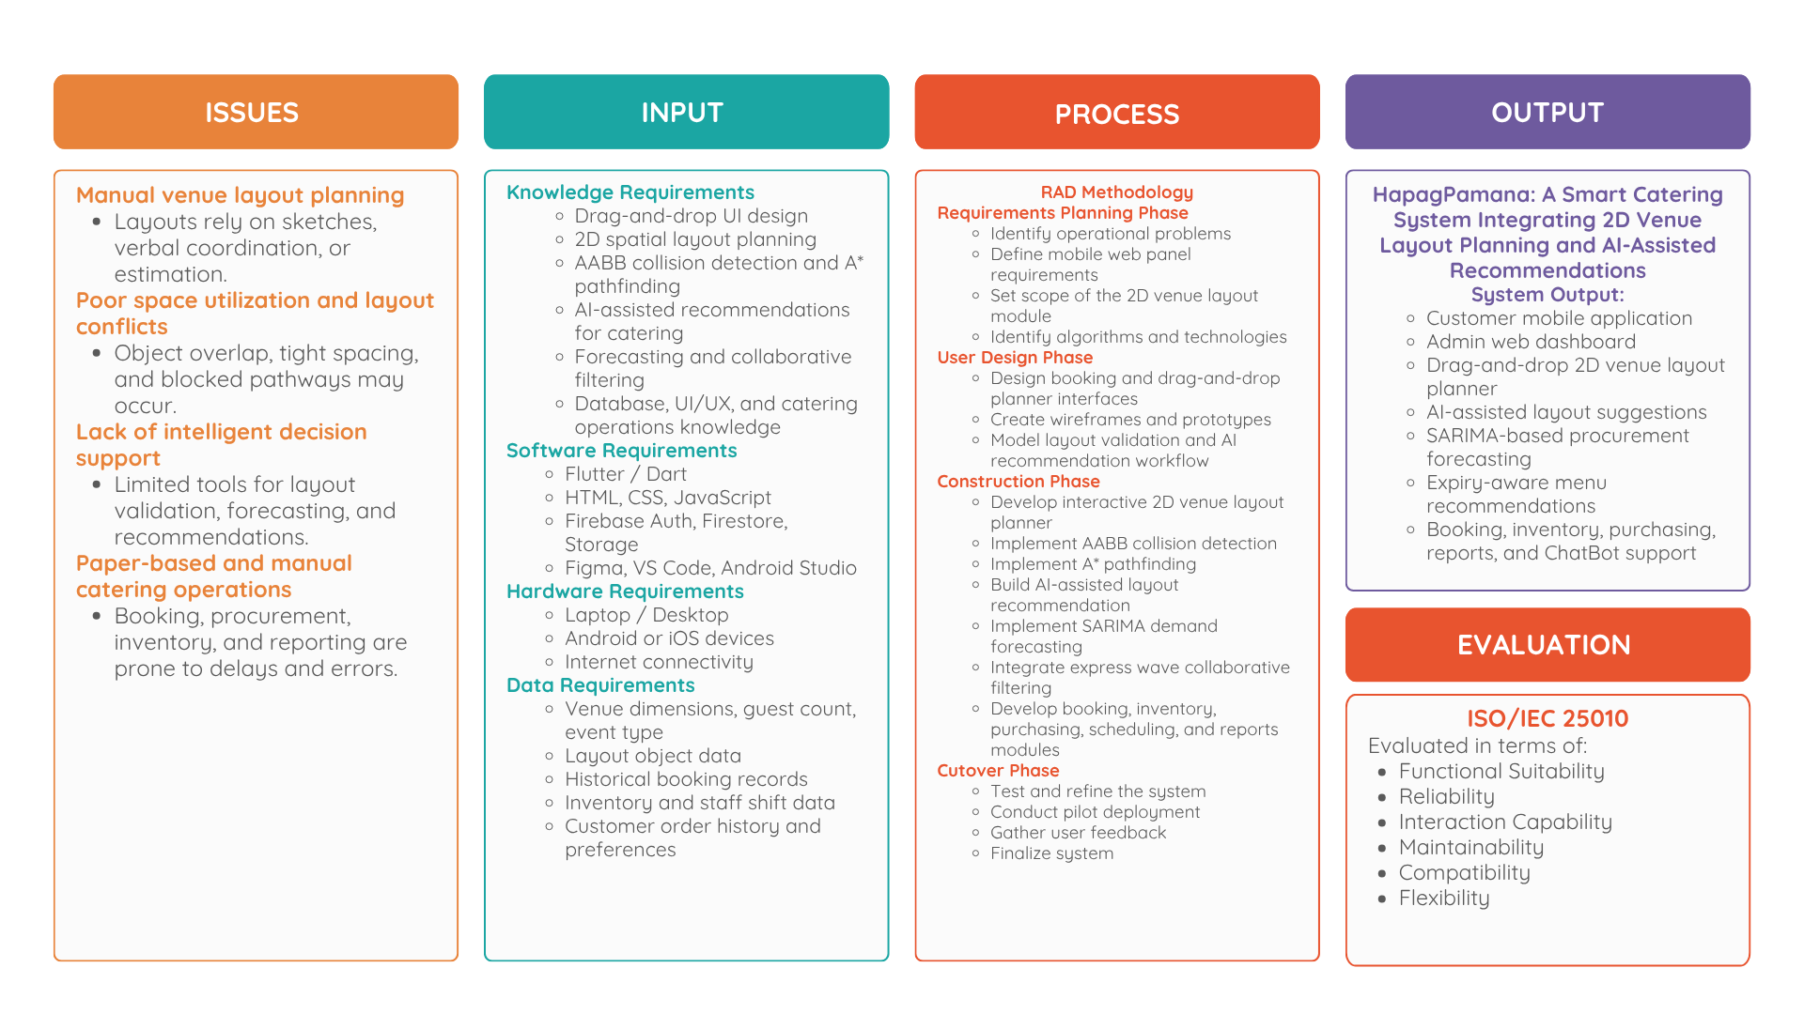
Figure 1
Conceptual Framework – Issues-Input-Process-Output (IIPO) Model of the HapagPamana System
Note. The IIPO model illustrates the flow from identified catering and layout planning issues through the data, knowledge, software, and hardware inputs required for system development; the RAD methodology phases and core algorithmic processes used in the development process; to the HapagPamana smart catering system as the primary output; with ISO/IEC 25010 evaluation as the final component.
The input requirements encompass four categories. First, data inputs include venue dimensions, guest count, event type, layout object positions and dimensions, historical catering booking records, recipe and menu data, inventory records, ingredient shelf-life data, and customer ordering behavior. These data serve as the foundation for the layout validation features, AI-assisted layout recommendations, SARIMA demand forecasting, and expiry-aware Collaborative Filtering. Second, knowledge requirements include drag-and-drop interface design, 3D spatial layout planning, collision detection, pathfinding algorithms, AI-assisted recommendation concepts, time-series forecasting, collaborative filtering, database management, UI/UX design, and catering business operations. Third, software requirements include Flutter/Dart for the customer mobile application, HTML, CSS, and JavaScript for the administrative web panel, Firebase Authentication, Cloud Firestore, Firebase Storage, Figma for interface prototyping, and development tools such as Visual Studio Code and Android Studio. Fourth, hardware requirements include developer laptops or desktop computers, Android or iOS mobile devices for testing, and internet connectivity for cloud-based synchronization and system deployment.
The process is structured through the RAD methodology phases: Requirements Planning, User Design, Construction, and Cutover. During the Requirements Planning Phase, the researchers identify the operational problems of HapagPamana Catering Services, define the requirements of the customer mobile application and administrative web panel, determine the scope of the 3D venue layout planning module, and identify the algorithms and technologies to be used. During the User Design Phase, the researchers design the booking interface, drag-and-drop layout planner, layout validation workflow, AI-assisted recommendation interface, and administrative dashboards through wireframes and prototypes. During the Construction Phase, the researchers develop the interactive 3D venue layout planner, implement Axis-Aligned Bounding Box (AABB) collision detection for overlap and spacing validation, implement A* pathfinding for checking walkable paths and guest flow, build the AI-assisted layout recommendation component, integrate SARIMA-based demand forecasting for procurement planning, integrate expiry-aware Collaborative Filtering for menu and catering recommendations, and develop the remaining modules for booking, inventory, purchasing, scheduling, and reports. During the Cutover Phase, the system undergoes testing, refinement, pilot deployment, user feedback collection, and final evaluation.
The output of the research is “HapagPamana: A Smart Catering System Integrating 3D Venue Layout Planning and AI-Assisted Catering Recommendations.” The system includes a customer mobile application that allows users to browse menus, place orders, book catering events, draft or manage event details, and interact with the 3D venue layout planner. Its main new feature is the interactive drag-and-drop venue layout planning tool, where customers and administrators can place tables, chairs, buffet stations, stages, and entrance or exit markers on a scaled venue grid. The system validates the layout through AABB collision detection and A* pathfinding, then provides AI-assisted suggestions for improving space utilization, accessibility, guest flow, and overall event arrangement. The system also includes SARIMA-based demand forecasting for procurement planning, expiry-aware Collaborative Filtering for menu recommendations, administrative dashboards for booking and event management, inventory and purchasing modules, reports and analytics, and Gabay AI catering assistance. The completed system is subsequently evaluated using the ISO/IEC 25010 quality model across six dimensions: Functional Suitability, Reliability, Interaction Capability, Maintainability, Compatibility, and Flexibility.

System Architecture
The HapagPamana cross-platform system employs a three-tier client-server architecture composed of the Presentation Tier, Logic Tier, and Data Tier. This architectural model separates the system into three functionally distinct layers: the user-facing interfaces, the application logic and algorithmic processing layer, and the persistent data storage layer. This separation supports modularity, maintainability, and scalability by allowing each tier to be updated, tested, and improved independently without disrupting the overall system operation. The three-tier model is appropriate for the HapagPamana system because it must support multiple types of users, including customers, administrators, and operational staff, while centralizing the processing of venue layout validation, AI-assisted recommendations, demand forecasting, inventory monitoring, and catering operations.
Figure 2 illustrates the three-tier system architecture of the HapagPamana platform. The diagram shows how users and system channels interact with the Presentation Tier through the customer mobile application, 3D layout planner interface, and administrative web panel. It also shows how the Logic Tier processes system requests through spatial validation, AI-assisted layout recommendation, SARIMA demand forecasting, expiry-aware Collaborative Filtering, Gabay services, operational modules, and centralized business rules. Finally, the Data Tier stores and secures all system data through Firebase Firestore, Firebase Authentication, Firebase Storage, and offline persistence or synchronization services.

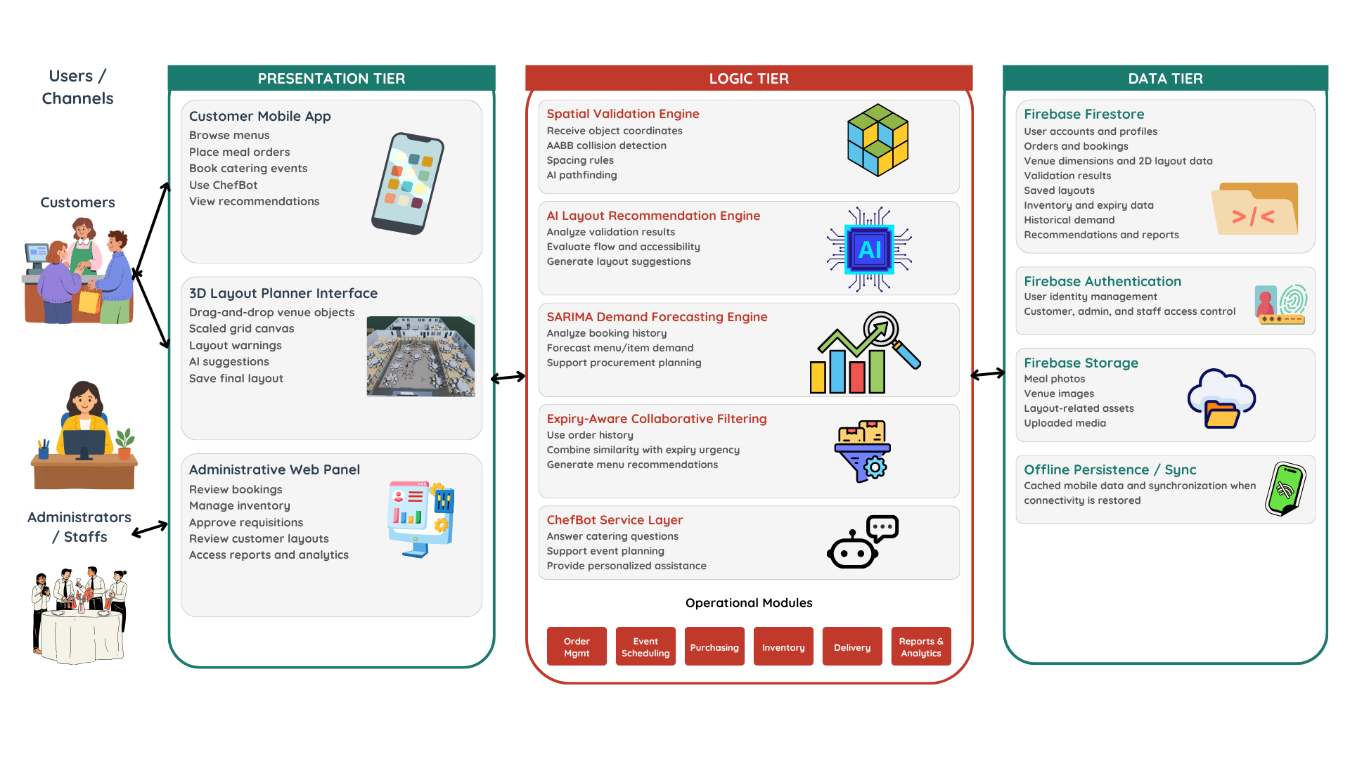
(https://canva.link/1xaac60opawh9xl)
Figure 2
Three-Tier System Architecture of the HapagPamana System
Presentation Tier. The Presentation Tier serves as the user-facing layer of the HapagPamana system. It includes the Flutter-based customer mobile application and the HTML, CSS, and JavaScript-based administrative web panel. Through the customer mobile application, users can browse menus, place meal orders, book catering events, access Gabay, view personalized recommendations, and use the 3D venue layout planner during the catering booking process. The 3D layout planner interface provides a scaled grid canvas where users can drag and drop venue objects such as tables, chairs, buffet stations, stage areas, and entrance or exit markers. This interface also displays layout warnings, AI-assisted suggestions, and the final saved arrangement. Through the administrative web panel, administrators and staff can review bookings and orders, manage inventory, approve requisitions, review customer-submitted layouts, and access reports and analytics. The Presentation Tier communicates with the Logic Tier by sending user actions, booking details, layout object coordinates, and system requests for validation and processing.
Logic Tier. The Logic Tier functions as the central processing layer of the HapagPamana system. It contains the application logic, business rules, validation services, algorithmic engines, and operational modules that process requests from the Presentation Tier and interact with the Data Tier. The primary novelty of this tier is the integration of the Spatial Validation Engine and the AI Layout Recommendation Engine. The Spatial Validation Engine receives object coordinates and dimensions from the 3D layout planner, applies Axis-Aligned Bounding Box (AABB) collision detection to identify object overlaps, checks spacing rules, converts the layout into a walkable grid, and applies the A* pathfinding algorithm to determine whether key movement paths, such as the path from the entrance to the buffet station, are clear and accessible. The AI Layout Recommendation Engine analyzes the results of the spatial validation process and generates practical suggestions for improving the layout based on flow, accessibility, capacity, visibility, safety, and object relationships.
The Logic Tier also includes the SARIMA Demand Forecasting Engine, which analyzes historical booking demand and forecasts future menu-item demand to support procurement planning. The Expiry-Aware Collaborative Filtering Engine uses customer order history, user preferences, and ingredient expiry urgency to generate menu and catering recommendations that support both personalization and inventory utilization. The Gabay Service Layer provides AI-assisted support by answering catering questions, assisting with event planning, and offering personalized recommendations. In addition, the Logic Tier contains the Operational Modules of the system, including Order Management, Event Scheduling, Purchasing, Inventory, Delivery, and Reports and Analytics. These modules are supported by API, business rules, and validation services that centralize system workflows and ensure consistent processing across customer, administrator, and staff functions.
Data Tier. The Data Tier manages all persistent system data, authentication records, media assets, and offline synchronization functions. Firebase Firestore serves as the primary cloud database and stores user accounts and profiles, menu items, customer orders, catering bookings, venue dimensions, 3D layout object data, collision and path validation results, saved final layouts, inventory records, ingredient expiry dates, historical demand records, recommendations, requisitions, and reports. Firebase Authentication manages user identity and access control for customers, administrators, and staff. Firebase Storage manages uploaded and non-structured media such as meal photos, venue images, layout-related assets, and other uploaded files. The Data Tier also supports offline persistence and synchronization, allowing cached mobile data to remain accessible when internet connectivity is unavailable and to synchronize automatically once connectivity is restored.
The overall system flow begins when a customer creates a catering booking and opens the 3D venue layout planner. The Presentation Tier sends the venue details, guest count, event type, and layout object positions to the Logic Tier. The Logic Tier validates the layout using AABB collision detection and A* pathfinding, stores the validation results in the Data Tier, and returns layout warnings or AI-assisted suggestions to the Presentation Tier. The customer or administrator may then revise the layout, accept the suggested arrangement, or save the final layout with the booking record. Once saved, the booking data also contributes to historical demand records, which support future SARIMA forecasting and recommendation processes. Through this architecture, HapagPamana supports both the physical planning of catering event layouts and the operational preparation of food, inventory, procurement, and service delivery.

Definition of Terms
The following terms are defined operationally as they are used in the context of this study and the HapagPamana cross-platform system:
A Pathfinding Algorithm.* A graph-search algorithm used in the HapagPamana 3D venue layout planner to compute the shortest walkable path between key points in the venue, such as the entrance, buffet area, stage, and exit, while avoiding blocked grid cells caused by tables, chairs, buffet stations, and other layout objects.
AI-Assisted Layout Recommendation. A system feature that analyzes a user-created venue layout and suggests improvements based on spacing, guest flow, accessibility, safety, visibility, capacity, and object relationships. It helps customers and administrators improve the arrangement of tables, chairs, buffet stations, stage areas, entrances, exits, and walkways.
Auto-Generated Purchase Requisition. A system feature within the HapagPamana demand forecasting and procurement module that automatically generates a draft purchase request when the SARIMA forecasting engine predicts that ingredient stock levels may fall below the required quantity for upcoming orders or catering events. This allows administrators to approve, modify, or process procurement requests more efficiently.
Axis-Aligned Bounding Box (AABB). A rectangular object boundary aligned with the x-axis and y-axis, used in the 3D venue layout planner to detect whether layout objects overlap or violate minimum spacing rules. In HapagPamana, AABB is applied to objects such as tables, chairs, buffet stations, stage areas, and other venue elements.
Catering Event Layout. The planned arrangement of tables, chairs, buffet stations, stage areas, entrance and exit points, and walkways inside an event venue. In HapagPamana, the catering event layout is created through a drag-and-drop 3D layout planner.
Catering Event Progress Tracker. A customer-facing feature within the HapagPamana mobile application that allows customers to monitor the preparation stages of their catering bookings, including booking confirmation, menu finalization, ingredient preparation, kitchen preparation, and delivery tracking.
Catering Event Readiness Score. An administrative monitoring feature within the HapagPamana system that displays the preparation completeness of upcoming catering events as a percentage. It includes supply availability checks, missing item tracking, and links to generate requisitions for missing supplies.
Catering Inventory Module. A dedicated software component within the HapagPamana system that tracks, monitors, and updates inventory items used for catering events, including event-specific food supplies, equipment, and materials. It generates color-coded low-stock alerts and usage records per catering event, separate from the Kitchen Inventory Module.
Gabay. An AI-powered catering assistant integrated within the HapagPamana customer mobile application. It answers catering and event planning questions, suggests catering packages based on budget and guest count, recommends healthier meal options, generates event checklists, and supports personalized meal and catering suggestions.
Collaborative Filtering. A recommendation method used in HapagPamana to suggest meals or catering packages by comparing a customer’s order history with the behavior and preferences of similar customers. It supports features such as personalized menu recommendations, “You Might Also Like,” and catering package suggestions.
Collision Detection. The process of checking whether two or more objects in the 3D venue layout overlap or are too close to one another. In HapagPamana, collision detection is used to identify layout conflicts among tables, chairs, buffet stations, stage areas, and other venue elements.
Dart. The programming language used with the Flutter framework to develop the HapagPamana mobile application. Dart is an object-oriented and strongly typed language developed by Google that supports cross-platform application development.
Demand Forecast Visual Dashboard. An administrative feature within the HapagPamana system that visually displays SARIMA-based demand forecasts, projected ingredient requirements, and peak ordering periods. It helps administrators prepare inventory and procurement plans before demand increases.
Digital Requisition and Approval Workflow. The electronic process within the HapagPamana system by which kitchen or catering staff submit purchasing requests, which are then routed to authorized administrators for digital approval before being forwarded to purchasing personnel for procurement action.
Drag-and-Drop Layout Planner. An interactive 3D interface that allows customers and administrators to place, move, and arrange catering objects on a scaled venue grid. It supports layout planning for tables, chairs, buffet stations, stage areas, entrances, exits, and walkways.
Expiry-Aware Recommendation. A recommendation feature that prioritizes menu items containing near-expiry ingredients so that at-risk stock can be used before spoilage. This feature combines customer preference patterns with inventory shelf-life information.
FEFO. First-Expired, First-Out; an inventory logic that prioritizes the use of items with the earliest expiration dates before items with later expiration dates. In HapagPamana, FEFO supports ingredient shelf-life management and expiry-aware recommendations.
Firebase. The cloud-based backend platform developed by Google and used as the primary backend service of the HapagPamana system. Firebase Firestore stores system data, Firebase Authentication manages user identity, Firebase Storage manages uploaded files, and Firestore offline persistence supports offline access and synchronization.
Flutter. The open-source cross-platform UI development framework developed by Google and used to build the HapagPamana customer mobile application. Flutter allows the system to run consistently on Android and iOS devices using a single codebase.
Grid Representation. A digital representation of the event venue divided into cells that can be marked as walkable or blocked. In HapagPamana, grid representation is used by the A* pathfinding algorithm to determine clear guest movement paths.
Ingredient Depletion Timeline. A monitoring feature within the HapagPamana demand forecasting module that predicts how long each ingredient stock may last based on projected demand. It uses color-coded indicators such as Green for Safe, Yellow for Low, and Red for Critical.
Ingredient Expiry-Aware Recommendation. A recommendation mechanism that incorporates the remaining shelf life of stocked ingredients into the recommendation process, allowing the system to prioritize menu items that use near-expiry ingredients.
ISO/IEC 25010. An international standard for software product quality used to evaluate information systems. In this study, the HapagPamana system is evaluated across six quality dimensions: Functional Suitability, Reliability, Interaction Capability, Maintainability, Compatibility, and Flexibility.
Kitchen Inventory Module. A dedicated software component within the HapagPamana system that tracks, monitors, and updates ingredients and supplies used in daily kitchen production operations, independently from the Catering Inventory Module.
Manhattan Distance. A grid-based distance heuristic calculated as the sum of the horizontal and vertical distance between two points. In HapagPamana, it is used by the A* pathfinding algorithm to estimate movement cost within the venue grid.
Offline-First Design. A mobile application development approach that allows core application features, such as menu browsing, order drafting, order history viewing, catering package browsing, and profile access, to remain available without an active internet connection. Data is synchronized automatically when connectivity is restored.
Rapid Application Development (RAD). An iterative and incremental software development methodology used in this study to build the HapagPamana system. It involves requirements planning, user design, construction, and cutover phases, with continuous stakeholder feedback and rapid prototyping.
Role-Based Access Control (RBAC). A security architecture applied in the HapagPamana system that restricts system access and functionality based on assigned user roles. The system defines access for customers, administrators, and staff.
SARIMA. Seasonal Autoregressive Integrated Moving Average; a time-series forecasting model used in HapagPamana to estimate future menu or ingredient demand based on historical seasonal patterns. It is denoted as SARIMA(p,d,q)(P,D,Q)s, where p, d, and q represent non-seasonal parameters, while P, D, Q, and s represent seasonal parameters.
Seasonal Demand Pattern Detection. A forecasting feature within the HapagPamana system that uses historical booking and order data analyzed through SARIMA to identify recurring seasonal or periodic demand patterns. It supports proactive inventory preparation and procurement planning.
Spatial Validation. The process of checking a proposed venue layout for object overlap, spacing violations, blocked pathways, and inefficient guest movement. In HapagPamana, spatial validation is performed using AABB collision detection and A* pathfinding.
Three-Tier Architecture. The system design pattern adopted for the HapagPamana platform, which separates the application into three interconnected layers: the Presentation Tier, Logic Tier, and Data Tier. This structure improves maintainability, scalability, and modularity.
Urgent Requisition Flagging. A feature within the HapagPamana purchasing module that assigns priority levels such as Normal, Urgent, and Critical to purchase requests. It helps ensure that procurement actions are handled according to inventory urgency.
Weekly Demand Forecast Report. An automatically generated report within the HapagPamana system that presents SARIMA-based predictions of ingredient consumption for the upcoming week, current stock levels, suggested reorder quantities, and estimated procurement costs to support purchasing decisions.

CHAPTER 3

RESEARCH METHODOLOGY

Project Design
HapagPamana is a smart catering system that integrates interactive 3D venue layout planning and AI-assisted catering recommendations to serve both the customer-facing and internal operational needs of HapagPamana Catering Services. The system is structured around two distinct interface environments: a Flutter-based mobile application for customers on Android and iOS, and a web-based administrative panel built with HTML, CSS, and JavaScript for the administrative, catering, kitchen, production, purchasing, warehouse, and delivery teams. Its primary contribution is an interactive 3D venue layout planner in which catering objects are placed on a scaled venue grid and validated in real time using Axis-Aligned Bounding Box (AABB) collision detection for object overlap and spacing, A* pathfinding for guest-flow and walkway checks, and an AI-assisted layout recommendation feature that generates and refines layout suggestions. Retained from the prior system design, the platform also integrates two decision-support algorithms that support procurement and personalization: a SARIMA-based demand forecasting engine that converts historical booking data into procurement recommendations, and an expiry-aware Collaborative Filtering recommendation engine that prioritizes near-expiry ingredients in personalized meal suggestions. These algorithmic components are complemented by supporting features including the Gabay AI catering assistant, offline mobile functionality, demand forecast dashboards, ingredient depletion timelines, auto-generated purchase requisitions, Catering Event Readiness Scores, and a Catering Event Progress Tracker, all operating within a three-tier client-server architecture. Development follows the Rapid Application Development (RAD) methodology, ensuring iterative refinement through continuous stakeholder feedback.

Mathematical Models
The HapagPamana system is anchored on a set of formally defined mathematical models. The primary models govern the interactive 3D venue layout planner and consist of the Axis-Aligned Bounding Box (AABB) collision-detection test and the A* shortest-path search. These are complemented by two retained decision-support models: the SARIMA time-series forecasting model and the user-based Collaborative Filtering model with an expiry urgency factor. This section presents the complete mathematical specification of each model, defines all notation, and explains how the equations translate into operational system behavior. Together, these models constitute the analytical core of the system and form the evidentiary basis for its expected contributions to layout quality, procurement alignment, and waste reduction.

Spatial Validation Models: AABB Collision Detection and A* Pathfinding
The interactive 3D venue layout planner represents every catering object as an axis-aligned rectangle defined by its position and dimensions, denoted (x, y, w, h), where x and y are the coordinates of the object on the venue grid and w and h are its width and height. Two objects A and B are detected as overlapping when their projections intersect on both axes at the same time. Formally, a collision exists when Ax < Bx + Bw and Ax + Aw > Bx on the horizontal axis and Ay < By + Bh and Ay + Ah > By on the vertical axis. To enforce a minimum clearance between objects, each rectangle is expanded by a spacing margin before the test is applied, so that objects placed closer than the required gap are reported as spacing violations even when they do not strictly overlap. Because the test compares only the edges of two rectangles, it executes in constant time per pair and is fast enough to run continuously while the administrator drags objects across the canvas.
To validate guest flow, the venue is discretized into a grid in which each cell is marked walkable or blocked depending on whether it is occupied by an object such as a table, chair, stage, or buffet. The A* search algorithm then computes the shortest walkable path between key points, such as the entrance and the buffet or service area, by expanding grid cells in order of their estimated total cost. For each cell n this cost is f(n) = g(n) + h(n), where g(n) is the accumulated movement cost from the start cell to n and h(n) is a heuristic estimate of the remaining cost from n to the goal. The planner uses the Manhattan distance as the heuristic, h(n) = |n.x - goal.x| + |n.y - goal.y|, which is appropriate for grid-based movement that proceeds horizontally and vertically. If A* fails to find a path, the arrangement is flagged as blocking guest movement; if a path is found, the walkway is reported as clear. This lets the planner detect layouts that contain no object overlaps yet still obstruct movement between important service points.
The outputs of these two models drive the real-time feedback shown in the Layout Builder, where the spacing indicator reflects the AABB result and the walk-path indicator reflects the A* result. The AI-assisted layout recommendation feature then uses the same spatial information, together with the celebration type and guest count, to generate and refine a candidate arrangement that the administrator can adjust before finalizing the floor plan that the customer reviews in the mobile application.

Batch-Level Expiry Tracking and FEFO Integration
To support spoilage-aware inventory handling, the system records the expiry date of every delivered ingredient at the point of delivery inspection and tracks it at the batch level. Capturing expiry information at intake ensures that the First-Expired, First-Out (FEFO) logic and the Collaborative Filtering recommendation engine receive accurate, up-to-date data on the spoilage proximity of active raw materials.

Data Architecture for Expiry Tracking
Expiry tracking is implemented within the NoSQL (Firestore) data tier, where each delivered ingredient is stored with the expiry date recorded by the stock clerk during delivery inspection. When a supplier or printed expiry date is unavailable, a standard shelf-life reference for the relevant perishable food category (e.g., raw meats, dairy, and produce) may be applied as a fallback, but the recorded date from inspection takes precedence so that the stored value reflects the actual condition of the received stock.
The data schema records this information by maintaining a dedicated ingredient_matrix collection. Each ingredient (i) may be associated with a standard shelf-life reference constant (S_{i}), measured in days, which serves only as a fallback estimate of typical shelf life when no recorded expiry date is available.

Expiry Capture at Delivery Inspection
In traditional kitchen management, bulk deliveries containing disparate items are often recorded with a single, inaccurate batch expiration date. The proposed system resolves this by disaggregating each delivery into individual item rows and capturing an expiry date for each one during inspection.
When a delivery is received, the system generates a unified Batch ID and disaggregates the invoice into individual item rows. During inspection, the stock clerk records the kilos or quantity, the number of items, and the expiry date for each item row, so that every unique raw-material instance carries its own independent expiration timestamp. Where a printed expiry date is unavailable, the system falls back to deriving the expiration timestamp from the item's standard shelf-life reference using the following linear equation:

Where:
- T₀ represents the absolute server timestamp of the delivery arrival (stock-in event).
- Sᵢ represents the standard shelf-life reference constant for ingredient i, used only as a fallback when no recorded expiry date is available.
- Tₑₓₖᵢᵣʸ represents the resulting expiration date for that specific raw-material instance, whether recorded at inspection or derived as a fallback.

State-Check Monitoring and FEFO Integration
Once the independent Tₑₓₖᵢᵣʸ timestamps are recorded, the system actively monitors the remaining lifespan of the active inventory through asynchronous state-checks. The time remaining before spoilage is continuously calculated as:

If ΔTᵣᵉᵐᵃᴵⁿᴵⁿᵍ falls below a configured critical threshold (e.g., < 2 days), the system automatically updates the status flag of the item to “Critical.” This dynamic status change serves as the primary trigger for the Expiry Urgency Factor (Eᵢ) utilized in the collaborative filtering recommendation engine, successfully closing the loop between backend inventory logistics and frontend customer demand stimulation.

Collaborative Filtering and Expiry-Aware Recommendation Integration
The proposed system utilizes a dual-objective recommendation architecture designed to solve a complex multi-criteria optimization problem: maximizing user satisfaction while simultaneously mitigating perishable inventory waste. This is achieved through the integration of User-Based Collaborative Filtering paired with a novel Expiry Urgency Factor.

Implicit Preference Scoring
Traditional recommendation engines rely on explicit user evaluations (e.g., 5-star rating systems), which often suffer from low user engagement in catering and food-service applications. To address this, the system derives preference vectors mathematically from implicit behavioral data. A user's preference intensity is determined strictly by their historical transaction frequency. The system constructs a sparse user-item interaction matrix where the weight of interaction is proportional to the number of times a specific user has successfully ordered a specific menu item or package.

User Similarity Computation
To generate predictive recommendations for an active user, the system identifies neighborhood clusters of users with mathematically similar historical purchasing behaviors. The proximity between any two user profiles is calculated utilizing the Cosine Similarity metric. This measures the cosine of the angle between two projected preference vectors in a multi-dimensional space, formalized as:
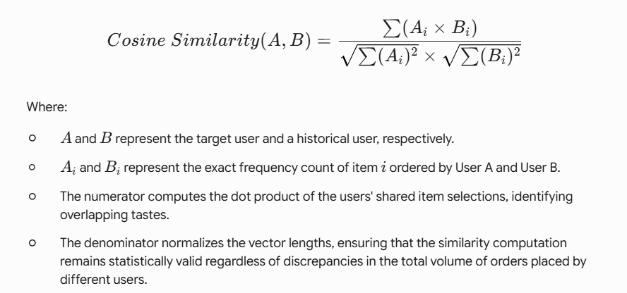

Expiry-Aware Integration and Dynamic Weighting
Standard collaborative filtering algorithms are entirely customer-centric. The proposed architecture introduces a business intelligence constraint by dynamically boosting the visibility of menu items containing ingredients nearing their critical shelf-life threshold.
Once the base collaborative filtering algorithm establishes a set of highly probable user preferences, the backend logic cross-references the underlying Bill of Materials (BOM) for those recommended dishes with the active inventory database. The system calculates a final adjusted ranking score (Sᵢⁿᵃˡ) to determine the item's rendering priority on the client interface using the following formula:
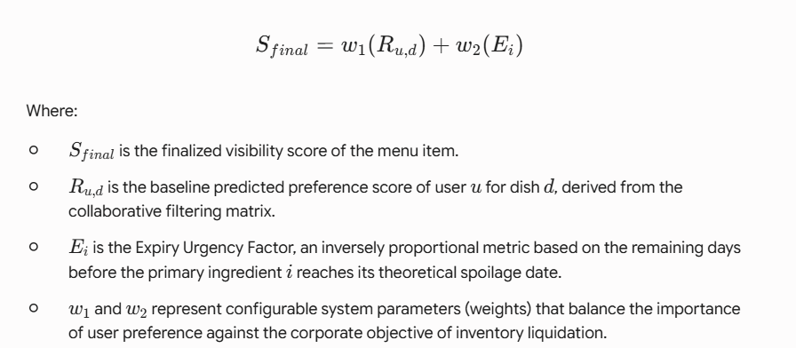
Through this algorithmic integration, the system effectively executes a digital First-Expired, First-Out (FEFO) strategy, proactively stimulating customer demand for at-risk perishable goods without compromising the personalization of the user experience.

Time-Series Demand Forecasting Using the SARIMA Model
To mitigate the financial losses associated with heuristic overpurchasing and raw material spoilage, the system implements a predictive procurement architecture driven by a Seasonal Autoregressive Integrated Moving Average (SARIMA) model. This algorithm analyzes historical catering booking data to autonomously forecast future ingredient requirements.

Model Selection and Justification
While traditional ARIMA models are proficient at predicting linear trends, catering and food service demand is inherently cyclical (e.g., higher volume on weekends, specific seasonal holidays). Therefore, the system utilizes the SARIMA extension to capture both non-seasonal and seasonal periodic fluctuations in the historical order data, ensuring a higher degree of predictive accuracy for inventory procurement.

Mathematical Formulation and Parameter Definition
The forecasting engine models the future demand of specific catering packages based on the configuration parameters formalized as SARIMA(p, d, q)(P, D, Q)ₛ. The system processes the historical time-series data through the following defined hyper-parameters:
Non-Seasonal Parameters (p, d, q):
- • p (Autoregressive order): The number of lag observations included in the model.
- • d (Degree of differencing): The number of times the raw observations are differenced to achieve time-series stationarity.
- • q (Moving average order): The size of the moving average window applied to past forecast errors.
Seasonal Parameters (P, D, Q)ₛ:
- • P, D, Q: The seasonal equivalents of the autoregressive, differencing, and moving average terms.
- • s (Seasonality): The periodicity of the time series. For the catering system's seasonal demand cycle, this parameter is initialized to s = 12 (representing a 12-month recurring seasonal demand cycle).

Algorithmic Workflow and BOM Explosion
The execution of the SARIMA model within the system's backend operates through a two-phase architecture:
- Demand Projection: The algorithm ingests historical transaction logs from the Firestore database to forecast the expected aggregate volume of specific menu items and catering packages for the upcoming operational week (T₊₁ to T₊₇).
- BOM Explosion and Aggregation: Forecasting finished dishes is insufficient for raw inventory management. Therefore, the system programmatically maps the forecasted dish volume against the centralized Bill of Materials (BOM) database. The system calculates the gross raw material requirement using the equation:
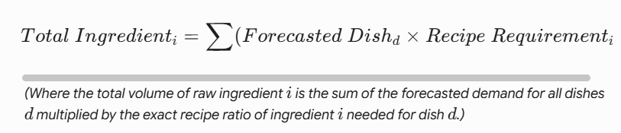
Through this automated BOM explosion, the system directly outputs a highly optimized, data-driven “Suggested Procurement List” for the catering administration. This mathematically prevents the overpurchasing of highly perishable raw materials, directly fulfilling the system's objective of mitigating baseline food waste.

Algorithm Trade-off Analysis
The selection of algorithms for the HapagPamana system was made after evaluating several candidate approaches against the operational constraints and data environment of a small-to-medium Philippine catering enterprise. The four algorithmic components of the system, namely the AABB collision-detection and A* pathfinding algorithms that drive the primary 3D venue layout planner, together with the retained SARIMA Demand Forecasting module and the User-Based Collaborative Filtering Recommendation engine, were each selected over viable alternatives based on a structured comparison of computational complexity, data requirements, interpretability, implementation feasibility, and alignment with the system's operational objectives. This section documents the trade-off analysis that informed each selection.
Trade-off Analysis 1: Collision Detection for Layout Validation, AABB vs. Alternative Methods. Two candidate collision-detection approaches were considered for validating object overlap and spacing in the 3D venue layout planner: Axis-Aligned Bounding Box (AABB) testing and Bounding Volume Hierarchy (BVH) structures. AABB testing represents each catering object as an axis-aligned rectangle and checks for overlap by comparing the edges of two rectangles, which runs in constant time per pair and is simple to implement. BVH organizes objects into a tree of nested bounding volumes to accelerate collision queries and is advantageous when a scene contains a very large number of objects or arbitrarily rotated and irregular shapes, because it prunes large portions of the search space. For the HapagPamana layout planner, however, the venue grid contains a bounded number of objects, such as tables, chairs, stage, and buffet furniture, that are well approximated as axis-aligned rectangles, and the dominant requirement is that collision and spacing checks run continuously and smoothly while the administrator drags objects across the canvas. Under these conditions, the overhead of constructing and maintaining a BVH tree is not justified, while AABB delivers the needed real-time responsiveness with minimal implementation complexity. AABB was therefore selected, with the understanding that its main limitation, the absence of arbitrary rotation, is acceptable because objects in the planner use predefined orientation states.

Trade-off Analysis 2: Pathfinding for Walkway Validation, A* vs. Dijkstra’s Algorithm. Two candidate graph-search approaches were considered for checking guest movement and walkable paths on the venue grid: the A* algorithm and Dijkstra’s algorithm. Both guarantee a shortest path on a weighted grid, but Dijkstra’s algorithm expands nodes uniformly outward from the start without any sense of direction toward the goal, exploring many cells that are not on the route. A* improves on this by adding a heuristic estimate of the remaining distance to the goal, expressed as f(n) = g(n) + h(n), which directs the search toward the target and typically expands far fewer cells. Because the layout planner must repeatedly check paths, for example from the entrance to the buffet or service area, while the layout is being edited, the directed and more efficient search of A* is better suited to real-time validation than the undirected expansion of Dijkstra’s algorithm. With an admissible Manhattan-distance heuristic appropriate for grid-based movement, A* returns the same optimal path as Dijkstra while doing less work, and it was therefore selected for walkway validation in the 3D venue layout planner.

Trade-off Analysis 3: Demand Forecasting, SARIMA vs. Alternative Methods. Three candidate forecasting approaches were considered for the HapagPamana inventory replenishment module: (1) the Seasonal Autoregressive Integrated Moving Average (SARIMA) model, (2) the Simple Moving Average (MA) method, and (3) Long Short-Term Memory (LSTM) neural networks. Each approach addresses the core problem of predicting future ingredient demand from historical order data, but differs substantially in data requirements, interpretability, seasonal modeling capacity, and implementation complexity.

Simple Moving Average (MA) computes demand forecasts as the arithmetic mean of a rolling window of recent observations. While MA is computationally transparent and requires minimal historical data, its fundamental limitation is its inability to model seasonality or autocorrelation in the demand signal. MA applies equal weight to all observations within the window and produces forecasts that are systematically miscalibrated for seasonal demand patterns—underestimating demand during peak event seasons and overestimating it during off-peak periods (Dellino et al., 2015, extended 2022; Tewari et al., 2022). Catering booking data is inherently seasonal, with demand peaks tied to the Philippine holiday calendar, academic year cycles, and recurring corporate event seasons. A forecasting model that ignores this structure—such as a simple moving average—generates procurement recommendations that consistently fail to align purchasing volume with actual seasonal demand, perpetuating the overpurchasing or understocking behaviors the system is designed to eliminate. Furthermore, Gardner (2022) established that while exponential smoothing and MA methods perform adequately for stable, non-seasonal demand, their error rates increase substantially in the presence of seasonal cycles—precisely the pattern exhibited by catering order data.

LSTM neural networks represent the state-of-the-art in sequence modeling and have demonstrated strong forecasting performance on large-scale food demand datasets (Phatangare et al., 2025; Morales et al., 2024). However, LSTM models require large volumes of training data (typically thousands of sequential observations), significant computational resources for training, hyperparameter tuning, and expertise in deep learning frameworks to implement and maintain correctly. The operational environment of HapagPamana—a small catering business with a bounded 16-item catalog and an early-stage digital order history at the point of system deployment—does not provide the data volume necessary for reliable LSTM training. Deploying a neural network within a Firebase serverless backend would introduce disproportionate computational overhead relative to the business value gained at this operational scale.

SARIMA was selected because it explicitly models the dual structure of catering demand: short-term autocorrelation captured by the ARIMA(p, d, q) component and recurring seasonal patterns captured by the seasonal (P, D, Q)s component at period s = 12 (monthly). This dual structure allows SARIMA to generate procurement forecasts that are calibrated to both recent demand trends and the longer-term seasonal regularities that drive catering order volumes in the Philippine context. Falatouri et al. (2022) directly demonstrated that SARIMA outperforms simpler methods for food service demand data with seasonal behavior, and Kwarteng and Andreevich (2024) confirmed SARIMA's superiority over non-seasonal ARIMA for datasets with periodic patterns. Nadhira et al. (2023) further validated SARIMA's application in inventory management contexts, showing notable reductions in forecast-driven stockout events compared to moving average baselines. SARIMA also satisfies the interpretability requirement: the Box-Jenkins parameter identification and diagnostic checking process produces a documented and auditable model specification that technical evaluators and system administrators can inspect, validate, and communicate to stakeholders—a practical advantage over the opaque latent representations of LSTM. The fitted SARIMA model can additionally be updated with new data each planning cycle using computationally efficient recursive estimation, making it sustainable within the Firebase Cloud Functions serverless execution environment without requiring GPU infrastructure.

Trade-off Analysis 4: Recommendation System, User-Based Collaborative Filtering vs. Alternative Approaches. Three candidate recommendation approaches were evaluated for the HapagPamana personalization module: (1) User-Based Collaborative Filtering (CF) with k-NN cosine similarity and Expiry Urgency Factor, (2) Content-Based Filtering (CBF), and (3) Matrix Factorization (MF) using Singular Value Decomposition (SVD). Each approach addresses the goal of surfacing personalized meal suggestions to authenticated customers but differs in data dependency, cold-start behavior, and computational requirements.

Content-Based Filtering generates recommendations by matching item attributes (e.g., cuisine type, ingredients, price range) to a user's inferred preferences. While CBF performs well for new users with no order history, it is limited to recommending items similar to what a user has already ordered, restricting menu exploration and failing to introduce customers to popular items outside their established preference profile (Bondevik et al., 2024). In the context of HapagPamana, where encouraging customers to explore new menu items is operationalized through the "Try Something New" recommendation feature, this limitation makes CBF insufficient as a standalone approach. Furthermore, CBF cannot natively incorporate inventory signals such as ingredient expiry dates—making the expiry-aware recommendation logic technically infeasible under a pure CBF architecture.

Matrix Factorization using SVD is a model-based collaborative filtering technique that decomposes the user-item rating matrix into latent factor representations, enabling more accurate recommendations at scale (Koren et al., 2022). However, SVD-based MF requires a sufficient number of users and interactions to produce stable latent factor representations, demands greater computational overhead than neighborhood-based methods, and operates as a black box, producing recommendations without a readily interpretable derivation path. The Algorithmic Components Visualization module (B.11), designed to make the recommendation logic fully traceable for administrative users and academic evaluators, is directly enabled by the step-by-step transparency of the user-based k-NN CF pipeline and cannot be replicated with SVD.

User-Based Collaborative Filtering with k-NN cosine similarity augmented by the Expiry Urgency Factor was selected because it simultaneously satisfies all three design requirements: (1) it operates directly on order history interactions without requiring item metadata; (2) it naturally supports cross-preference menu item discovery; and (3) it produces fully interpretable, step-by-step recommendation outputs traceable to specific user similarity scores, neighbor order histories, and the expiry urgency computation. Critically, the expiry-aware extension—the Sfinal = w1(R̂u,d) + w2(Ei) scoring function defined in the Mathematical Models section—introduces a multi-objective optimization capability that neither CBF nor SVD-based MF can replicate without fundamental architectural redesign. Christakou et al. (2022) confirmed that behavioral order features further improve CF recommendation accuracy over time as order history accumulates, supporting the system's long-term performance trajectory. A hybrid model incorporating both CF and content-based signals is identified in the Three-Year Product Roadmap as the planned upgrade path as the system scales beyond the initial HapagPamana deployment.

Technology Stack and Computing Standards
Component | Technology / Standard
Mobile Framework | Flutter 3.x (Dart) — single codebase for Android 10+ and iOS 14+ customer mobile app; web-based admin panel built with HTML, CSS, and JavaScript
Backend / API | Firebase Cloud Functions (serverless) with RESTful API design; HTTPS/TLS 1.3 for all client-server communication
Database | Firebase Firestore (cloud-hosted NoSQL document database) with Firestore offline persistence for offline-first mobile features
Authentication | Firebase Authentication with JWT-based session management; bcrypt password hashing; Role-Based Access Control (RBAC) enforced at API gateway layer
Push Notifications | Firebase Cloud Messaging (FCM) for cross-platform order status notifications, offline order sync confirmations, and admin announcements
Cloud Storage | Firebase Storage for menu item images, catering package photos, and uploaded procurement documents
UI/UX Design | Figma for wireframing and high-fidelity prototyping; Material Design 3 (MD3) guidelines for the Flutter mobile app
Algorithmic Modules | Interactive 3D Venue Layout Planner using Axis-Aligned Bounding Box (AABB) collision detection for object overlap and spacing validation, A* pathfinding for guest-flow and walkway validation, and an AI-assisted layout recommendation feature; SARIMA-based Demand Forecasting for inventory replenishment, demand dashboards, depletion timelines, weekly reports, seasonal pattern detection, auto-generated requisitions, and Catering Event Readiness Scores; User-Based Collaborative Filtering (k-NN cosine similarity) for “You Might Also Like,” “Try Something New,” and Catering Package Recommendations
Smart Features | Gabay AI Catering Assistant (AI-powered conversational assistant for event planning, budget recommendations, nutrition guidance, and downloadable event checklists); Offline-First Mobile Design (Firestore offline persistence for menu browsing, order drafting, order history, catering browsing, and profile management); Catering Event Progress Tracker
Version Control | Git with GitHub; feature-branch workflow with pull request reviews
Testing Tools | Flutter Test and Mockito for unit/widget testing; Firebase Emulator Suite for local backend testing; BrowserStack for cross-device compatibility
Security Standards | HTTPS/TLS 1.3; JWT authentication; OWASP security guidelines; Philippine Data Privacy Act (RA 10173) compliance; end-to-end payment data encryption (cards never stored in full)

Table 1. Technology Stack and Computing Standards of the HapagPamana System

Design Discussion
The goal of this project is to develop HapagPamana, a cross-platform catering management system integrating an interactive 3D venue layout planner with AABB collision detection and A* pathfinding, a SARIMA-based Demand Forecasting module, and a Collaborative Filtering Recommendation engine, alongside smart features including the Gabay AI catering assistant, offline mobile functionality, and a comprehensive administrative web panel covering order management, purchasing, and dual inventory modules. The system is designed to address the manual, paper-based operational challenges of HapagPamana Catering Services while delivering a personalized and accessible customer experience across Android and iOS platforms.
The HapagPamana system encompasses two primary interface environments: a Flutter-based cross-platform mobile application for customers and an HTML-CSS-JavaScript administrative web panel for the administrative and operational teams. The mobile application integrates the customer-facing 3D venue Layout Preview, Collaborative Filtering-powered personalized meal recommendations, an AI-powered Gabay catering assistant, offline-first functionality, and a Catering Event Progress Tracker. The administrative web panel provides a real-time KPI Dashboard, module feature controls, purchasing and inventory management, the Layout Builder that powers the interactive 3D venue layout planner with AABB collision detection and A* pathfinding, and a SARIMA-based Demand Forecasting module with visual dashboards, ingredient depletion timelines, and auto-generated purchase requisitions.
During the conceptualization of the system design, several interface and dashboard layouts were evaluated for the administrative web panel with the objective of identifying the most performant and usable interface for real-time catering management and inventory monitoring. To determine the optimal interface design, the researchers developed three candidate design concepts.
For Design 1, the researchers developed a minimal dashboard layout focusing on essential operational metrics and real-time order status, prioritizing a lightweight interface to improve system responsiveness and reduce visual clutter during peak operational hours. Amber and off-white were selected as the primary colors, consistent with the HapagPamana brand identity, to maintain visual coherence with the customer-facing mobile application.
For Design 2, the researchers created a comprehensive operations dashboard designed to simulate a professional catering management environment. This design incorporates organized KPI panels, demand forecast visualizations, inventory monitoring summaries, purchasing workflow overviews, and multi-module navigation to support administrators in managing multiple operational functions simultaneously. Teal, dark green, and neutral gray were integrated into the color scheme to maintain a professional and operationally appropriate appearance suitable for administrative and purchasing staff.
For Design 3, the researchers designed a more interactive and feature-rich interface focused on accessibility for business owners with limited technical backgrounds. The design incorporates simplified graphical visualizations, color-coded inventory alerts, an integrated notification center, and a role-based quick-access panel to improve usability and readability for non-technical users. Warm tones combined with modern interface elements were incorporated to create an approachable operational environment for the HapagPamana business owner and kitchen staff.

Summary of Constraints
Table 2 presents the comparison of the three HapagPamana administrative web panel interface designs developed by the researchers. Design 1 consists of a minimal real-time dashboard interface for fast operational monitoring. Design 2 consists of a comprehensive operations dashboard for multi-module management and professional administrative use. Design 3 consists of an accessible, owner-oriented dashboard with simplified visualizations and color-coded alerts.
The dashboard response time, memory usage, and application file size were the primary constraints considered in evaluating the three interface designs.
Table 2
Design Trade-off 1
Designs | Dashboard Response Time | Memory Usage | File Size
Design 1: Minimal real-time operational dashboard with core KPI metrics | 1.38 seconds | 298 MB | 17.2 MB
Design 2: Comprehensive operations dashboard with multi-module navigation and demand forecast visualizations | 2.91 seconds | 541 MB | 32.6 MB
Design 3: Owner-oriented accessible dashboard with simplified visualizations and color-coded alerts | 2.04 seconds | 413 MB | 25.1 MB

Design Trade-Offs
Design trade-offs were applied to determine the best interface for the HapagPamana administrative web panel. Performance and efficiency were measured for each of the identified design constraints. The design that best satisfies a criterion is assigned the governing rank of ten (10). The subordinate rank is computed as the percentage difference between the governing value and the compared value, applied against the governing rank.
Equation 1. Percentage Difference Formula
% difference for MIN = (Higher Value − Lower Value) / Higher Value

Equation 2. Subordinate Rank Formula
Subordinate Rank = Governing Rank − [(%difference) × 10]

Each criterion was assigned an importance score on a scale from 0 to 10, with 0 being the least important and 10 being the most important. The raw performance metrics presented in Table 2 were used as the basis for calculating the comparative ranks and scores ultimately summarized in Table 6.
Trade-Off 1: Dashboard Response Time. Table 3 shows the comparison of the three HapagPamana administrative dashboard designs in terms of dashboard response time, defined as the amount of time required for the system dashboard to fully load and display real-time operational data including order metrics, inventory status, and demand forecast information.
Design 1 was assigned the governing rank of 10 because it achieved the fastest dashboard response time of 1.38 seconds and was therefore considered the best-performing design for this criterion.
Table 3
Design Trade-off 2
Design | Dashboard Response Time
Design 1: Minimal real-time operational dashboard | 1.38 seconds
Design 2: Comprehensive operations dashboard | 2.91 seconds
Design 3: Owner-oriented accessible dashboard | 2.04 seconds
Computation of Ranking for Trade-Off 1 between Design 1 and Design 2:
% difference for MIN = (2.91 − 1.38) / 2.91 = 0.53
Subordinate Rank = 10 − [(0.53) × 10] = 4.7
Computation of Ranking for Trade-Off 1 between Design 1 and Design 3:
% difference for MIN = (2.04 − 1.38) / 2.04 = 0.32
Subordinate Rank = 10 − [(0.32) × 10] = 6.8
Trade-Off 2: Memory Usage. Table 4 shows the comparison of the three designs according to memory consumption, defined as the amount of RAM utilized during system execution while processing real-time operational data and dashboard visualizations including demand forecast charts and inventory monitoring panels.
Design 1 was assigned the governing rank of 10 because it consumed the least amount of memory at 298 MB and was therefore considered the best-performing design for this criterion.
Table 4
Design Trade-off 3
Design | Memory Usage
Design 1: Minimal real-time operational dashboard | 298 MB
Design 2: Comprehensive operations dashboard | 541 MB
Design 3: Owner-oriented accessible dashboard | 413 MB
Computation of Ranking for Trade-Off 2 between Design 1 and Design 2:
% difference for MIN = (541 − 298) / 541 = 0.45
Subordinate Rank = 10 − [(0.45) × 10] = 5.5
Computation of Ranking for Trade-Off 2 between Design 1 and Design 3:
% difference for MIN = (413 − 298) / 413 = 0.28
Subordinate Rank = 10 − [(0.28) × 10] = 7.2
Trade-Off 3: File Size. Table 5 shows the comparison of the three designs according to application file size, defined as the total storage memory consumed by the administrative web panel application package.
Design 1 was assigned the governing rank of 10 because it achieved the smallest file size of 17.2 MB and was therefore considered the best-performing design for this criterion.
Table 5
Design Trade-off 4
Design | File Size
Design 1: Minimal real-time operational dashboard | 17.2 MB
Design 2: Comprehensive operations dashboard | 32.6 MB
Design 3: Owner-oriented accessible dashboard | 25.1 MB
Computation of Ranking for Trade-Off 3 between Design 1 and Design 2:
% difference for MIN = (32.6 − 17.2) / 32.6 = 0.47
Subordinate Rank = 10 − [(0.47) × 10] = 5.3
Computation of Ranking for Trade-Off 3 between Design 1 and Design 3:
% difference for MIN = (25.1 − 17.2) / 25.1 = 0.31
Subordinate Rank = 10 − [(0.31) × 10] = 6.9

Criterion Performance
After comparing the three HapagPamana administrative dashboard designs according to the selected constraints, the criteria were analyzed by importance to determine the most suitable interface design for the HapagPamana system.
Table 6
Criterion Performance Summary
Decision Criteria | Criterion Importance | Design 1 | Design 2 | Design 3
Dashboard Response Time | 9 | 10 | 4.7 | 6.8
Memory Usage | 10 | 10 | 5.5 | 7.2
File Size | 8 | 10 | 5.3 | 6.9
Overall Rank |  | 270 | 139.7 | 188.4

Influence of Design Trade-Offs in Final Design
The effectiveness and efficiency of the HapagPamana administrative web panel interface designs were evaluated using design trade-offs. Dashboard response time, memory usage, and application file size were used as the primary metrics for comparing the three generated dashboard designs.
Based on the evaluation results, Design 1 was selected as the primary interface design for the HapagPamana administrative web panel because it demonstrated the best balance between performance, efficiency, and usability. Although Design 2 provided comprehensive multi-module navigation and advanced operational visualizations and Design 3 offered greater accessibility for non-technical business owners, Design 1 achieved the highest overall ranking of 270 due to its optimized response time, lower memory consumption, and smaller application file size.
To further improve the functionality and usability of the HapagPamana administrative system, the researchers integrated selected interface elements from Designs 2 and 3 into the final implementation of Design 1. Specifically, the real-time KPI Dashboard, Order Status Breakdown chart, and demand forecast visual panels from Design 2 were incorporated alongside the color-coded inventory alerts, feature toggle controls, and role-based quick-action shortcuts characteristic of Design 3, resulting in the finalized administrative web panel described in the System Modules and Screen-Level Features section of this chapter.
A post-integration validation was conducted to ensure that the inclusion of these specific modules did not degrade Design 1’s baseline performance thresholds.

Project Development
The HapagPamana system is developed following the Rapid Application Development (RAD) methodology, as established in the theoretical framework of Chapter 2. RAD is suited to this capstone project because it accommodates the time-bound development timeline while ensuring continuous engagement with HapagPamana’s business owner and production manager at each iterative phase (Martin, 1991; Damanik & Suendri, 2022). The RAD process is structured into four sequential phases:

Phase 1: Requirements Planning (Weeks 1–3)
In this phase, the proponents conduct structured interviews and system observation sessions with HapagPamana’s business owner and production manager to identify operational pain points, document current workflows, and elicit system requirements. Key activities include:
- Conducting semi-structured interviews with the business owner (Quinto, S. M. M.) and production manager (Libag, A. M.) to gather current-state workflow documentation for order management, inventory tracking, purchasing, and catering scheduling.
- Performing document analysis of existing paper-based tools including catering journals, booking logs, petty cash voucher templates, and spreadsheet-based inventory records.
- Developing a Requirements Specification Document aligned with IEEE 830 standards, defining all functional requirements (FR) and non-functional requirements (NFR) for each system module, including smart features (Gabay, offline functionality, demand forecasting sub-features, and Collaborative Filtering sub-features).
- Establishing system boundaries and producing UML use case diagrams representing the system’s user roles, namely the Customer and the role-based administrative team (Administrator, Supervisor, Event Prep Clerk, Event Logistics, Head Chef, Kitchen Staff, Production Manager, Production Staff, Purchasing Staff, Stock Clerk, and Logistics), and all system modules.
- Defining the full technology stack—Flutter/Dart, Firebase Firestore, Firebase Authentication, Firebase Cloud Messaging, Firebase Storage, and Firestore offline persistence—and configuring the GitHub repository with a feature-branch workflow.

Phase 2: User Design (Weeks 4–8)
The User Design phase translates requirements into validated design artifacts through active stakeholder collaboration:
- Wireframing and High-Fidelity Prototyping: All customer mobile screens—including Gabay chat interface, offline status indicators and Offline Hub screen, Order History screen, Personalization and AI feature surfaces (“You Might Also Like” recommendation row, “Try Something New” featured card, Catering Package detail with “Recommended for You” indicators), demand forecast dashboards, the 3D venue Layout Preview screen, Catering Event Progress Tracker, and Catering Event Readiness Score—and all admin web panel views including the KPI Dashboard, Feature Toggles panel, Purchasing Module, Kitchen and Catering Inventory Modules, Demand Forecasting Module, the Layout Builder, and Algorithmic Components Visualization (B.11) are designed in Figma following Material Design 3 guidelines, iteratively refined through feedback sessions with the business owner and a pilot group of five target users.
- Firestore Data Model Design: Firebase Firestore collection schemas are designed covering Users, Orders, OrderHistory, Menus, CateringEvents, Deliveries, InventoryItems (kitchen and catering sub-collections), Requisitions, PurchaseOrders, Announcements, ForecastData, GabayConversations, and AlgorithmicLogs (storing CF similarity matrices, k-NN outputs, and SARIMA computation records for the B.11 visualization).
- API Contract Design: RESTful endpoint contracts are documented using OpenAPI Specification (OAS) 3.0 for all module interactions between the Flutter front end and Firebase Cloud Functions, including endpoints for SARIMA computation, CF recommendation retrieval, and Gabay conversation handling.
- Algorithmic Design: The AABB collision-detection test and A* pathfinding model for the 3D venue layout planner, the SARIMA model for the Demand Forecasting module, the user-based k-NN cosine similarity computation for the Collaborative Filtering module, and the Gabay conversation logic are mathematically specified and validated against sample data.
- UML Sequence and Activity Diagrams: Produced for all critical workflows—meal order placement, catering booking with Progress Tracker, requisition approval chain, SARIMA replenishment trigger, personalized recommendation generation, Gabay interaction flow, and offline synchronization flow.

Phase 3: Construction (Weeks 9–18)
System construction proceeds iteratively across four sprints, each delivering testable module increments:

Sprint 1 (Weeks 9–11): Authentication, Role Management, Guest and Customer Interface
- Implement Firebase Authentication with JWT session management and RBAC.
- Build Splash Screen, Guest Landing Page, Customer Login Screen, and Admin Login Screen in Flutter.
- Develop Guest Home, Guest Menu (with category filters), and Guest Catering package browsing screens.
- Deploy initial Firestore collections for Users and Menus with seed data.
- Implement Firestore offline persistence configuration for offline menu and catering package browsing.

Sprint 2 (Weeks 12–14): Authenticated Customer Module, Collaborative Filtering, Gabay, and Offline Features
- Implement authenticated Customer Home Screen, Customer Menu Browse Screen (with Collaborative Filtering integration), Customer Orders Screen with Catering Event Progress Tracker, Order History Screen, the 3D venue Layout Preview screen for reviewing and accepting finalized floor plans, and Profile/Settings module.
- Build Personal Info, Delivery Addresses, Payment Methods, Order History, Gabay AI assistant interface, and Terms & Privacy screens.
- Implement the Collaborative Filtering engine: compute cosine similarity scores between customer order history vectors and surface “You Might Also Like,” “Try Something New,” and Catering Package Recommendations.
- Implement Gabay AI catering assistant: event planning Q&A, budget-based package suggestions, nutrition guidance, and downloadable event checklist generation.
- Implement offline functionality: Offline Hub screen with four-tile navigation (Browse Menu & Catering Packages, Draft an Order, Order History, Profile Access), offline menu browsing with “Available Offline” indicators and item-level Offline badges, offline order drafting and queue with automatic synchronization and “Book a Catering Event (OFFLINE)” banner, offline order history access, offline catering package browsing, and offline profile management with pending synchronization indicators. Persistent “You’re Offline” banner and status bar implemented across all offline-capable screens.
- Implement Catering Event Progress Tracker for customer-facing booking status monitoring.
- Implement FCM push notifications for order status updates and offline order synchronization confirmations.

Sprint 3 (Weeks 15–16): Administrative Web Panel
- Build the HTML/CSS/JS admin web panel with all primary tabs: Dashboard (real-time KPI metrics, Orders This Week chart, Order Status Breakdown donut, Recent Orders live feed, Active Sessions panel, and Quick Actions), User Management (CRUD operations and status controls), Feature Toggles (individual on/off controls for all system modules), Analytics (Reports & Analytics), the role-based catering, kitchen, production, purchasing, warehouse, and delivery workflow pages, and the Layout Builder, the administrative 3D venue layout planner that places catering objects on a scaled grid and validates them in real time using AABB collision detection and A* pathfinding, with an AI-assisted layout recommendation feature.
- Implement Notifications & Announcements module with audience segmentation and scheduling.
- Build System Settings & Role Management with admin account creation and role assignment.

Sprint 4 (Weeks 17–18): Purchasing, Inventory Modules, and SARIMA Demand Forecasting
- Implement the digital requisition submission and multi-level approval workflow with Urgent Requisition Flagging (Normal, Urgent, Critical priority levels) and automatic escalation.
- Build the Kitchen Inventory Module (ingredient stock-in/stock-out, color-coded low-stock threshold alerts, automated requisition triggers).
- Build the Catering Inventory Module (per-event supply assignment, availability checks for upcoming catering events).
- Integrate the SARIMA-based Demand Forecasting module: apply SARIMA to historical order data, generate Demand Forecast Visual Dashboards (7–14 day horizon), Ingredient Depletion Timelines with color-coded indicators, Weekly Demand Forecast Reports with suggested reorder quantities and estimated costs, Seasonal Demand Pattern Detection with advisory notifications, Auto-Generated Purchase Requisitions triggered by projected shortfalls, and Catering Event Readiness Scores with missing item tracking and direct requisition links.
- Build the Algorithmic Components Visualization interface (B.11): render the User Order History Matrix, User Similarity Matrix (cosine similarity), k-NN Visualization plot, SARIMA Inventory Forecasting table (with forecast horizon selection, reorder-point computation, and Suggested Order output), Collaborative Filtering step-by-step trace panel, and Top Recommendations display with predicted scores for each target user.
Conduct end-to-end integration testing across all modules using the Firebase Emulator Suite.

Phase 4: Cutover (Weeks 19–20)
- Deploy the HTML/CSS/JS admin web panel and Firebase backend to production (Firebase Hosting + Cloud Functions).
- Distribute the Flutter mobile application as an Android APK to test users and via Apple TestFlight for iOS evaluators.
- Conduct User Acceptance Testing (UAT) sessions with all evaluator groups.
- Address critical UAT findings and release the final system build.
- Prepare system documentation: User Manual, Administrator Guide, and API Reference.

Testing and Operating Procedure
The HapagPamana system undergoes a multi-layered testing strategy aligned with the ISO/IEC 25010 quality characteristics used in the evaluation framework.

Unit Testing
Unit tests are written for all critical Dart business logic classes in the Flutter application using the flutter_test package and Mockito for dependency injection. Firebase Cloud Function logic is tested using the Firebase Emulator Suite. A minimum unit test coverage threshold of 80% is enforced across all core service classes, including the Collaborative Filtering cosine similarity computation, the SARIMA demand forecasting calculation, and the AABB collision detection and A* pathfinding logic underlying the 3D Layout Planner.

Integration and API Testing
All Firestore read/write operations, Firestore offline persistence sync behavior, and Cloud Function endpoints are tested using the Firebase Emulator Suite and Postman collections, verifying correct data flow, authentication enforcement, RBAC boundaries, offline cache consistency, and error handling for both valid and invalid inputs. API contract conformance is validated against the OAS 3.0 documentation produced in the User Design phase.

Cross-Platform Compatibility Testing
The Flutter mobile application is tested on a minimum of four physical devices and emulators: Android 10, Android 12, Android 14, and iOS 16. BrowserStack is used for extended device coverage across screen sizes. Offline functionality is verified by testing all four offline feature categories (menu browsing, order drafting, order history, catering browsing, profile management) under simulated network outage conditions on both Android and iOS devices. The HTML/CSS/JS admin web panel is tested across Chrome (latest), Firefox (latest), and Safari (latest) on desktop and tablet viewports.

Performance Testing
API response time targets are established: order placement, menu retrieval, and status query endpoints must respond within 2 seconds under normal load; report generation and inventory analytics within 5 seconds. Load testing using Apache JMeter simulates concurrent user scenarios (25, 50, and 100 concurrent sessions) to verify system stability during peak catering event booking periods. FCM notification delivery latency is monitored to ensure push notifications for order status updates and offline sync confirmations are received within 30 seconds of server-side trigger.

Security Testing
- JWT token expiration (1-hour access token, 7-day refresh token) and refresh mechanism testing.
- RBAC enforcement: verifying that customer-role tokens cannot access administrative Firestore collections or Cloud Function endpoints reserved for administrators.
- Input validation and injection prevention testing using OWASP ZAP automated scanning on all public-facing API endpoints.
- HTTPS enforcement: all plain HTTP requests are redirected to HTTPS; TLS 1.3 is enforced on all Firebase Hosting and Cloud Functions endpoints.
- Payment data security validation: verifying that full card numbers are never persisted in Firestore and that the Payment Methods screen’s security notice accurately reflects encryption implementation.

Project Evaluation
The HapagPamana system is evaluated by three distinct evaluator groups to ensure comprehensive assessment of both functional performance and real-world usability:

Technical Expert Evaluation
A panel of at least three (3) computing or information technology professionals—including faculty members with expertise in software engineering, mobile application development, or information systems—evaluates the system against technical criteria: system architecture quality, Firestore data model integrity, RBAC implementation correctness, Collaborative Filtering recommendation accuracy, SARIMA forecasting validity, AABB and A* layout-validation correctness, Gabay conversational accuracy and relevance, offline synchronization correctness, security implementation, and Flutter cross-platform code quality. Expert evaluators are provided access to the running system, system documentation, and the API reference.

End-User Evaluation
A purposive sample of fifteen (15) to twenty (20) target end users participates in structured UAT sessions composed of:
- HapagPamana’s business owner and designated administrator (2 participants)—representing the administrative user role, evaluating the Admin Panel modules (KPI Dashboard, User Management, Feature Toggles, Analytics, Notifications & Announcements, Settings & Roles, Purchasing Module, Kitchen and Catering Inventory Modules, Demand Forecast Dashboards, Catering Event Readiness Scores, the Layout Builder, and Algorithmic Components Visualization).
- HapagPamana’s purchasing and kitchen staff (2–3 participants)—evaluating the Purchasing and Inventory modules, including Urgent Requisition Flagging and Auto-Generated Purchase Requisitions.
- Actual and potential customers: students, working professionals, and household members residing in Quezon City with prior digital food ordering experience (10–15 participants)—evaluating the Customer Mobile Application including Guest browsing, authentication, ordering, catering booking, Order History, Profile settings, Gabay, personalized recommendations (“You Might Also Like,” “Try Something New,” Catering Package Recommendations), Catering Event Progress Tracker, and Offline Functionality (Offline Hub, offline menu browsing, offline order drafting, offline order history, offline profile access).

Each participant completes predefined task scenarios (e.g., browse the guest menu offline using the Offline Hub, register an account, place a meal order, view order history, book a catering package, use Gabay to plan an event, view personalized recommendations via “You Might Also Like” and “Try Something New,” track a catering booking through the Catering Event Progress Tracker, build and finalize a venue layout in the Layout Builder, review and accept a finalized floor plan on the 3D Layout Preview screen, submit a purchase requisition, flag an urgent procurement need, update inventory stock, review a demand forecast dashboard, review the Algorithmic Components Visualization, generate a report) followed by the ISO/IEC 25010 evaluation questionnaire.

Partner Organization Validation
HapagPamana’s business owner provides final operational validation, confirming that the system accurately reflects the partner organization’s workflows as documented during the Requirements Planning phase, and that it satisfactorily addresses the four core identified problems: (1) manual venue layout planning, addressed by the interactive 3D venue layout planner with AABB collision detection and A* pathfinding; (2) poor space utilization and layout conflicts, addressed by real-time spacing and walkway validation together with the AI-assisted layout recommendation feature; (3) the lack of intelligent decision support, addressed by the SARIMA Demand Forecasting module and the expiry-aware Collaborative Filtering recommendation engine; and (4) paper-based and manual catering operations, addressed by the digitized booking, scheduling, purchasing, inventory, and reporting modules.

Evaluation data are consolidated and analyzed using descriptive statistics (weighted mean and standard deviation per quality dimension and per evaluator group). A Likert mean score of 4.0 or above across all dimensions is the target acceptance threshold.

Work Plan (Work Breakdown Structure)
Table 7 presents the Work Breakdown Structure (WBS) of the HapagPamana capstone project across a 20-week development timeline, organized by RAD phase.

Table 7
Work Breakdown Structure – HapagPamana Cross-Platform Catering Management System

# | Task / Deliverable | Responsible | Week(s) | Output
 | Phase 1: Requirements Planning |  | 1–3
1. | Stakeholder interviews and workflow documentation (incl. smart features requirements) | All members | 1–2 | Interview transcript
2. | Requirements Specification Document (IEEE 830) | Espino, Penola | 2–3 | RSD
3. | UML use case and context diagrams | Egil, Libag | 3 | UML diagrams
4. | Technology stack finalization and GitHub setup | Espino | 3 | Dev environment
 | Phase 2: User Design |  | 4–8
1. | Figma wireframes and high-fidelity prototypes (all screens incl. Gabay, offline indicators, demand dashboards, CF recommendation surfaces, 3D Layout Preview and Layout Builder, and Catering Event Progress Tracker) | Espino, Libag | 4–5 | Prototype
2. | Firestore data model and collection schema design (incl. ForecastData, GabayConversations) | Egil, Penola | 5–6 | Data model
3. | OAS 3.0 API contract documentation (incl. SARIMA, CF, Gabay, offline sync endpoints) | Espino | 6–7 | API spec
4. | AABB, A*, SARIMA, and CF algorithm specification; Gabay conversation logic design | Egil, Penola | 6–7 | Algorithm spec
5. | Prototype validation sessions with stakeholders | All members | 7–8 | Feedback report
 | Phase 3: Construction |  | 9–18
1. | Sprint 1: Auth, RBAC, guest/customer interface, offline persistence configuration | Espino, Egil | 9–11 | Sprint 1 build
2. | Sprint 2: Customer module, Order History Screen, CF recommendation integration (“You Might Also Like,” “Try Something New,” Catering Package Recommendations), 3D Layout Preview screen, Gabay, Offline Hub and offline features, Catering Event Progress Tracker | All members | 12–14 | Sprint 2 build
3. | Sprint 3: Admin web panel (KPI Dashboard, User Management, Feature Toggles, Analytics, Notifications & Announcements, Settings & Role Management, role-based team workflow pages, and Layout Builder with AABB collision detection and A* pathfinding) | Libag, Penola | 15–16 | Sprint 3 build
4. | Sprint 4: Purchasing (with Urgent Requisition Flagging), inventory modules, SARIMA demand forecasting (dashboards, depletion timelines, weekly reports, seasonal detection, auto-requisitions, Catering Event Readiness Scores), Algorithmic Components Visualization (B.11) | All members | 17–18 | Sprint 4 build
 | Phase 4: Cutover |  | 19–20
1. | Firebase Hosting/Cloud Functions deployment; APK distribution | Espino, Egil | 19 | Live system
2. | UAT sessions with all evaluator groups (incl. Gabay, offline, and smart features evaluation) | All members | 19–20 | UAT data
3. | Issue resolution and final system build | All members | 20 | Final release
4. | System documentation (User Manual, Admin Guide, API Reference) | All members | 20 | Documentation

Potential for Commercialization
The HapagPamana system is designed with commercial deployment viability as an integral consideration. While the initial implementation serves HapagPamana Catering Services as a dedicated partner, the system's modular Flutter/Firebase architecture, multi-role design, and scalable cloud backend position it for broader commercial adoption within the Philippine food service market.

Market Model
TAM, SAM, and SOM Market Segmentation for the HapagPamana Commercial Platform

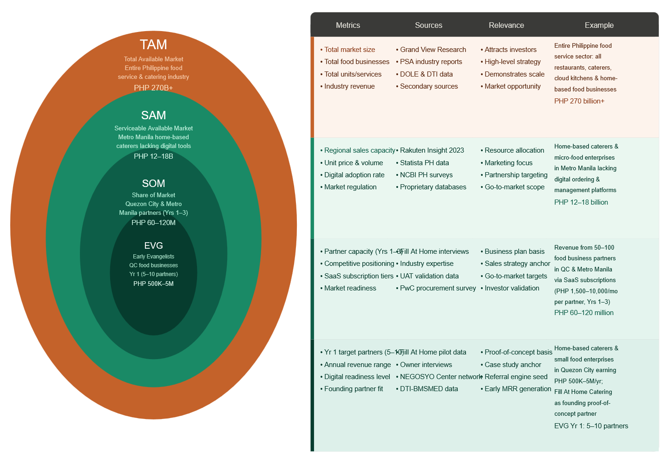
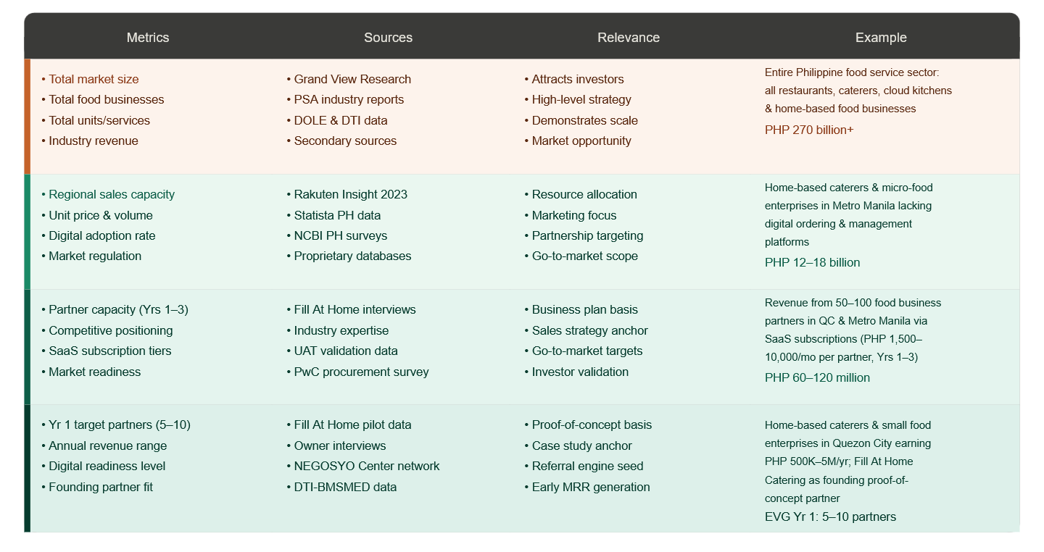
Note. TAM = Total Available Market (entire Philippine food service sector); SAM = Serviceable Available Market (Metro Manila home-based caterers and micro food enterprises lacking digital platforms); SOM = Share of Market (realistic initial capture based on the HapagPamana SaaS subscription model and direct partnership go-to-market strategy); EVG = Early Evangelists Group (founding-year target partners serving as the proof-of-concept anchor for commercial deployment).
As illustrated in Figure 1, the HapagPamana commercial platform addresses a large and underserved market segment within the Philippine food service industry. The Total Available Market (TAM) encompasses the entire Philippine food service and catering industry valued at over PHP 270 billion, covering all restaurants, caterers, cloud kitchens, institutional food services, and home-based food businesses nationwide. The Serviceable Available Market (SAM) is estimated at PHP 12–18 billion, representing small and medium-scale home-based caterers, community kitchens, and micro-food enterprises in Metro Manila and adjacent urban centers that currently lack dedicated digital ordering and catering management platforms. The Share of Market (SOM) targeted within the first three years of commercial operations is estimated at PHP 60–120 million, corresponding to 50–100 food business partners in Quezon City and Metro Manila subscribing under the SaaS licensing model. The Early Evangelists Group (EVG) for Year 1 are 5–10 home-based caterers and small food enterprises in Quezon City generating PHP 500,000–5 million in annual revenue, with HapagPamana Catering Services serving as the founding proof-of-concept partner.

Measurable Benefits
The HapagPamana system offers the following distinct, measurable benefits:
- Visual, Validated Event Planning: The interactive 3D venue layout planner lets customers and administrators arrange tables, chairs, stage, buffet, and walkways on a scaled venue grid and receive immediate, automated feedback through AABB collision detection, A* walkway validation, and AI-assisted layout recommendations, replacing hand-drawn sketches and day-of rearrangement with a transparent pre-event plan; this capability is not available in existing consumer food platforms or in the partner’s current manual process.
- Integrated End-to-End Operations: Unlike consumer-facing platforms (FoodPanda, GrabFood) that handle delivery only, HapagPamana integrates an interactive 3D venue layout planner, customer ordering, catering booking, Gabay AI assistance, digital purchasing workflows, and dual inventory tracking, including intelligent replenishment via SARIMA-based demand forecasting, in a single unified platform.
- Personalized Customer Experience: The Collaborative Filtering recommendation engine surfaces personalized meal suggestions on the Menu screen for each authenticated customer, replacing the static catalog experience and increasing likelihood of repeat orders and menu exploration.
- Cost Reduction Through Inventory Accuracy: Real-time digital inventory tracking with automated low-stock alerts and SARIMA demand forecasting is projected to reduce perishable overstocking waste by an estimated 15–25% and minimize stockout-driven order cancellations.
- Process Efficiency: The digital requisition-to-approval workflow replaces paper-based petty cash voucher routing, reducing procurement approval cycle times from multiple days to same-day processing.
- Granular Operational Control: The Feature Toggles panel in the Admin Panel allows administrators to enable or disable individual system modules in real time via a single toggle switch, without requiring code deployments. Controllable features include: Carousel Display, Order Management, Catering Packages, Requisitions Module, Pantry Stock Tracking, Reports & Analytics, Push Notifications, Maintenance Mode, Receipt Upload, and Marketing Campaigns.
- Compliance and Data Trust: The Terms and Privacy modal, payment data encryption notice, and RA 10173 compliance framework build customer trust in the platform, which is critical for adoption by privacy-conscious Filipino consumers.

Three-Year Product Roadmap
Table 8. Three-Year Product Roadmap for HapagPamana

Dimension | Year 1 (2026) | Year 2 (2027) | Year 3 (2028)
Performance | Single-partner deployment; up to 200 concurrent users; < 2-second API response for core transactions via Firebase. | Multi-partner SaaS; up to 1,000 concurrent users; Firestore index and caching layer optimization. | High-availability architecture; 5,000+ concurrent users; 99.5% uptime SLA guaranteed.
Pricing | Free pilot deployment for HapagPamana as founding partner. | SaaS subscription: PHP 1,500–3,500/month per food business, tiered by order volume. | Enterprise plan for multi-branch businesses: PHP 6,000–10,000/month; transaction revenue sharing at 0.5–1% per completed order.
Key Features | Guest browsing, authenticated ordering, catering booking, interactive 3D venue layout planner with AABB collision detection and A* pathfinding (Layout Builder and 3D Layout Preview), Order History, Gabay, CF recommendations (“You Might Also Like,” “Try Something New,” Catering Package Recommendations), Offline Hub and offline features, admin panel (KPI Dashboard, User Management, Feature Toggles, Analytics, Notifications, Settings & Roles), purchasing, dual inventory, demand forecasting, Algorithmic Components Visualization. | Multi-tenant architecture; custom branding per food business; third-party logistics API integration (Lalamove, J&T); loyalty and rewards module; SMS notifications. | Upgraded CF model with hybrid filtering; deep-learning demand forecasting (LSTM); enhanced AI-assisted layout generation; white-label licensing for ICT resellers; API marketplace for third-party integrations.

Go-to-Market Strategy
Distribution Channels:
- Direct Partnership: Primary Year 1 channel through direct outreach to home-based caterers and small food enterprises in Quezon City via personal referrals, NEGOSYO Center Quezon City partnerships, and DTI-BMSMED partner networks.
- Digital Marketing: Targeted social media advertising (Facebook and Instagram) directed at food business owners in Metro Manila, showcasing operational efficiency gains and ROI case studies from the HapagPamana pilot deployment.
- App Stores: Customer-facing Flutter mobile application published on Google Play Store (Android) and Apple App Store (iOS) for organic discovery by end users of partner food businesses.
- ICT Reseller Partnerships (Year 2+): Engagement with local ICT solution providers and IT consultancies serving the food service sector as value-added resellers of the HapagPamana SaaS platform.

Marketing Programs:
- Free 30-Day Trial with full onboarding support (system configuration, staff training, data migration) to reduce adoption barriers for early evangelist partners.
- Case Study Program: HapagPamana Catering Services' documented operational improvements serve as the anchor case study for sales materials and conference presentations (TIP Research Symposium, Philippine Food Industry Summit).
- Referral Incentive Program: Existing partners who refer new clients receive a one-month subscription credit, creating community-driven growth.
- Content Marketing: Blog and YouTube channel featuring platform tutorials, food business digitization guides, and Gabay AI feature highlights to build organic search visibility among food business owners.

Business Model

Value Chain Positioning
The HapagPamana platform operates as a technology enabler within the food service value chain, positioned across three layers:
- Upstream (Customer Interface): Digitizes customer acquisition and order fulfillment by replacing manual telephone and social media order intake with a structured guest browsing and authenticated mobile ordering system.
- Midstream (Production and Operations): Connects order volumes directly to real-time inventory depletion data via the dual inventory modules, with the Time-Series Demand Forecasting engine enabling proactive procurement decisions before stock reaches critical levels.
- Downstream (Supply and Procurement): Replaces paper-based purchasing workflows with digital requisition-to-approval chains and electronic purchase order generation, integrating Gabay AI assistance for catering planning at the customer-facing layer.

In the broader ICT value chain, the HapagPamana system operates as a SaaS platform provider, delivering application-layer services to food business clients while leveraging Firebase (Google) as cloud infrastructure and GCash/Maya as payment integration partners.

Revenue Generation Model
- SaaS Subscription Fees (Primary): Monthly licensing fees per food business partner, tiered by transaction volume and active users (PHP 1,500–10,000/month depending on tier).
- Transaction-Based Revenue Sharing (Year 3+): 0.5–1.0% of GMV per completed digital order processed through the platform.
- White-Label Licensing (Year 3+): One-time and annual fees for ICT resellers deploying a branded version of the HapagPamana platform.
- Premium Add-Ons: Optional paid modules such as advanced analytics, upgraded hybrid CF + ARIMA demand forecasting, and multi-branch management capabilities.

Cost Model
- Development Costs: Labor costs for Flutter/Firebase development, QA, and documentation during the capstone phase (estimated PHP 80,000–120,000 development-equivalent value).
- Firebase Infrastructure Costs: Monthly Firestore, Cloud Functions, Firebase Hosting, FCM, and Firebase Storage fees (estimated PHP 2,500–5,000/month at initial scale on the Firebase Blaze pay-as-you-go plan).
- Payment Gateway Integration Fees: GCash/Maya transaction fees (typically 1.5–2.5% per transaction, borne by the food business partner or passed through at cost).
- Marketing and Customer Acquisition Costs: Digital advertising spend (PHP 5,000–15,000/month in Year 1), content production, and event sponsorship.
- Support and Maintenance: Ongoing labor for bug fixes, Firebase security rule updates, Cloud Function updates, and customer support (estimated 20–40 developer hours per month post-launch).

Success Metrics

Metric | Year 1 Target | Year 3 Target
Food business partners onboarded | 3–5 | 50–100
Monthly Recurring Revenue (MRR) | PHP 15,000–25,000 | PHP 300,000–600,000
Active monthly customer app users | 200–500 | 10,000+
UAT quality score (ISO/IEC 25010) | ≥ 4.0 / 5.0 | ≥ 4.2 / 5.0
System uptime (Firebase SLA) | ≥ 99.0% | ≥ 99.5%
Partner monthly churn rate | < 20% | < 10%
CF recommendation click-through rate | Baseline establishment | ≥ 15% on recommended items

Risk Factors and Mitigation

Risk | Description | Mitigation
Low digital adoption by small food businesses | Food business owners may lack technical confidence or consistent internet access. | Provide free onboarding, simplified admin UI (Core Modules toggles), and offline-capable data input. Partner with DTI-NEGOSYO Centers for digital literacy outreach.
Competition from large aggregators | GrabFood for Business or similar may expand into catering management features. | Differentiate through catering-specific features (event scheduling, dual inventory, Gabay AI, CF recommendations), localized pricing, and deep customization for Philippine micro-enterprises.
Data security breach | Unauthorized access to customer payment data, Firestore records, or admin accounts. | Enforce HTTPS/TLS 1.3, Firebase Authentication with JWT, RBAC Firestore rules, OWASP ZAP scanning. Comply with RA 10173 and NPC guidelines. Never store full card numbers.
Firebase scalability under peak load | Sudden order spikes during peak catering seasons (Christmas, New Year) may increase Firestore read/write costs and latency. | Design Firestore indexes for high-frequency query paths; enable Firebase App Check; monitor usage via Firebase Console and set budget alerts.
Regulatory compliance | RA 10173 (Data Privacy), RA 8792 (E-Commerce Act), and BSP digital payment guidelines impose compliance requirements. | Conduct Privacy Impact Assessment (PIA); register as data controller with the NPC; maintain data processing agreements with food business partners; implement Terms and Privacy modal for user consent.

Revenue Level for Breakeven
Based on projected monthly operating costs of PHP 25,000–35,000 (Firebase infrastructure, payment gateway fees, and minimal marketing spend), the HapagPamana platform is projected to achieve monthly breakeven at approximately 10–15 food business partners subscribing at the base tier (PHP 2,500/month per partner). At an assumed 10% monthly growth rate in partner acquisition from Year 1 to Year 2, the platform is projected to reach positive monthly cash flow by Month 12–18 of commercial operations. Full recovery of development-equivalent costs is projected within 24–30 months of commercial launch, contingent on meeting Year 2 SOM targets.

These projections are grounded in the system's finalized Flutter/Firebase architecture which eliminates traditional server hosting costs through Firebase's serverless model — and are subject to validation through the system's User Acceptance Testing outcomes, which will provide measurable evidence of operational value sufficient to support the commercial case for deployment beyond the founding HapagPamana Catering Services partner.

CHAPTER 4

RESULTS AND DISCUSSION

References
Abuda, J. T., et al. (2025). Assessing the financial challenges of food businesses in Gumaca, Quezon. Scimatic Journal of Management and Social Sciences. https://scimatic.org/storage/journals/11/pdfs/5017.pdf
Angeles-Agdeppa, I., Toledo, M. B., & Zamora, J. A. T. (2023). Does plate waste matter? A two-stage cluster survey to assess household plate waste in the Philippines. BMC Public Health, 23(1). https://www.ncbi.nlm.nih.gov/pmc/articles/PMC9811705/
Barrion, A. S., et al. (2023). Food loss and waste in the Philippines: A literature review. Food Research, 7(6), 278–289. https://www.researchgate.net/publication/376952222

Bondevik, J. N., Bennin, K. E., Babur, Ö., & Ersch, C. (2024). A systematic review on food ecommender systems. Expert Systems with Applications, 238(E), Article 122166. https://doi.org/10.1016/j.eswa.2023.122166
Boronat-Navarro, M., et al. (2r021). A green model for the catering industry under demand uncertainty. Journal of Cleaner Production, 166. https://www.sciencedirect.com/science/article/abs/pii/S0959652617318176
Christakou, C., Vrettos, S., & Stafylopatis, A. (2022). Improving collaborative filtering with behavioral order features for food recommendation. Expert Systems with Applications, 195, 116518. https://doi.org/10.1016/j.eswa.2022.116518
Cordero, D. A., Jr. (2024). Addressing malnutrition and food insecurity in the Philippines. SAGE Open. https://doi.org/10.1177/03795721241244675
CPD Online College. (2026). Food storage techniques: Best practice for 2025. CPD Online Knowledge Base. https://cpdonline.co.uk/knowledge-base/food-hygiene/food-storage/
Cvent. (n.d.). Cvent event diagramming. https://www.cvent.com/en/event-marketing-management/cvent-event-design-software
Damanik, S. F., & Suendri, S. (2022). RAD-based information system development. International Journal of Research and Review, 9(5), 441–448.
Davis, F. D. (1989). Perceived usefulness, perceived ease of use, and user acceptance of information technology. MIS Quarterly, 13(3), 319–340. https://doi.org/10.2307/249008
Dellino, G., et al. (2015, extended applications 2022). A hybrid seasonal ARIMA and quantile regression for daily food sales forecasting. International Journal of Production Economics. https://www.sciencedirect.com/science/article/abs/pii/S092552731500378
Devarapalli, C. A. (2024). Application development using Flutter and React Native: Cross-platform development. ResearchGate. https://www.researchgate.net/publication/380558561
Digamon, S. M. D. (2023). Analysis on the food waste management practices and strategies of fruit and vegetable vendors in Titay, Zamboanga Sibugay. UPLB Undergraduate Theses. https://www.ukdr.uplb.edu.ph/etd-undergrad/11827
Dwivedi, Y. K., et al. (2024). Enhancing resilience and reducing waste in food supply chains: A systematic review leveraging emerging technologies. International Journal of Logistics Research and Applications. https://www.tandfonline.com/doi/full/10.1080/13675567.2024.2406555
E-Control Systems. (2025). Proper restaurant food storage guidelines: Requirements for commercial kitchens. E-Control Systems Blog. https://econtrolsystems.com/blog/proper-food-storage-restaurants
Estepa, L. S., Adem, M. D. M., Villanueva, E. R., Rufon, J. F., & Galang, E. M. (2025). Technology acceptability of the inventory management application on selected catering services. Puissant (Step Academic Press), 6.
Eventdex. (2025, November 14). Streamline seating arrangements using Eventdex event seating software. https://www.eventdex.com/features/event-seating-software/
Falatouri, T., et al. (2022). Predictive analytics for demand forecasting: A comparison of SARIMA and LSTM in retail supply chain management. Procedia Computer Science, 200, 993–1003. https://www.sciencedirect.com/science/article/pii/S1877050922003076
FilipiKnow. (2022, March 25). How to start a catering business in the Philippines: A beginner's guide. https://filipiknow.net/catering-business-in-the-philippines/
FoodDocs. (2025). Restaurant food storage guidelines to know. FoodDocs Knowledge Base. https://www.fooddocs.com/post/restaurant-food-storage-guidelines

Frontiers in Artificial Intelligence. (2024). Exploring the potential of AI-driven food waste management strategies in hospitality for household application. Frontiers in AI, 7. https://pmc.ncbi.nlm.nih.gov/articles/PMC11799730/
Gardner, E. S., Jr. (2022). Exponential smoothing and the moving average in demand forecasting: A review. International Journal of Forecasting, 38(4), 1–15. https://doi.org/10.1016/j.ijforecast.2022.01.004
Gitnux. (2026, February 11). Top 10 best event seating software of 2026. https://gitnux.org/best/event-seating-software?
Google. (2024). Cloud Firestore offline data access. Firebase Documentation. https://firebase.google.com/docs/firestore/manage-data/enable-offline
Grand View Research. (2024). Catering service procurement & cost intelligence report, 2030. https://www.grandviewresearch.com/pipeline/catering-services-market-procurement-intelligence-report
Guimaraes, N. S., et al. (2024). Plate food waste in food services: A systematic review and meta-analysis. Nutrients, 16(10), 1429. https://www.ncbi.nlm.nih.gov/pmc/articles/PMC11123872/
Gupta, M., Dheekonda, V., & Masum, M. (2024). Genie: Enhancing information management in the restaurant industry through AI-powered chatbot. International Journal of Information Management Data Insights, 4(2), 100255. https://doi.org/10.1016/j.jjimei.2024.100255
Hartantyo, S. H. P., et al. (2023). Food safety controls during bulk food preparation—an observational analysis. Foods, 12(12), 2376. https://www.ncbi.nlm.nih.gov/pmc/articles/PMC10297087/
Hyndman, R. J., & Athanasopoulos, G. (2021). Forecasting: Principles and practice (3rd ed.). OTexts. https://otexts.com/fpp3/
IBM. (2023). What is three-tier architecture? IBM Think. https://www.ibm.com/think/topics/three-tier-architecture
Jordan, J., Villalon, G., & Callada, J. (2021). Food waste management in hotels: A pilot study in the Philippines. WWF-Philippines. https://archive.wwf.org.ph/wp-content/uploads/2021/10/Food-Waste-Case-Study.pdf
Karne, P. (2022). Management system for a restaurant [Capstone project, Governors State University]. OPUS Open Portal to University Scholarship. https://opus.govst.edu/capstones/569
Karttunen, E., Lintukangas, K., & Hallikas, J. (2023). Digital transformation of the purchasing and supply management process. International Journal of Physical Distribution & Logistics Management, 53(5–6), 685–706. https://doi.org/10.1108/IJPDLM-06-2022-0199
Khachab, D. (2024). Using new technologies to address food waste in the restaurant industry. Restaurant Technology News. https://restauranttechnologynews.com/2024/03/
Koren, Y., Rendle, S., & Bell, R. (2022). Advances in collaborative filtering. In F. Ricci et al. (Eds.), Recommender systems handbook (3rd ed., pp. 91–142). Springer. https://doi.org/10.1007/978-1-0716-2197-4_3
Kwarteng, S. B., & Andreevich, P. A. (2024). Comparative analysis of ARIMA, SARIMA and Prophet model in forecasting. Research & Development, 5(4), 110–120. https://sciencepublishinggroup.com/article/10.11648/j.rd.20240504.13
Lazatin, L., et al. (2021). Financial challenges of MSMEs: Raw material volatility and limited financial literacy. Cited in Scimatic Journal, 2025. https://scimatic.org/storage/journals/11/pdfs/5017.pdf
Liang, T., et al. (2025). Revolutionizing the hospitality industry: The impact of AI technologies on efficient food management and food waste reduction. Journal of Tourism Futures. https://www.emerald.com/jtf/article/doi/10.1108/JTF-02-2025-0033/
Martin, J. (1991). Rapid application development. Macmillan Publishing.
Martinez-Lopez, F. J., et al. (2024). Identifying factors affecting food waste reduction strategies in independent restaurants. Science of the Total Environment. https://www.sciencedirect.com/science/article/pii/S0959652624002129
Mata, M. D., Ancheta, R., Jr., Batucan, G., & Gonzales, G. (2024). Exploring technology acceptance model with system characteristics to investigate sustainable building information modeling adoption in the architecture, engineering, and construction industry: The case of the Philippines. Social Sciences & Humanities Open. https://doi.org/10.1016/j.ssaho.2024.100967
Morales, R., et al. (2024). Machine learning models for short-term demand forecasting in food catering services: A solution to reduce food waste. Journal of Cleaner Production, 434. https://www.sciencedirect.com/science/article/pii/S0959652623044232
Muppaneni, K. (2024). Progressive web apps: Offline UX benchmarking. International Journal of Emerging Trends in Computer Science and Information Technology, 5(2), 174–183. https://doi.org/10.63282/3050-9246.IJETCSIT-V5I2P119
Nadhira, V. A., et al. (2023). Optimization of demand forecasting and inventory management using SARIMAX. ResearchGate. https://www.researchgate.net/publication/373523277
Ngo, T. T. H., et al. (2025). Assessing inventory strategies on business performance among food manufacturing enterprises. International Journal of Research and Innovation in Social Science, 9(4), 695–723. https://rsisinternational.org/journals/ijriss/articles/assessing-inventory-strategies
Parilla, E. S., et al. (2023). Impact of inventory management on financial performance of MSMEs in Santiago City. American Journal of Economics and Business Innovation, 2(3), 11–24. https://www.researchgate.net/publication/373385793
People Places Plates. (2026, February 19). Cooking goes digital: Home-based food businesses in PH. https://peopleplacesplates.ph/cooking-home-based-food-businesses-ph/
Planning Pod. (2025, January 31). Tripleseat vs Caterease vs Planning Pod: Venue management software competitors, alternatives, pricing. https://planningpod.com/blog/tripleseat-vs-caterease-vs-planning-pod-venue-management-software-competitors-pricing
Phatangare, S., Sharma, L., Mate, A., Jaiswal, O., & Pardeshi, D. (2025). Revolutionizing food ordering: An ML-driven system for predictive sales and inventory optimization. 2025 International Conference on Computing Technologies (ICOCT).
Prismm. (n.d.). Floor planning software for vendors, venues, and planners. https://www.prismm.com/solutions/event-design-software/floor-planning-software-venues-planners-vendors
PwC. (2024). Global digital procurement survey – 5th edition. PricewaterhouseCoopers. https://www.pwc.com/gx/en/services/consulting/digital-operations/digital-procurement-survey.html
Quinto, S. M. M., & Libag, A. M. (2025). Interview transcript: HapagPamana catering services—proposed system discussion [Personal communication]. HapagPamana Catering Services, Quezon City, Philippines.
Rajaratnam, D. (2023). An investigation of airline catering supply chain processes. University of Hertfordshire Engineering Doctorate Thesis. https://uhra.herts.ac.uk/id/eprint/15916/
Rosauro, G., et al. (2025). Operational cost control in food and beverage establishments in Southern Oriental Mindoro, Philippines. International Journal of Research and Innovation in Social Science. https://rsisinternational.org/journals/ijriss/articles/operational-cost-control
SafetyCulture. (2026). Food storage best practices for businesses. SafetyCulture Knowledge Base. https://safetyculture.com/topics/food-storage
Sam, Y. H., Goh, J. L., Lee, Y. X., Chin, P. T., & Lim, J. M. (2023). The implementation of mobile application ordering system to optimize the user experience of food and beverage industry. In 2023 IEEE 14th Control and System Graduate Research Colloquium (ICSGRC) (pp. 176–181). IEEE. https://doi.org/10.1109/ICSGRC57744.2023.10215430
Samonte, M., Alvarez, D., Monteloyola, C., & Ogaya, L. (2024). YugTalk: A Filipino-based augmentative and alternative communication mobile application for pediatric patients with speech disorders. In Proceedings of the 2024 8th International Conference on Education and E-Learning. ACM. https://doi.org/10.1145/3719487.3719530
Secretario, R. G., & Naval, G. H. (2021). Inventory management practices of micro, small and medium grocery stores in Daet, Camarines Norte. International Journal of Current Science Research and Review, 4(11), 1514–1524. https://ijcsrr.org/single-view/?id=4610&pid=4586
Shaker, A. A., et al. (2023). Facilitating in-house mobile app development within psychiatric outpatient services for patients diagnosed with borderline personality disorder: Rapid Application Development approach. JMIR Human Factors, 10, e46928. https://doi.org/10.2196/46928
Sharma, K., et al. (2023). Food recommendation system based on collaborative filtering and taste profiling. ResearchGate.
Sithole, H. J., & Niebuhr, U. (2022). A generic framework for decision support in retail inventory management. arXiv preprint. https://arxiv.org/pdf/2207.13923
Speck, M., et al. (2021). Food waste management in the catering industry: Enablers and interrelationships. Industrial Marketing Management, 93, 1–12. https://www.sciencedirect.com/science/article/abs/pii/S0019850121000274
SwipeSum. (2025). The ultimate guide to catering software solutions. https://www.swipesum.com/insights/the-ultimate-guide-to-catering-software-solutions
Tanaman, M. T., Monterde, J. B., Munar, J. N., Monterde, J. E., & Gumapac, M. T. (2023). Web-based inventory management system. International Journal of Science and Advanced Information Technology, 12(5), 44–48. https://www.warse.org/IJSAIT/static/pdf/file/ijsait021252023.pdf
Tandfonline. (2022). Raw material variability in food manufacturing: A data-driven snack food industry case. International Journal of Production Research, 61(2), 294–320. https://www.tandfonline.com/doi/full/10.1080/21693277.2022.2083030
Tarlak, F. (2023). The use of predictive microbiology for the prediction of the shelf life of food products. Foods, 12(23), 4261. https://doi.org/10.3390/foods12234261
Tewari, A., et al. (2022). Applications of ARIMA/SARIMA models in agricultural engineering. Agricultural Reviews. https://arccjournals.com/journal/agricultural-reviews/R-2780
Thongsri, N., Warintarawej, P., Chotkaew, S., & Saetang, W. (2022). Implementation of a personalized food recommendation system based on collaborative filtering and knapsack method. International Journal of Electrical and Computer Engineering, 12(1), 630–638. https://doi.org/10.11591/ijece.v12i1.pp630-638
Toroba, A. O., et al. (2025). Micro-business owners' inventory management practices. International Journal of Research and Innovation in Social Science, 9(9), 4550–4559. https://rsisinternational.org/journals/ijriss/articles/micro-business-owners-inventory-management-practices/
Tripleseat. (n.d.). What is Tripleseat Floorplans? https://support.tripleseat.com/hc/en-us/articles/24113016974103-What-is-Tripleseat-Floorplans
United States Department of Agriculture. (2024). FoodKeeper app. USDA Food Safety and Inspection Service. https://www.foodsafety.gov/keep-food-safe/foodkeeper-app
University of Amsterdam. (2025). Cross-platform mobile app development: A comprehensive review of current approaches and frameworks [Literature study]. https://staff.fnwi.uva.nl/a.s.z.belloum/LiteratureStudies/Reports/2025-Cross-Platform-Mobile-App-Dev.pdf
Urugo, M. M., et al. (2024). A comprehensive review of current approaches on food waste reduction strategies. Comprehensive Reviews in Food Science and Food Safety, 23(5). https://ift.onlinelibrary.wiley.com/doi/10.1111/1541-4337.70011
Van der Walt, J., & Bean, W. (2022). Inventory management for the in-flight catering industry: A case of uncertain demand and product substitutability. Computers & Industrial Engineering, 163, 107843. https://www.sciencedirect.com/sciece/article/abs/pii/S0360835221008184
Wanjiru, I. K., & Makori, M. (2024). A comparative assessment of Holt-Winter exponential smoothing and ARIMA for inventory optimization in supply chains. Results in Control and Optimization. https://www.sciencedirect.com/science/article/pii/S294986352400027X
Wasdin, M. (2023). How a technology-enabled approach to food waste reduction can revolutionize restaurant efficiency. Restaurant Technology News. https://restauranttechnologynews.com/2023/10/

An, Z., Wang, C., Pan, Z., & Li, Y. (2024). Improved A* navigation path-planning algorithm based on grid map. ISPRS International Journal of Geo-Information, 13(5), 166. https://doi.org/10.3390/ijgi13050166
Barrion, A. S. A., Calayag, J. A. S., Nguyen-Orca, M. F. R., & Melo-Rijik, M. N. (2023). Food loss and waste in the Philippines: A literature review. Food Research, 7(6), 278-289. https://doi.org/10.26656/fr.2017.7(6).127
Chemlal, M., Bouchra, M., & Bourekkadi, S. (2024). A restaurant recommendation system based on collaborative filtering: A review. CEUR Workshop Proceedings. https://ceur-ws.org/Vol-3935/Paper13.pdf
Clark, Q. M., Kanavikar, D. B., Clark, J., & Donnelly, P. J. (2024). Exploring the potential of AI-driven food waste management strategies used in the hospitality industry for application in household settings. Frontiers in Artificial Intelligence. https://doi.org/10.3389/frai.2024.1429477
Damanik, F. N. S., & Suendri. (2022). The application of Rapid Application Development (RAD) method in information system development. Journal of Information Systems and Informatics, 4(4).
Gracilla, R. A., et al. (2025). Development of a web-based reservation system to improve the efficiency of catering services. ResearchGate. https://www.researchgate.net/publication/394595981_Development_of_a_Web-Based_Reservation_System_to_Improve_the_Efficiency_of_Catering_Services
Jiawen, W. (2024). Digital transformation in catering industry: Current developments and policy recommendations. Francis Academic Press. https://www.francis-press.com/papers/16005
Kabir, R., Watanobe, Y., Islam, M. R., & Naruse, K. (2023). Enhanced robot motion block of A-star algorithm for robotic path planning. arXiv. https://doi.org/10.48550/arXiv.2312.15738
Mileff, P. (2023). Collision detection in 3D games. Production Systems and Information Engineering, 11(3), 10-26. https://doi.org/10.32968/psaie.2023.3.2
Sam, C. Y., et al. (2023). Technology acceptance factors affecting mobile food ordering applications. International Journal of Academic Research in Business and Social Sciences.
Yap, Z. T., Hamid, S., & Sulaiman, S. (2024). Hybrid-based food recommender system utilizing KNN and collaborative filtering approaches. Cogent Engineering, 11(1), 2436125. https://doi.org/10.1080/23311916.2024.2436125
Zhao, Y. (2024). E-commerce demand forecasting using SARIMA model and K-means clustering analysis. Journal of Innovation and Development. https://drpress.org/ojs/index.php/jid/article/view/22102
Zong, Z., Chen, G., Zhan, Z., Yu, F., & Tan, G. (2024). HouseTune: Two-stage floorplan generation with LLM assistance. arXiv. https://doi.org/10.48550/arXiv.2411.12279

References for TIP Library-Sourced Books
Alsuwaiyel, M. H. (2022). Algorithms: Design techniques and analysis (2nd ed.). World Scientific Publishing.
Baker, C. (n.d.). Machine learning. Larsen & Keller.
Harding, M. (n.d.). Human-computer interaction: Fundamentals and practice. Larsen & Keller.
Hooda, S., Sood, V. M., Singh, Y., Dalal, S., & Sood, M. (Eds.). (2023). Agile software development: Trends, challenges and applications. John Wiley & Sons / Scrivener Publishing.
Howell, R. R. (2023). Algorithms: A top-down approach. World Scientific Publishing.
Joshi, D. (2023). Building cross-platform apps with Flutter and Dart: Build scalable apps for Android, iOS, and web from a single codebase. BPB Publications.
Kuzmiakova, A. (2024). Advanced data management: For SQL, NoSQL, cloud and distributed databases. Arcler Press.
Mobile applications development technologies (2nd ed.). (n.d.). 3G E-Learning.
Nixon, R. (n.d.). HTML5 and CSS3 masterclass: Flexbox, CSS Grid, and more. [Publisher information to be confirmed from physical copy].
Stewart, O. (2025). Cloud computing architectures and solutions. 3G E-Learning.

Appendices

Appendix A: Letter of Cooperation



Appendix B: Interview Questions




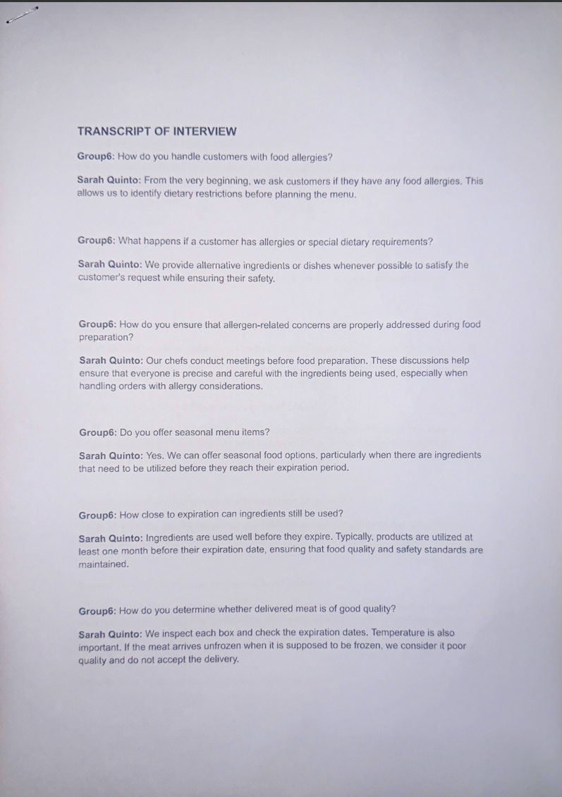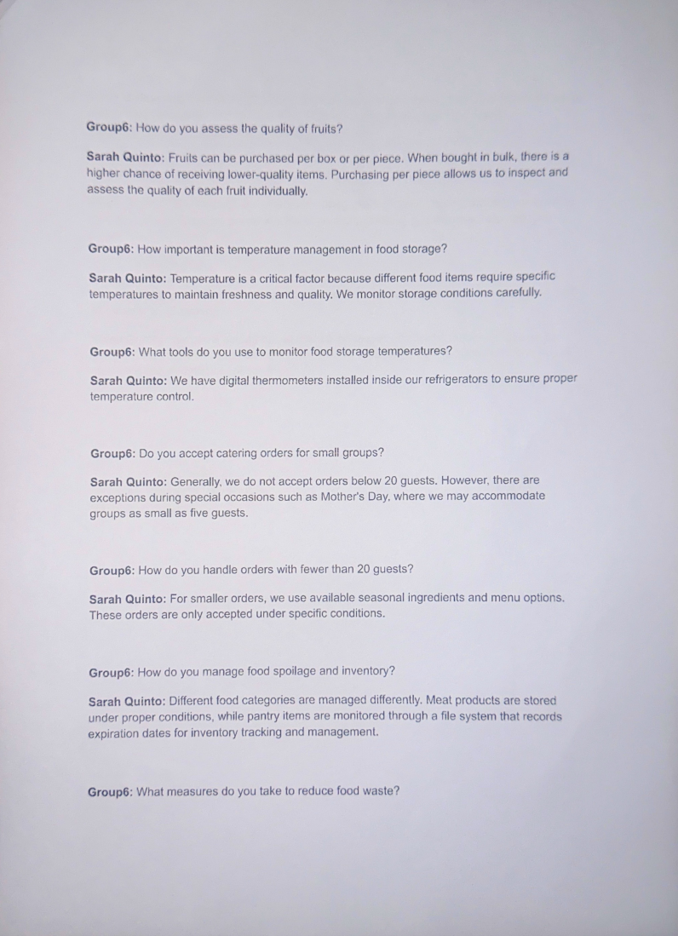


Appendix C: Commitment Letter


Appendix D: SALES 2023 -2026

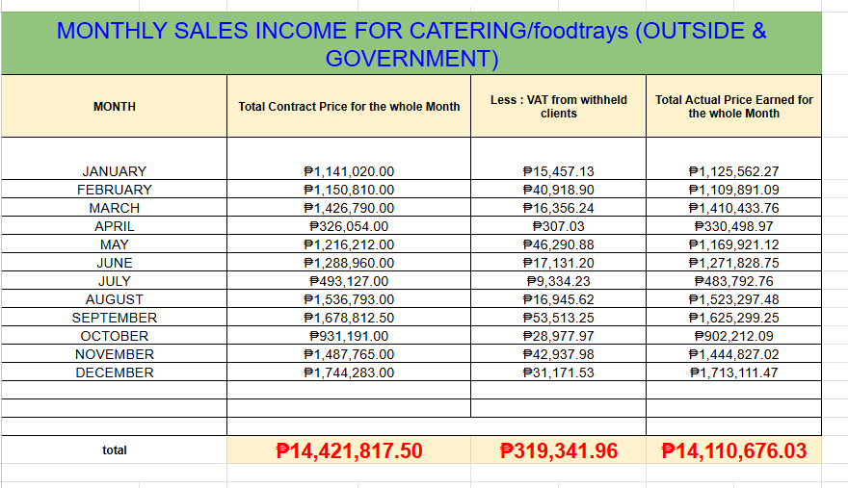
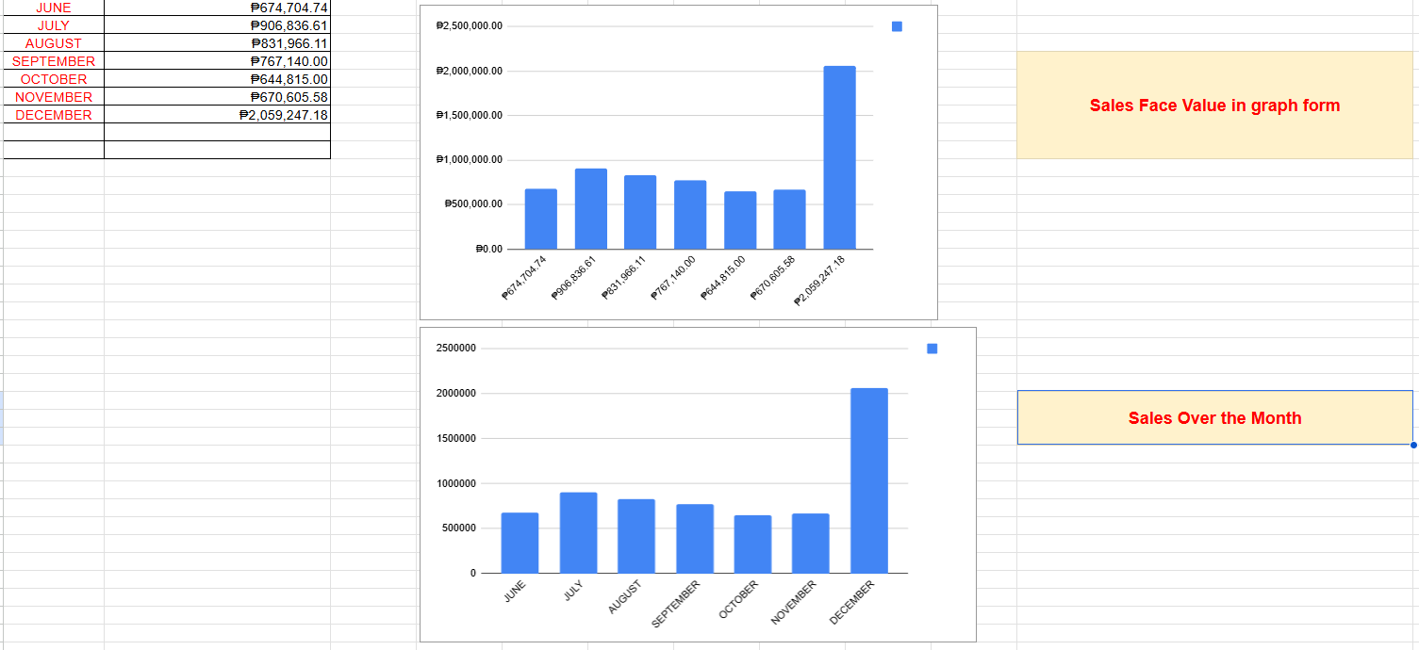
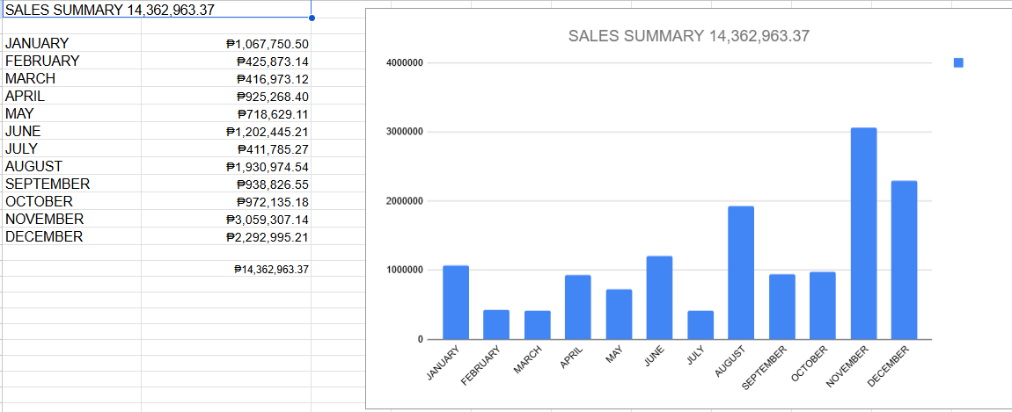
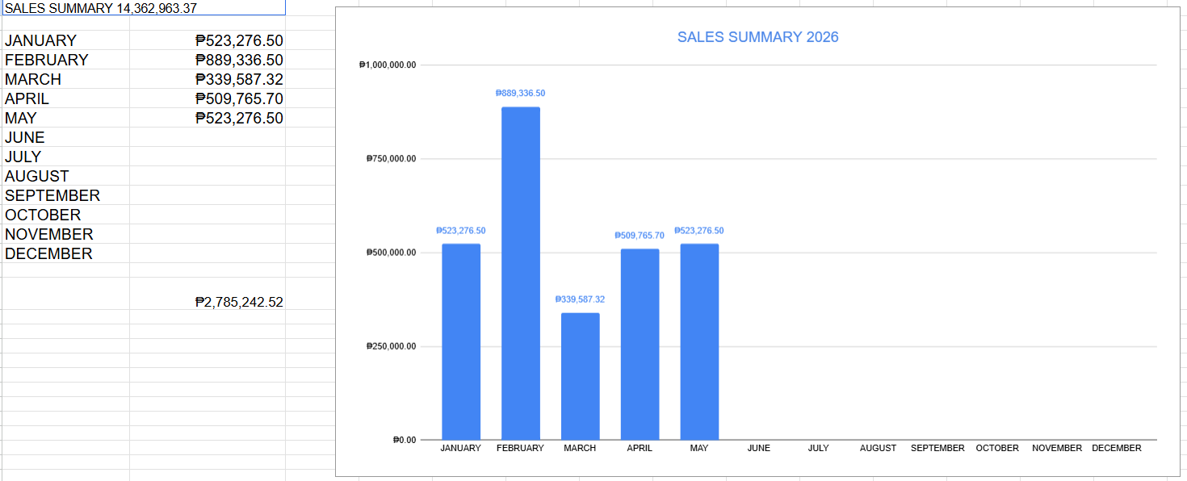

Appendix E: Recipe Costing Sheet
https://docs.google.com/spreadsheets/d/1jdBOwe9jCPKzT7JpIiUjh8XfLOyBfWCyVrBAXhiXiwM/edit?gid=0#gid=0

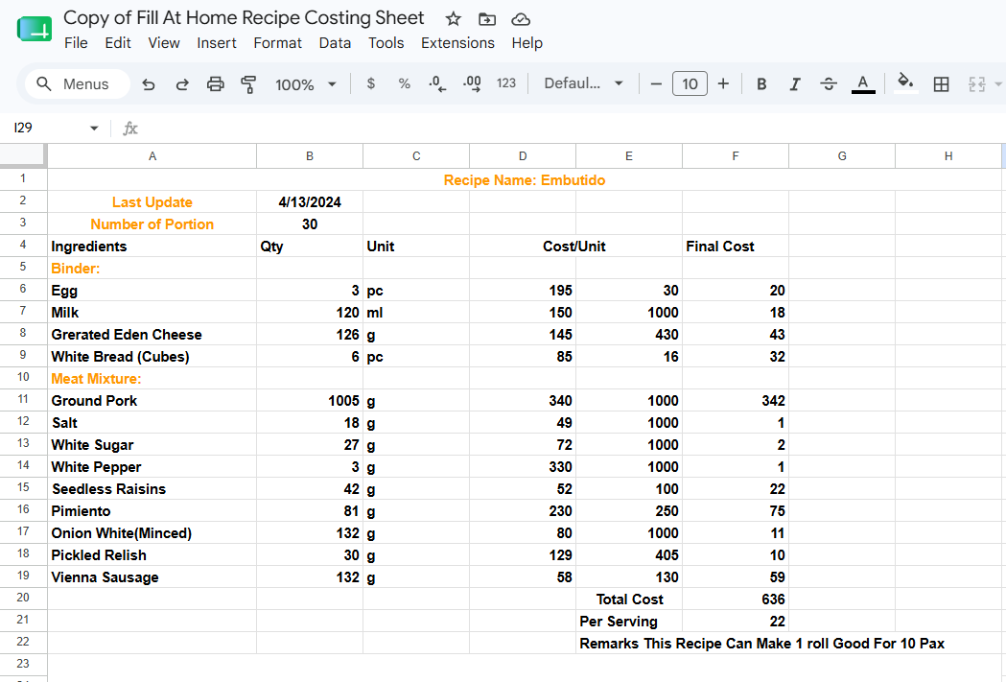

Appendix F: Data sheet of Orders
https://docs.google.com/spreadsheets/d/1sUktR7WSr3IqlK81ZBU_VZ3r1jeZLUaZkGscD9dQqG0/edit?gid=1367452310#gid=1367452310

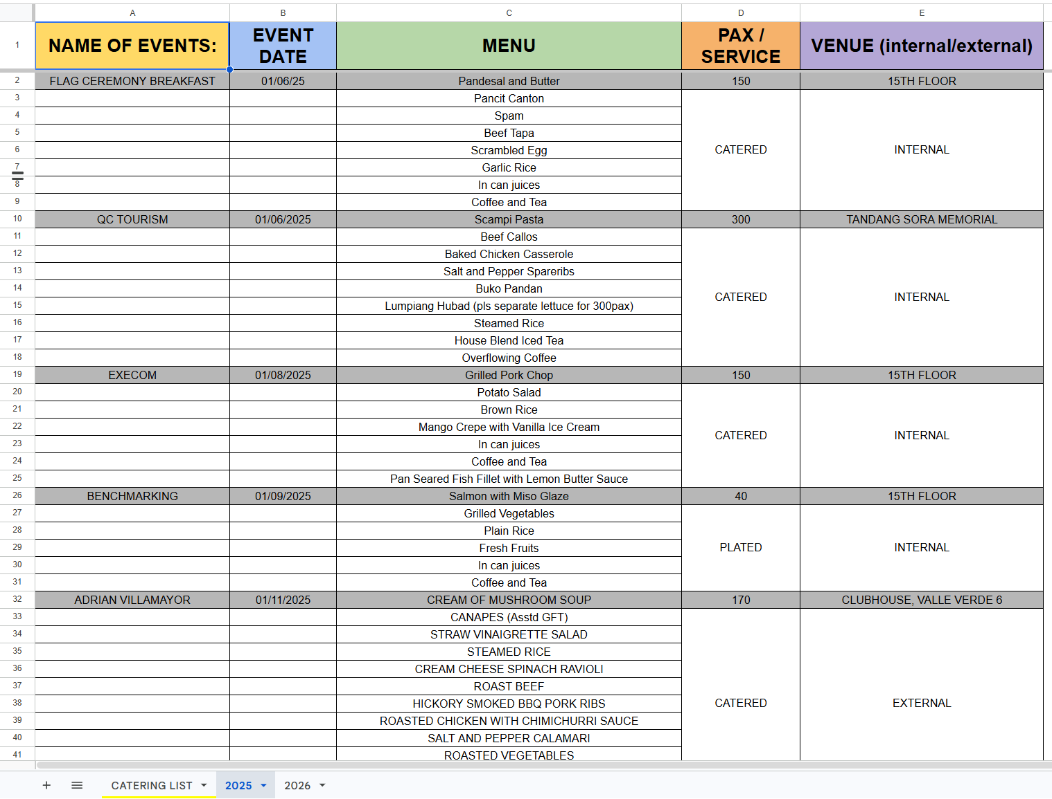

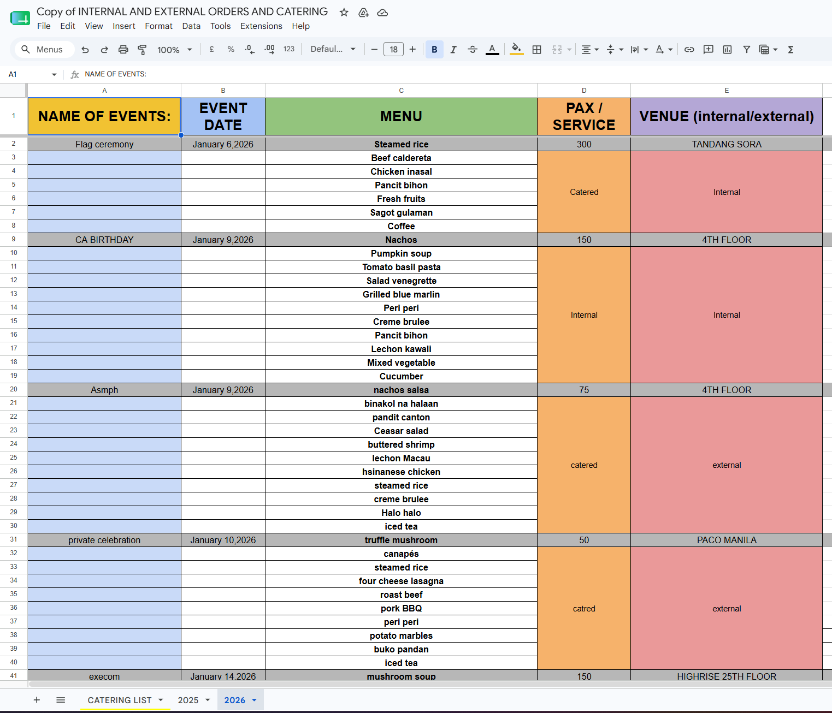

Appendix G: Risk Management Plan

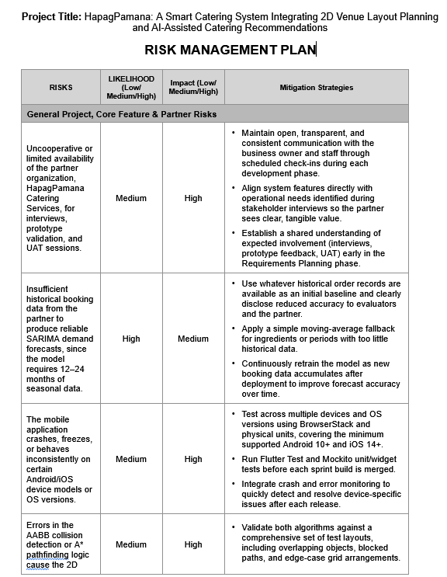

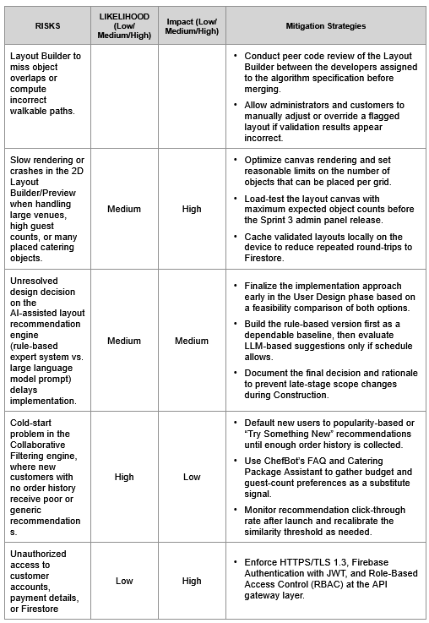
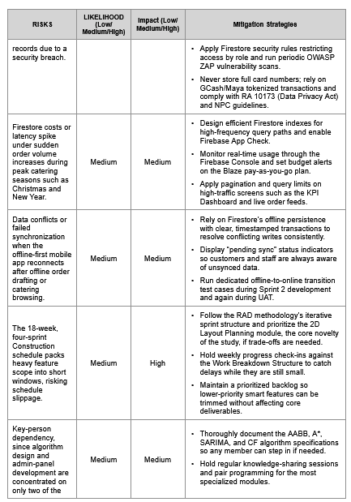
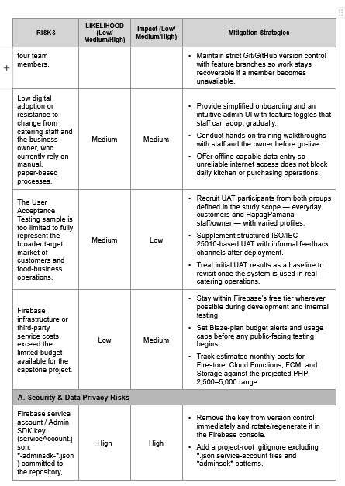
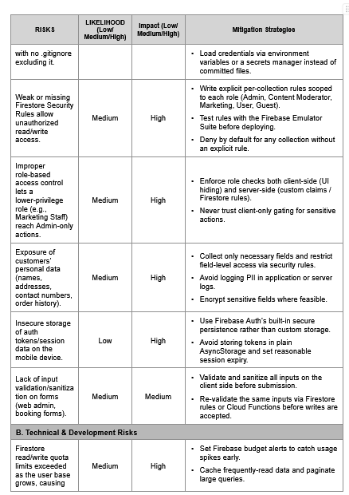
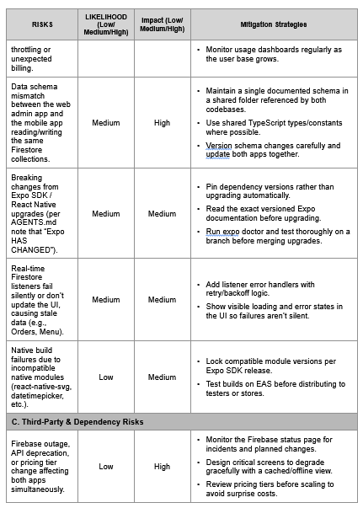
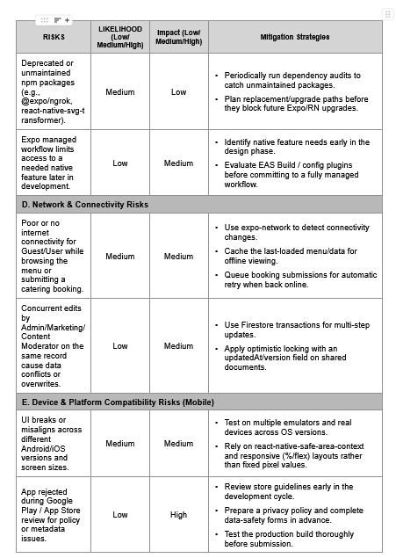
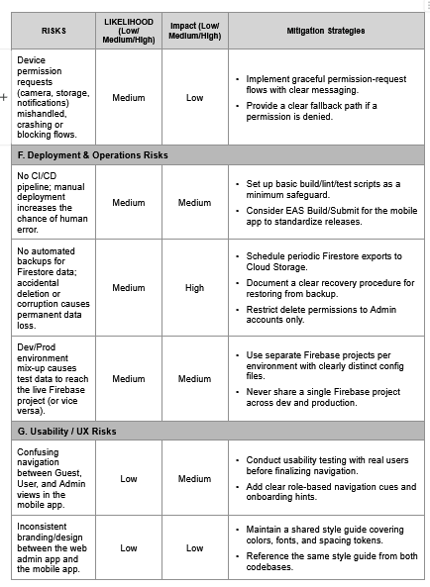
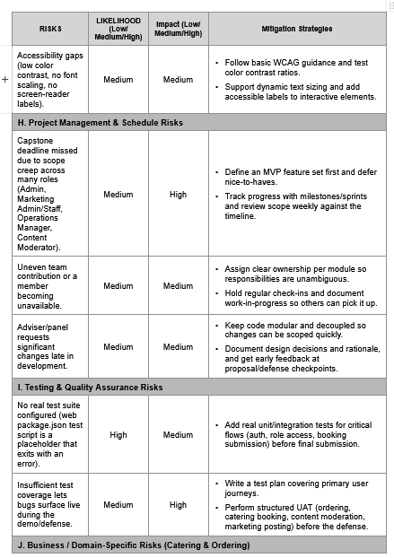
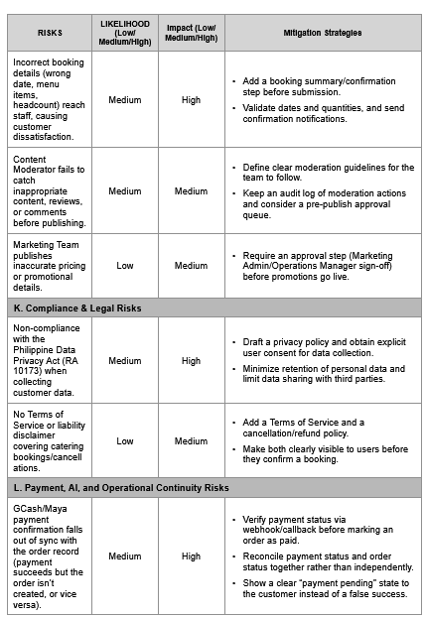
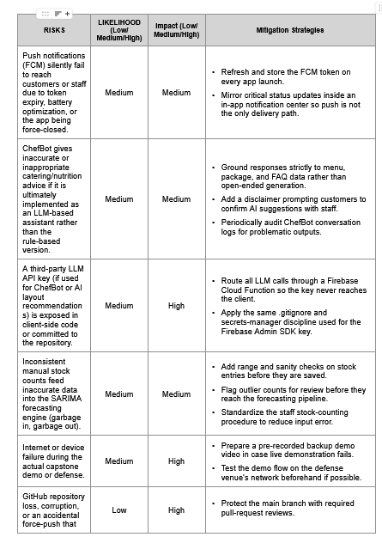
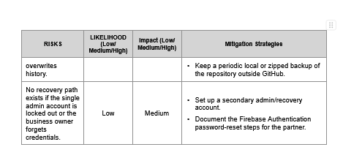

Appendix H: AI Tool Declaration




Appendix I: Storyboard

System Modules and Screen-Level Features
This section presents the screen-level modules of the HapagPamana system as implemented across the customer mobile application and the administrative web panel. The screens are organized into five groups: the guest pages available before sign-in, the authentication screens, the authenticated customer modules, the catering booking flow, and the administrative web panel modules. Each screenshot is described in terms of its function and how it supports the core features of the system, namely the interactive 3D venue layout planner, the SARIMA-based demand forecasting engine, and the expiry-aware Collaborative Filtering recommendation system.
Guest Page Modules
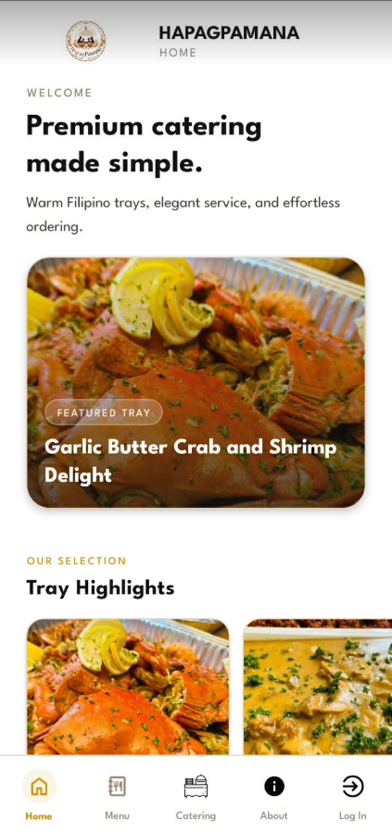
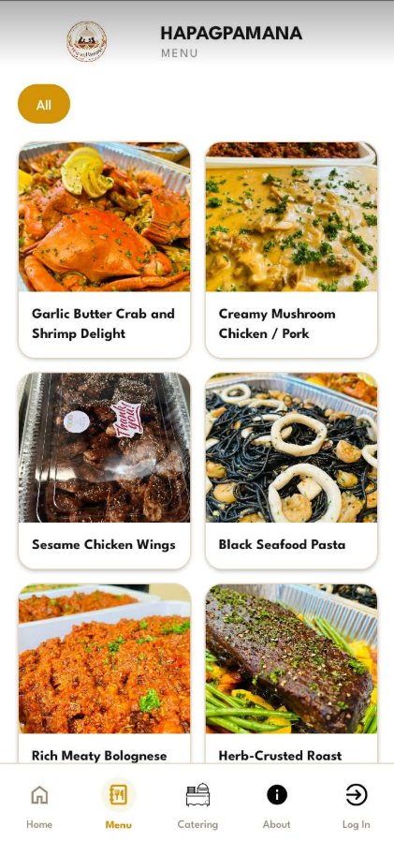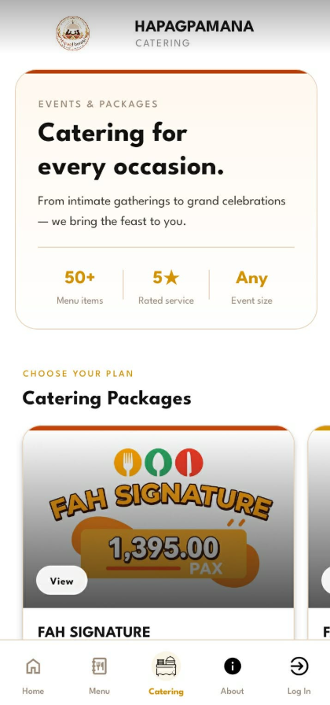
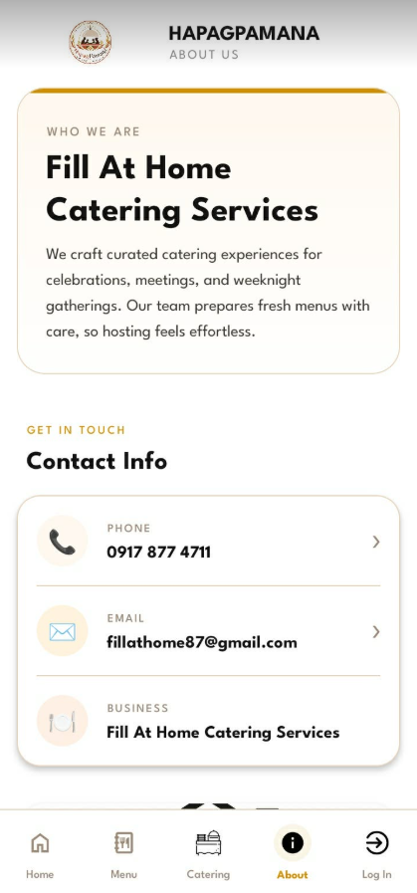
The guest pages allow visitors to explore HapagPamana before creating an account. The Landing Screen opens the application with the HapagPamana logo, a short tagline stating that the business prepares food for everyone every day, and a Book Now button that invites the visitor to begin browsing.
The Guest Home Screen introduces the business through a featured tray and a Tray Highlights carousel, giving first-time visitors a quick preview of popular dishes. The Guest Menu Screen displays the full catalog of dishes in a scrollable grid with category filters, allowing visitors to browse items such as the seafood, chicken, pasta, and roast selections.
The Guest Catering Screen presents the available catering packages together with summary statistics for the number of menu items, service rating, and supported event size, and lets visitors preview package options such as the Signature tier. The Guest About Screen provides the business profile and contact information, including phone, email, and business name, so visitors can reach the caterer directly. A persistent bottom navigation bar with Home, Menu, Catering, About, and Log In links lets guests move between these pages and proceed to authentication.

Authentication Modules (Log In and Sign Up)
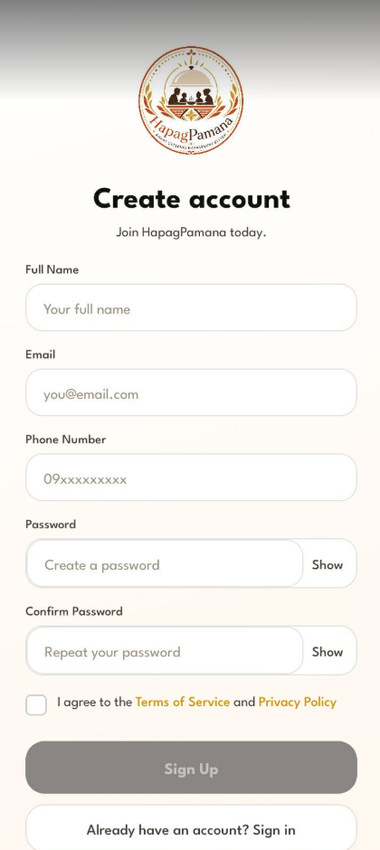
The authentication modules control access to the personalized features of the system. The Log In Screen presents the HapagPamana logo with email and password fields, a Log In button, and a link to create a new account, allowing returning customers to sign in and place another order.
The Create Account Screen collects the new customer’s full name, email, phone number, and password, requires agreement to the Terms of Service and Privacy Policy, and registers the account through Firebase Authentication before granting access to the authenticated experience.
Authenticated Customer Modules
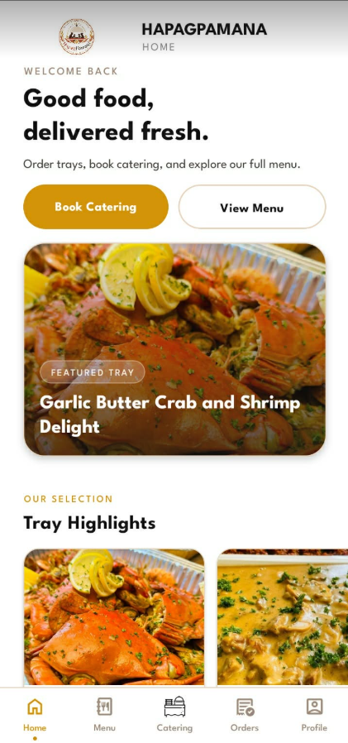
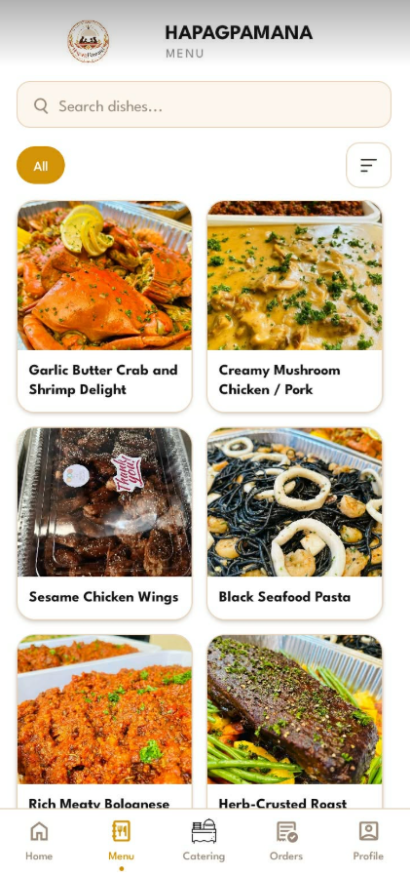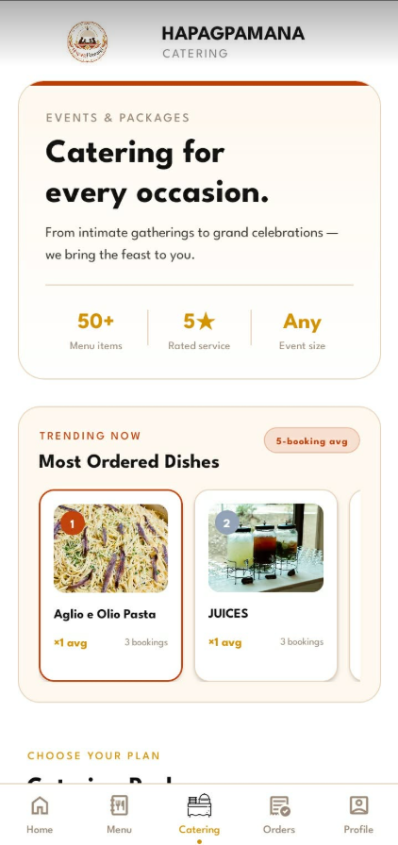
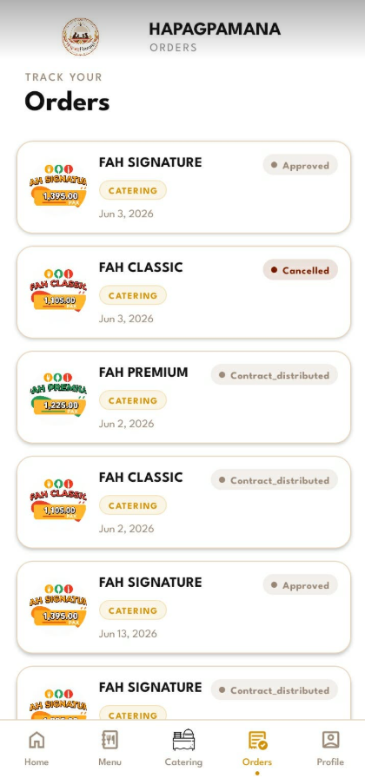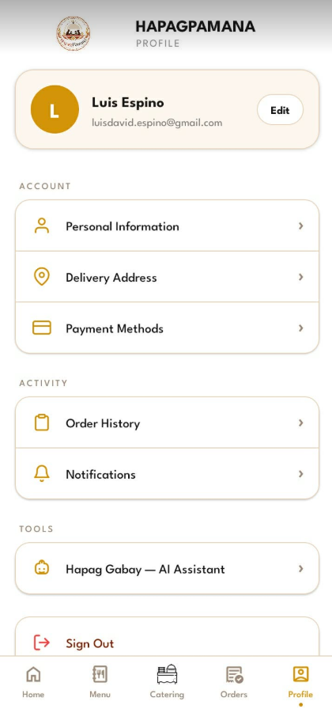
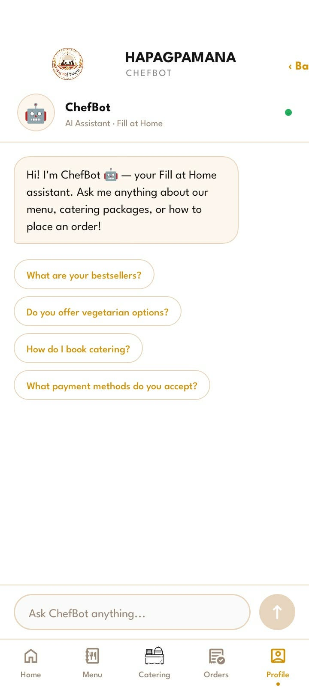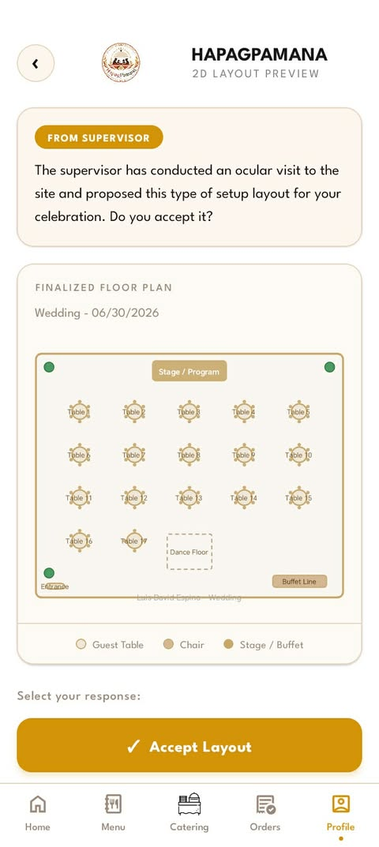
Once authenticated, the customer gains access to the full mobile experience. The authenticated entry screen mirrors the branded landing view and routes the signed-in user into the application. The Customer Home Screen greets the user and provides quick Book Catering and View Menu actions above a featured tray and Tray Highlights, serving as the main hub for ordering and catering.
The Customer Menu Screen adds a search bar and a sorting control to the dish grid so the customer can look up specific dishes and filter by category. The Customer Catering Screen surfaces the catering packages together with a Most Ordered Dishes panel; this trending panel is generated by the Collaborative Filtering engine, which ranks dishes by how frequently similar customers have ordered them, improving menu discovery.
The Orders Screen lets the customer track the status of each catering booking, displaying entries with labels such as Approved, Cancelled, and Distributed alongside the package tier and event date. The Profile Screen organizes the account into Personal Information, Delivery Address, and Payment Methods, with quick links to Order History, Notifications, the Gabay assistant, and a Sign Out control.
The Gabay Screen provides an AI catering assistant that answers menu and booking questions and offers suggested prompts such as bestsellers, vegetarian options, and how to book catering. The 3D Layout Preview Screen is the customer-facing view of the venue layout planner; it displays the finalized floor plan prepared by the administrator for the customer’s event, showing the placement of guest tables, chairs, stage, dance floor, and buffet line, and lets the customer review and accept the proposed arrangement through an Accept Layout action.

Catering Booking Flow (Customer Side)

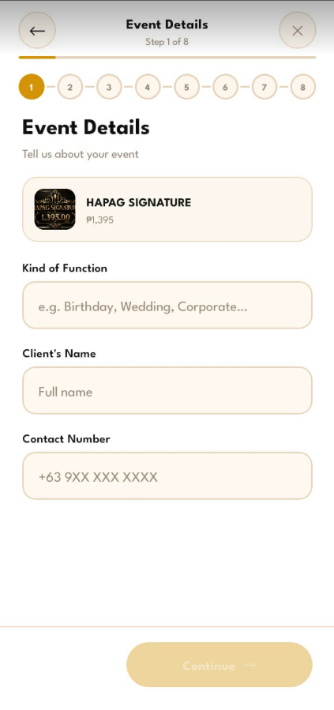
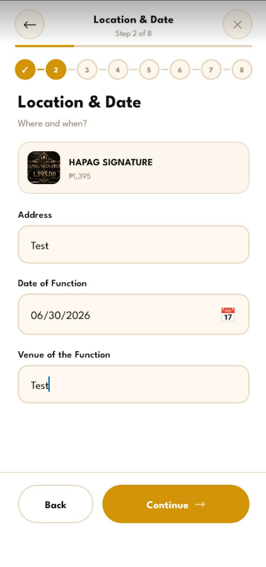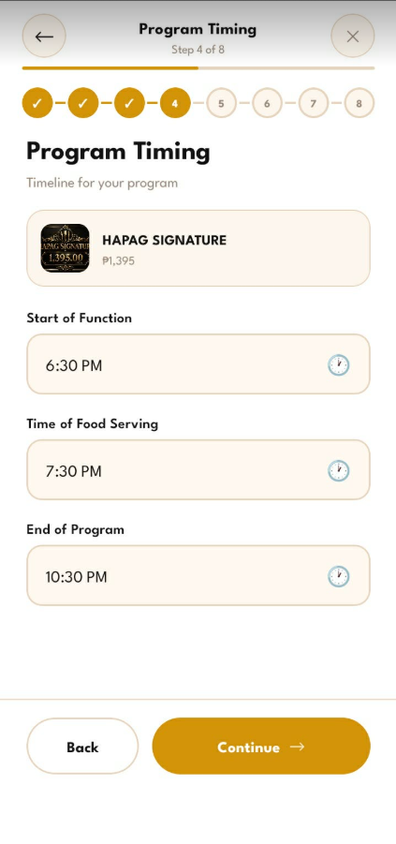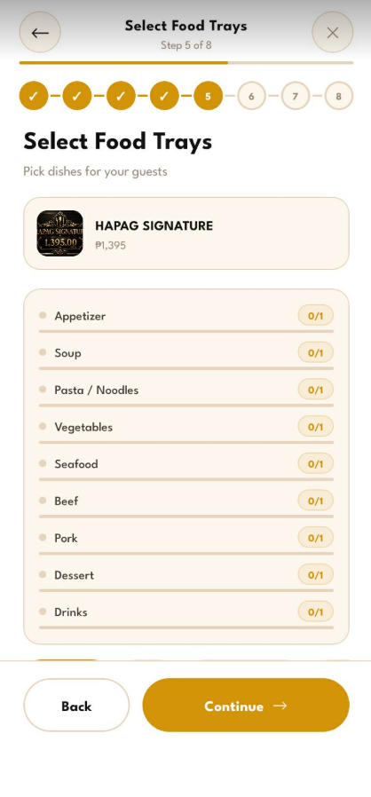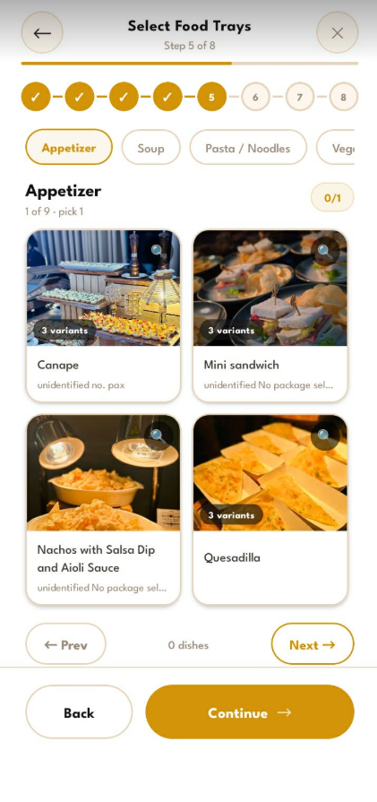
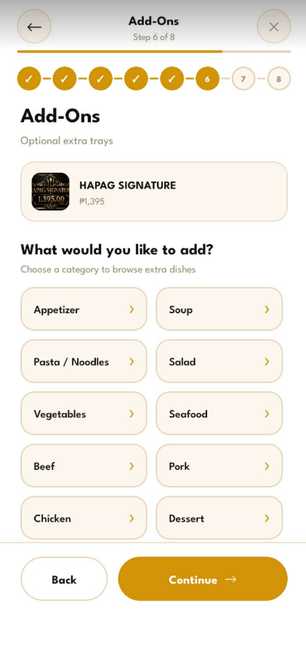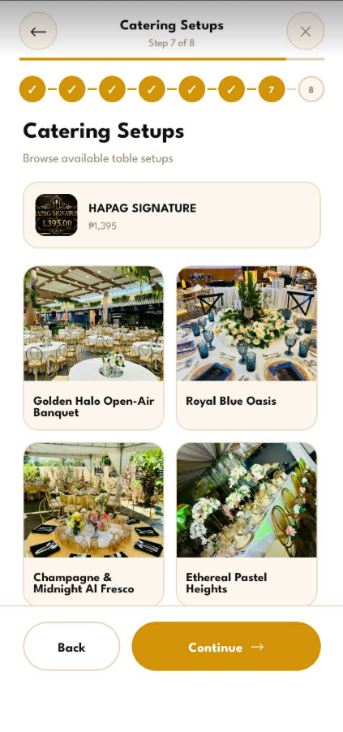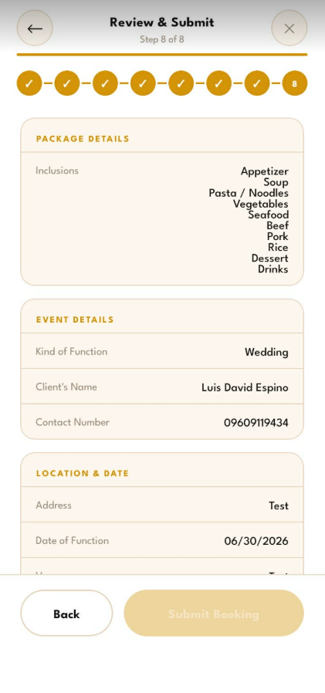
The catering booking flow guides the customer through a structured, multi-step wizard for reserving a catering event. It begins with the Package Detail Screen, which presents the selected catering package, its inclusions across courses such as appetizer, soup, pasta, vegetables, seafood, beef, pork, rice, dessert, and drinks, and a Book This Package action that starts the wizard.
The wizard then proceeds in sequence. The Event Details step records the kind of function, the client name, and the contact number. The Location and Date step records the venue address and the date of the function. The Program Timing step records the start of the function, the time of food serving, and the end of the program. The Select Food Trays step lets the customer choose dishes per course, with a detail view that presents the available options and variants within each course.
The Add-Ons step offers optional extra trays organized by course, while the Catering Setups step lets the customer browse predefined table-setup styles for the event. The flow concludes with the Review and Submit step, which consolidates the package inclusions, the event details, and the location and date into a single summary for confirmation before the booking is submitted to the administrator for processing.
Administrative Web Panel Modules
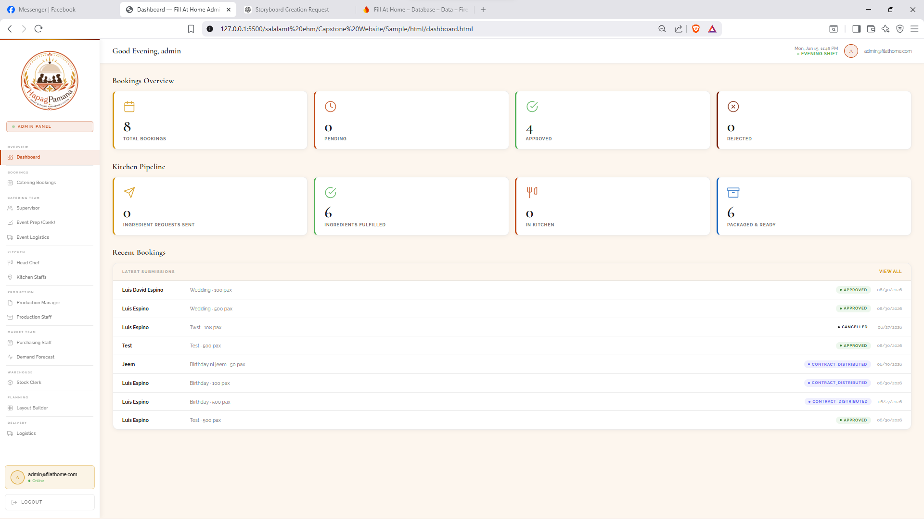
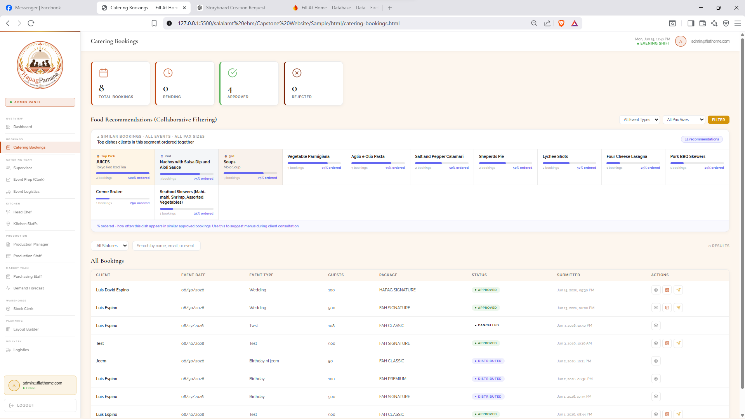
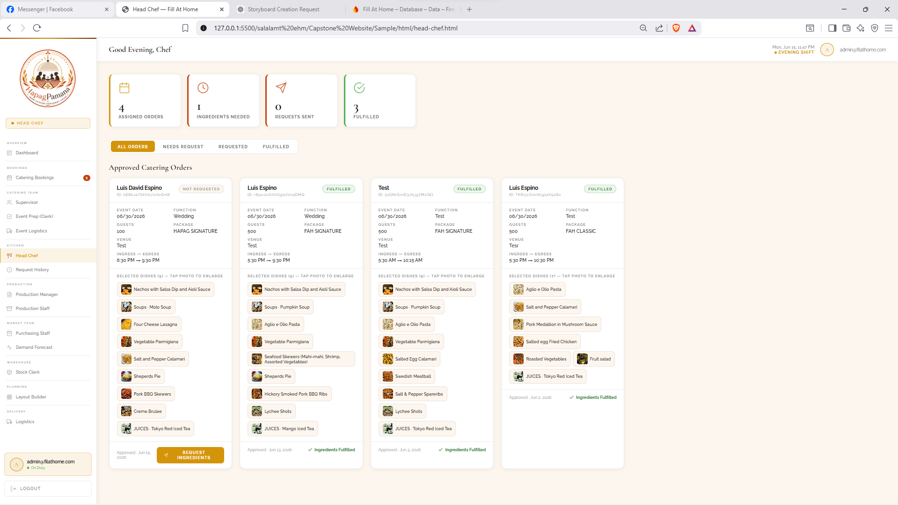
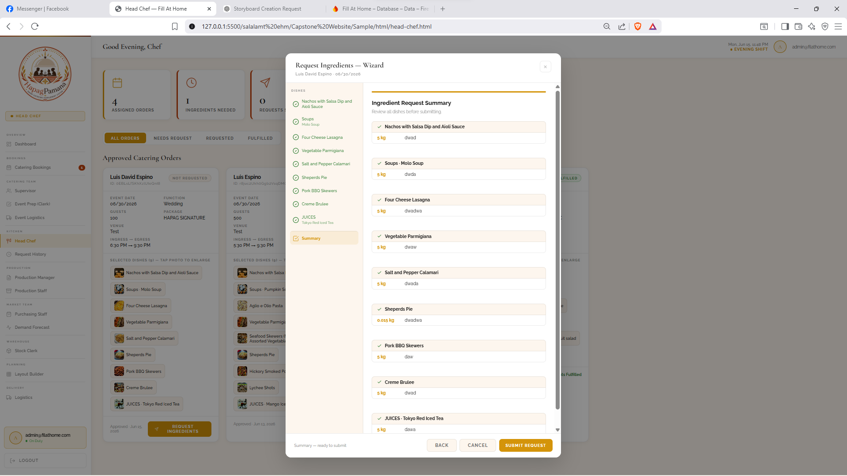
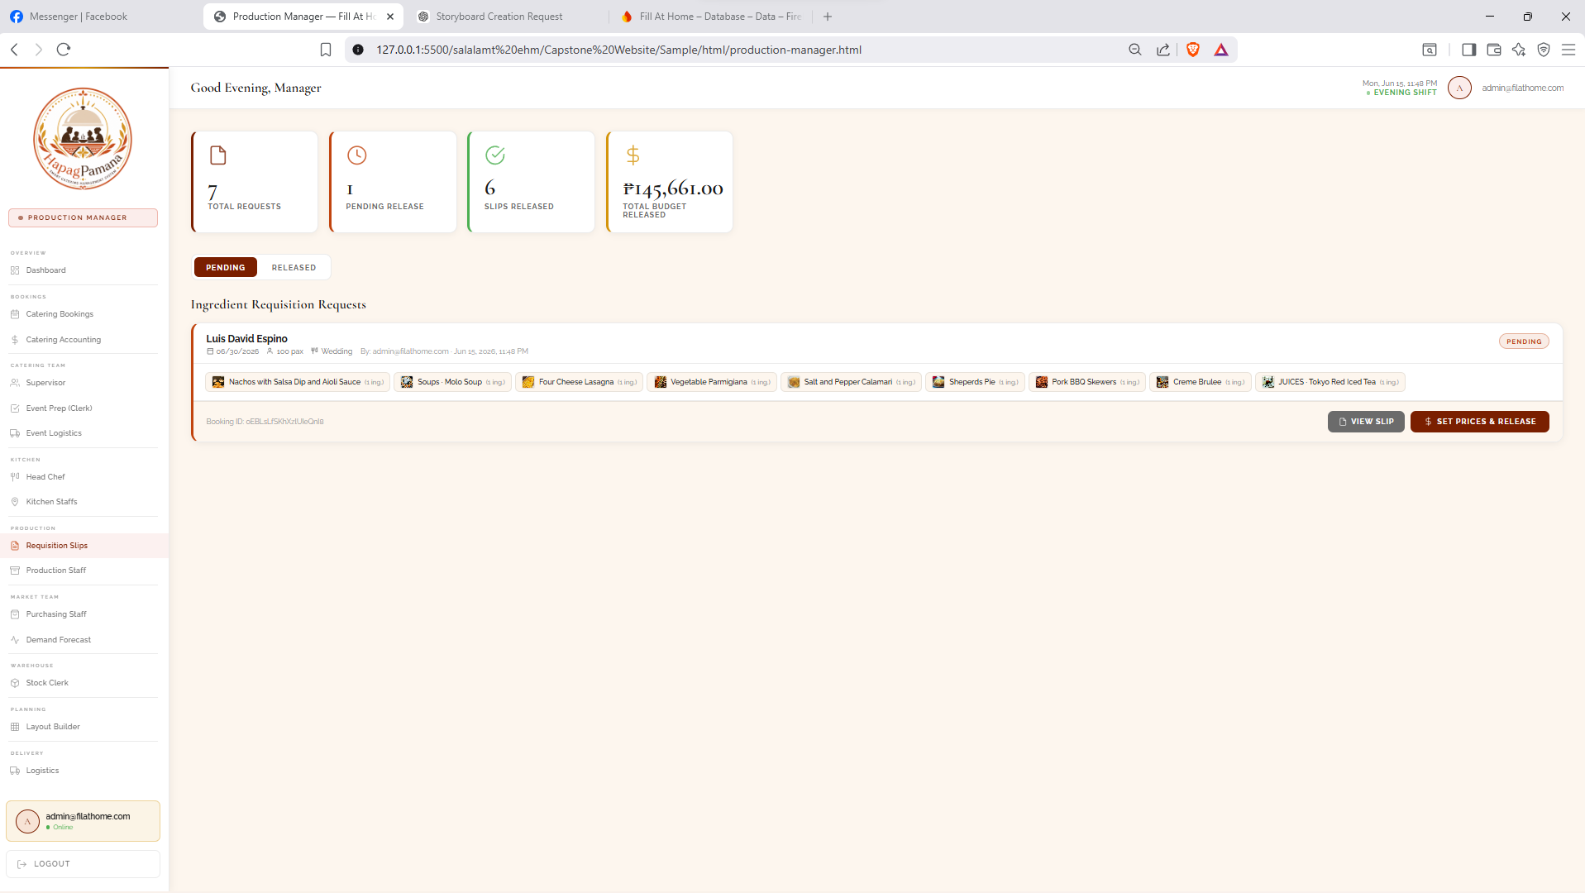
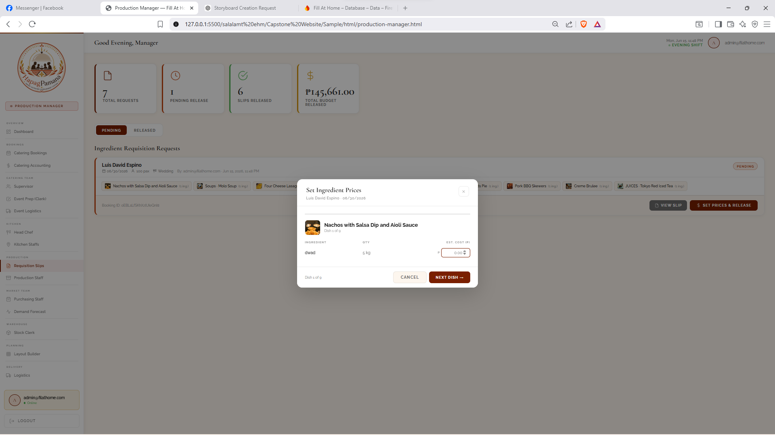
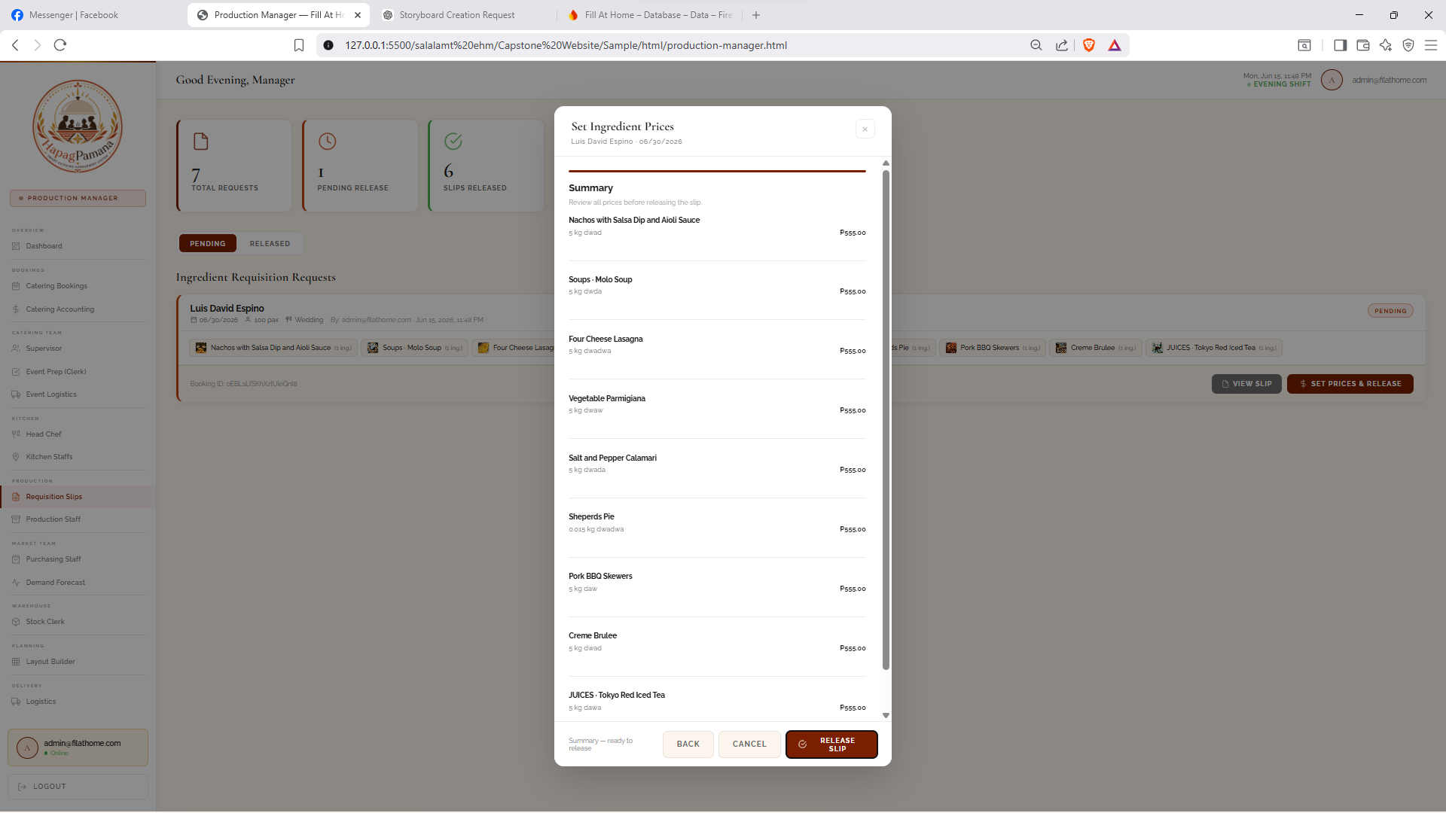
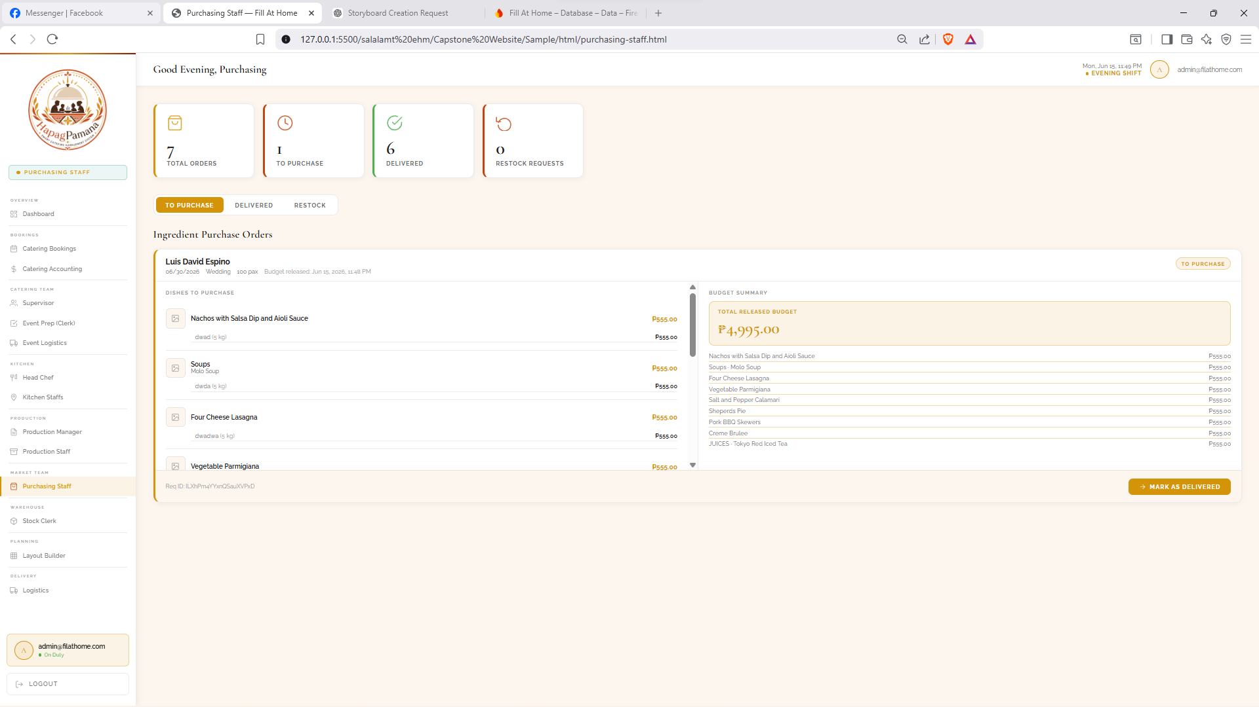
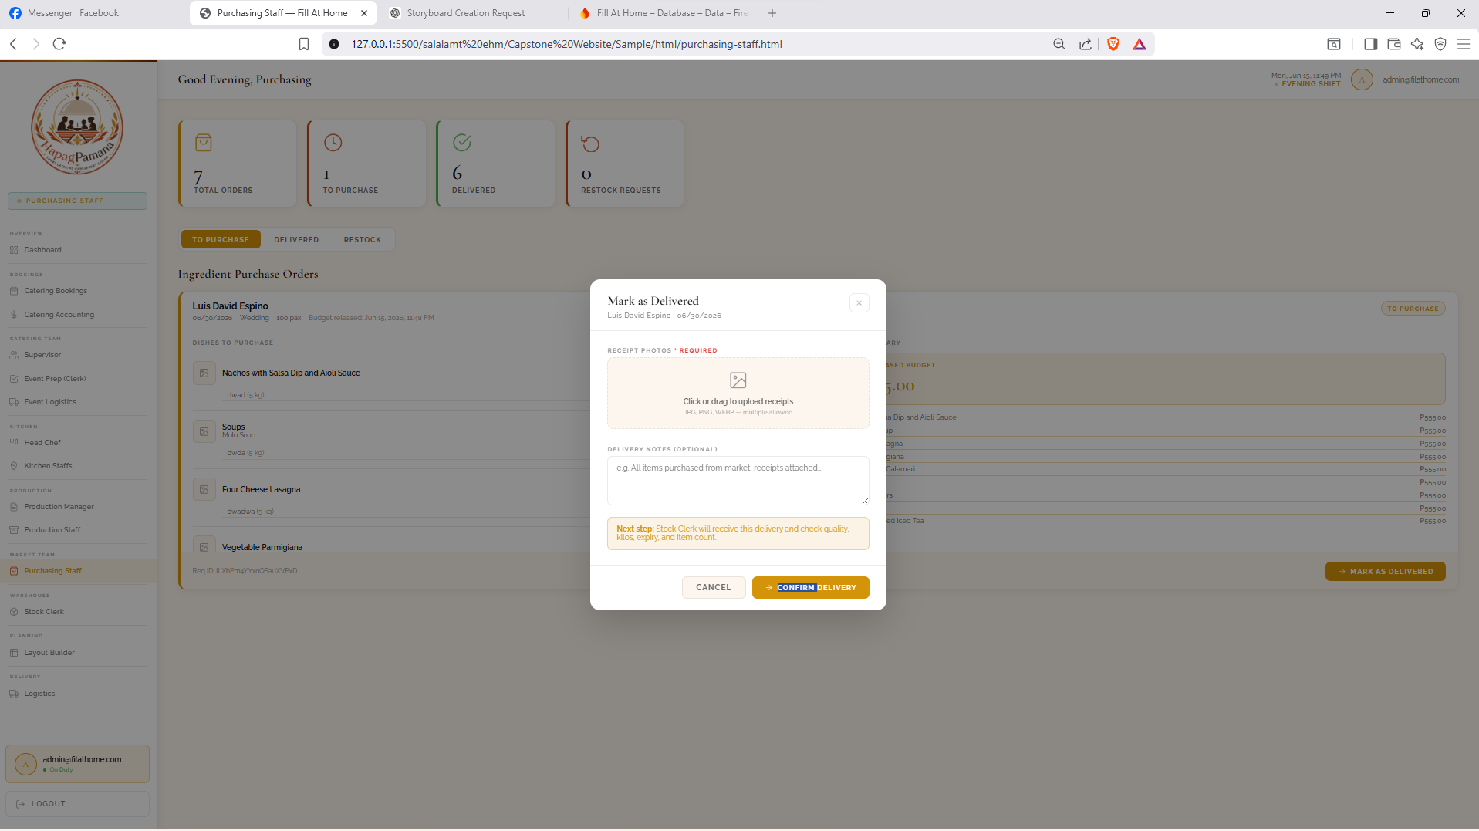
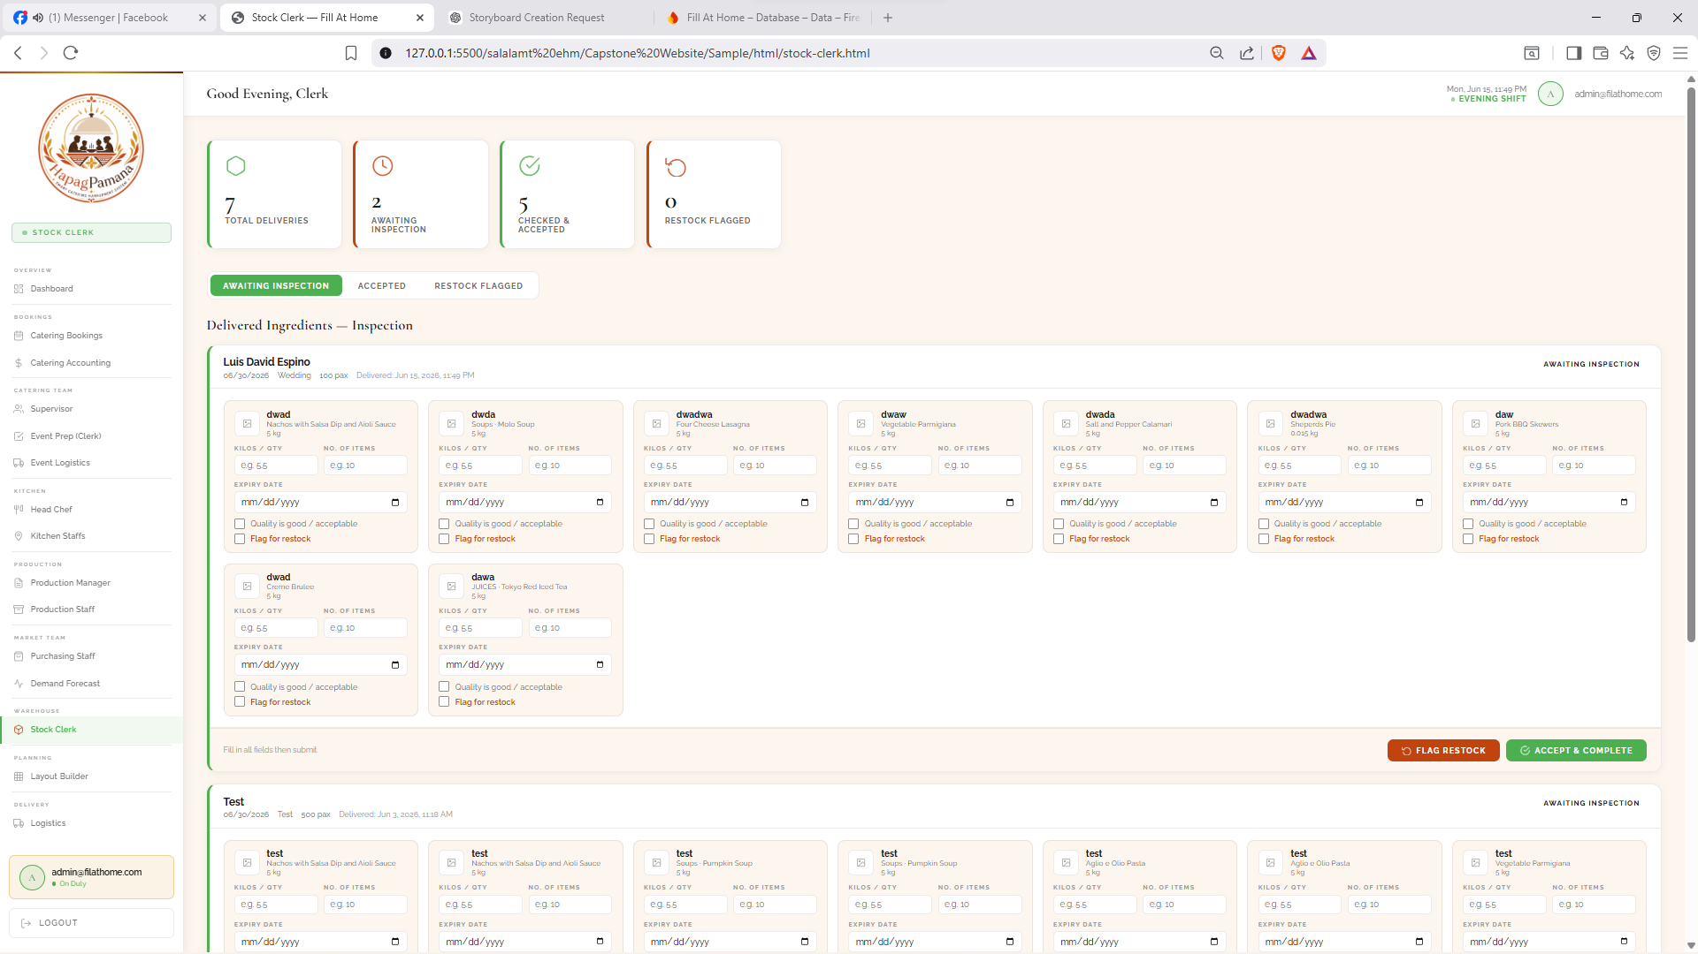
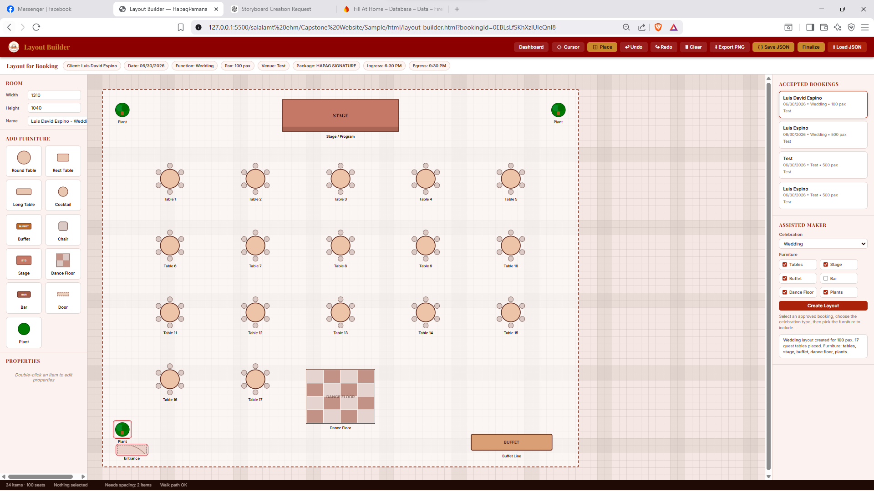

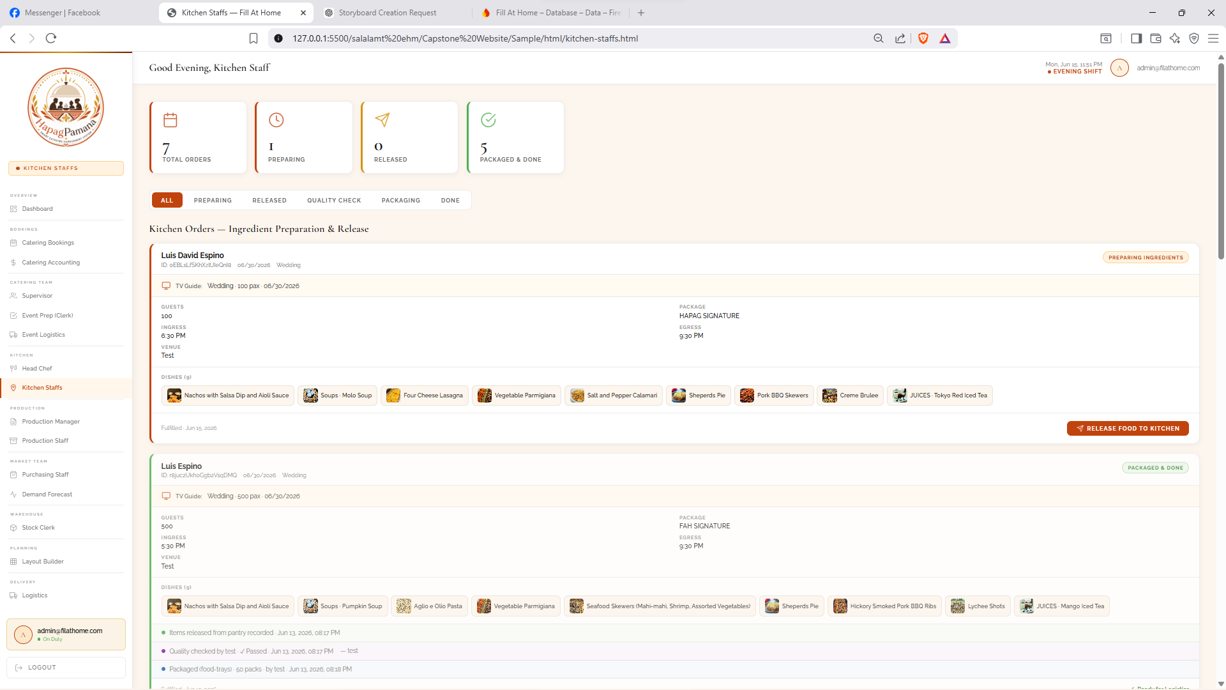
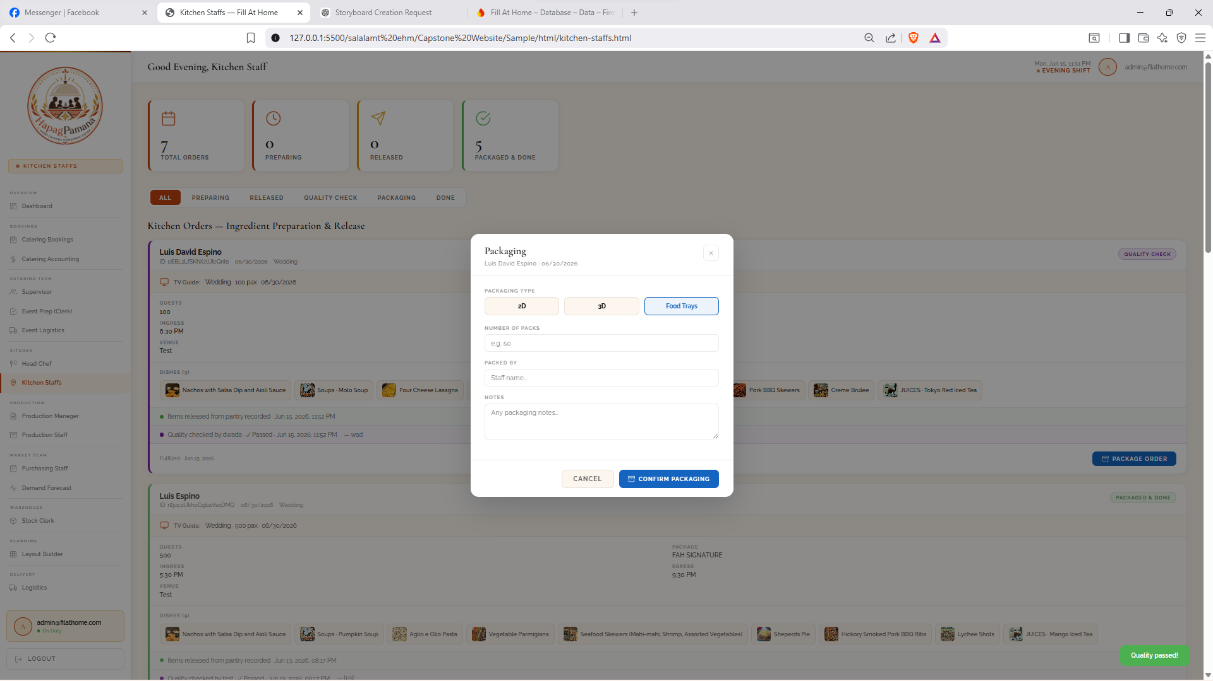
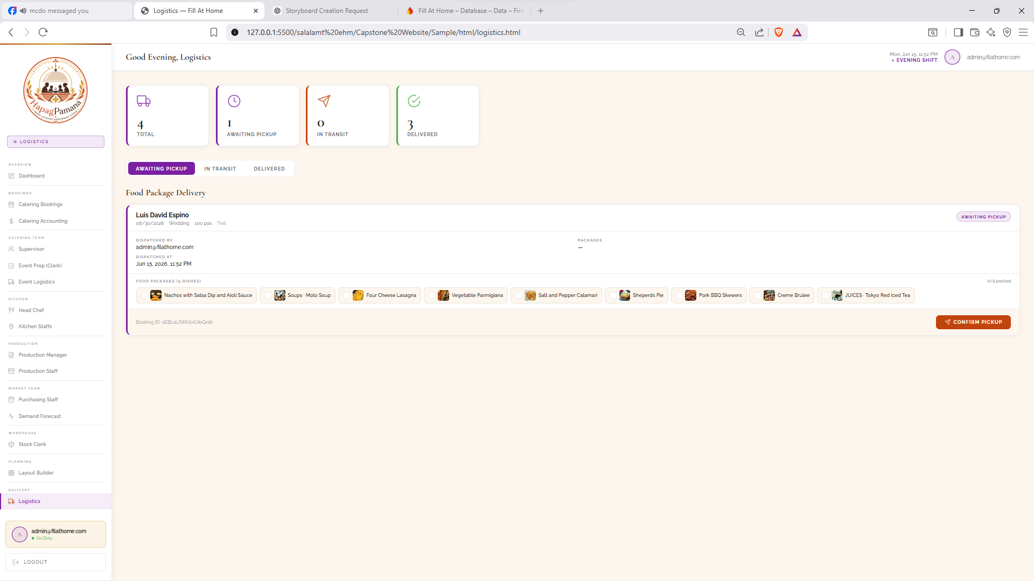
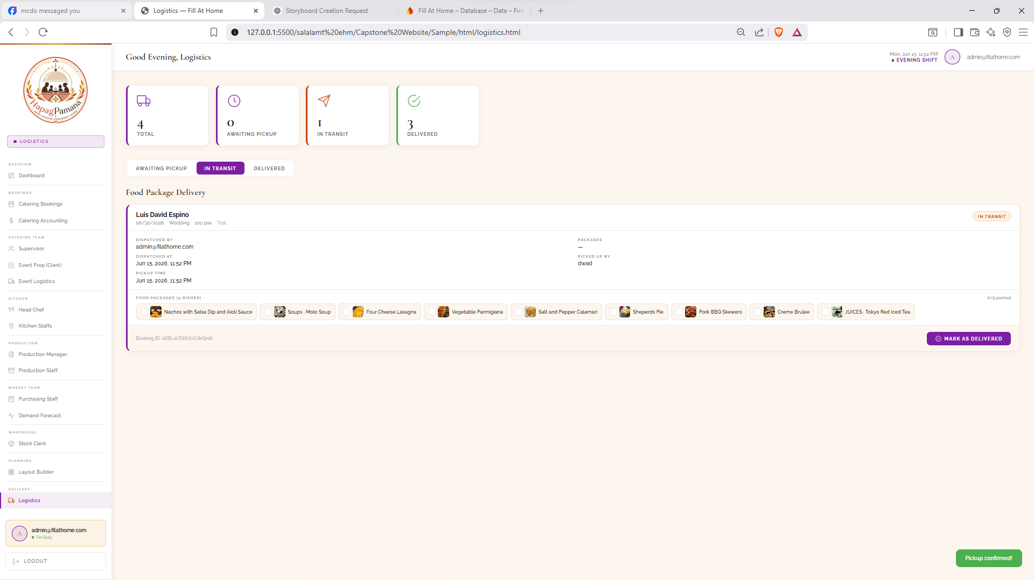
The administrative web panel is a role-based control center used by the catering team to manage bookings, the kitchen pipeline, procurement, the venue layout, and delivery. The Dashboard provides an at-a-glance overview through Bookings Overview cards for total, pending, approved, and rejected bookings and a Kitchen Pipeline summary for ingredient requests sent, ingredients fulfilled, items in the kitchen, and packaged-and-ready orders, together with a live feed of recent bookings. A left-hand navigation menu organizes the panel by team, covering the catering team, kitchen, production, market team, warehouse, planning, and delivery functions.
The Catering Bookings Screen lists all submitted bookings with their status and provides a Food Recommendations panel powered by Collaborative Filtering. This panel ranks the dishes most frequently ordered together by clients in similar event segments and reports the percentage of similar approved bookings that included each dish, helping staff suggest menus during client consultation.
The Head Chef Screen displays the approved catering orders assigned to the kitchen, each card listing the event details and selected dishes, and provides a Request Ingredients action. The Request Ingredients Wizard then steps through each dish so the chef can specify the quantity of every ingredient and review a consolidated summary before submitting the request to production.
The Production Manager Screen receives these ingredient requisition requests and tracks the released budget. The Set Ingredient Prices dialog lets the manager enter an estimated cost for each ingredient dish by dish and review a price summary before releasing the requisition slip. The Purchasing Staff Screen lists the released purchase orders with their dishes and total released budget, and the Mark as Delivered dialog requires the staff to upload receipt photos and add delivery notes before confirming the purchase, after which the delivery passes to the stock clerk.
The Stock Clerk Screen handles incoming deliveries through a per-ingredient inspection form in which the clerk records the kilos or quantity, the number of items, and the expiry date of each delivered ingredient, and marks whether its quality is acceptable or flags it for restock. The expiry dates recorded at this step supply the spoilage information later used by the expiry-aware recommendation logic.
The Layout Builder is the administrative side of the interactive 3D venue layout planner and the primary novelty of the system. It loads an approved booking and presents a scaled venue canvas on which the administrator drags and drops furniture such as round tables, rectangular tables, long tables, cocktail tables, chairs, stage, dance floor, buffet, bar, doors, and plants. As objects are placed, the planner validates the arrangement in real time: a spacing indicator reports objects that violate minimum clearance using Axis-Aligned Bounding Box collision detection, while a walk-path indicator confirms that a clear route exists from the entrance to the service areas using A* pathfinding.
An Assisted Maker panel lets the administrator select the celebration type and the furniture to include and then automatically generates a starting layout for the given guest count, after which the administrator can refine, export, save, and finalize the floor plan that the customer later reviews on the 3D Layout Preview screen. This makes the Layout Builder the source of the validated layout that flows to the customer application.
The Kitchen Staff Screen manages food preparation and release, tracking each order through preparing, released, quality check, packaging, and done stages, with a Packaging dialog that records the packaging type, the number of packs, and the staff who packed the order. The Logistics Screen manages food package delivery, moving each order through awaiting pickup, in transit, and delivered states and recording who dispatched and picked up the packages. Together, these administrative modules form a complete pipeline that runs from booking and menu recommendation, through kitchen preparation, procurement, and inventory inspection, to venue layout planning and final delivery.

Appendix J: Grammarly and Plagiarism Results

Grammar Checking Result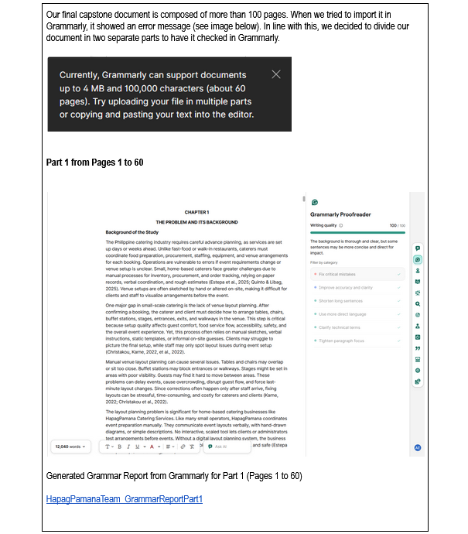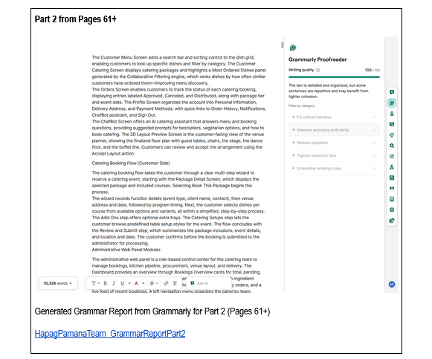

Plagiarism Result



